Global Hyperspectral Imaging Spectral-Library of Agricultural-Crops (GHISA)
Country/Region: United States of America
Readme file for the spectral library data
These spectral library data (GHISA-USA-EO-1-Hyperion-data-of-crops-1g.csv) contain a hyperspectral library of agricultural crops gathered from different agroecological zones of USA (Figure 1). The hyperspectral data were gathered for leading world crops consisting of Corn, Cotton, Rice, Soybean, and Winter Wheat of USA. Hyperspectral data were obtained from the Earth Observing-1 (EO-1) Hyperion satellite images available in the USGS satellite data archive (https://earthexplorer.usgs.gov/). There are over 70,000 EO-1 Hyperion images for the world gathered from the 2001-2015 time-period. Crop type reference data were obtained from the USDA Cropland Data Layer (CDL) (https://nassgeodata.gmu.edu/CropScape/).
The spectral library data (GHISA-USA-EO-1-Hyperion-data-of-crops-1g.csv) contain GHISA for USA derived from multiple years of EO-1 Hyperion data for Corn, Cotton, Rice, Soybean, and Winter Wheat crops spread across USA (Figure 1). The EO-1 Hyperion data are converted into surface reflectance using methods and procedures described in Aneece and Thenkabail (2018) and Aneece and Thenkabail (in review) and using codes developed on the Google Earth Engine (GEE) cloud computing platform (https://developers.google.com/earth-engine/).
The GHISA data for USA are available in the file “GHISA-USA-EO-1-Hyperion-data-of-crops-1g.csv”. Example spectra are shown in Figure 2. Acronyms and IDs in the spectral library data file (GHISA-USA-EO-1-Hyperion-data-of-crops-1g.csv) are explained below:
UniqueID: This is an identification number associated with each spectral profile.
Country: Country for which the data were collected
Image: EO-1 Hyperion Image ID
Month: Month in which the EO-1 Hyperion image was collected
Year: Year in which the EO-1 Hyperion image was collected
JD: Julian day on which the image was collected
Coordinates: long, lat: precise latitude and longitude of the data
Crop: Crop for which the data were collected
Growth stage: Crop growth stage at which the data were collected
X447 to X2395: EO-1 Hyperion hyperspectral narrowband (HNB) band center. Note: Values in the atmospheric windows were removed. These are the spectral regions where you will see no data (NA). Hyperion collects data in 400 to 2500 nm. However, wavebands in the beginning and end of the range are uncalibrated and/ or noisy, and were dropped from the analysis (see Aneece and Thenkabail, 2018 and Aneece and Thenkabail, in review)
Data format: .csv file
References:
Aneece, I., and Thenkabail, P.S. 2018. Spaceborne Hyperspectral EO-1 Hyperion data pre-processing: Methods, approaches, and algorithms. Book Chapter 9 in Volume I: Introduction, Sensor Systems, Spectral Libraries, and Data Mining”. In Book: “Hyperspectral Remote Sensing of Vegetation (Second Edition, 4 Volume Set). CRC Press- Taylor and Francis group, Boca Raton, London, New York. (Editors: Thenkabail, P.S., Lyon, G.J., and Huete, A.). (Editors: Thenkabail, P.S., Lyon, G.J., and Huete, A.). IP-091722
Aneece, I., and Thenkabail, P.S. In Review. Accuracies Achieved in Classifying Five Leading World
Crop Types and their Growth Stages using Optimal Earth Observing-1 Hyperion Hyperspectral Narrowbands on Google Earth Engine.
FAO. Food and Agriculture Organization of the United Nations: GAEZ- Global Agro-Ecological Zones, 2018. Available at <http://www.fao.org/nr/gaez/en/>.
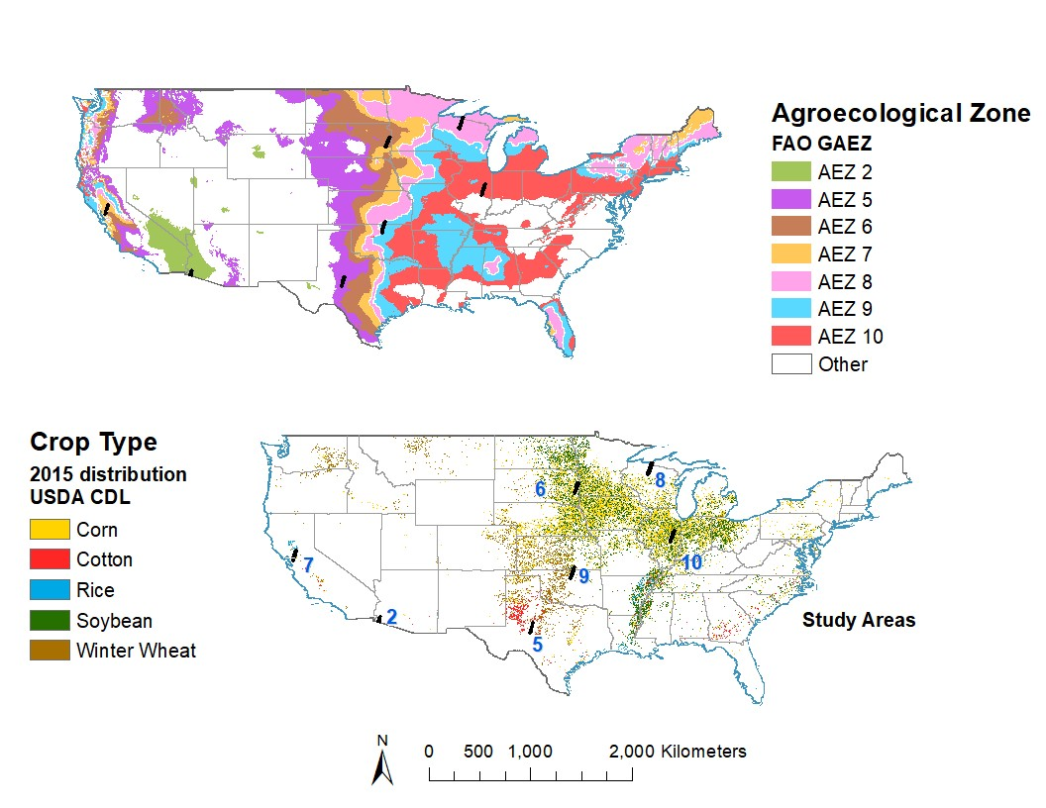
Figure 1: Study areas throughout the US in various agroecological zones. US study areas, named according to agroecological zones (AEZs) in which they are located. AEZs as defined by FAO (FAO, 2018). [Aneece and Thenkabail, in review]

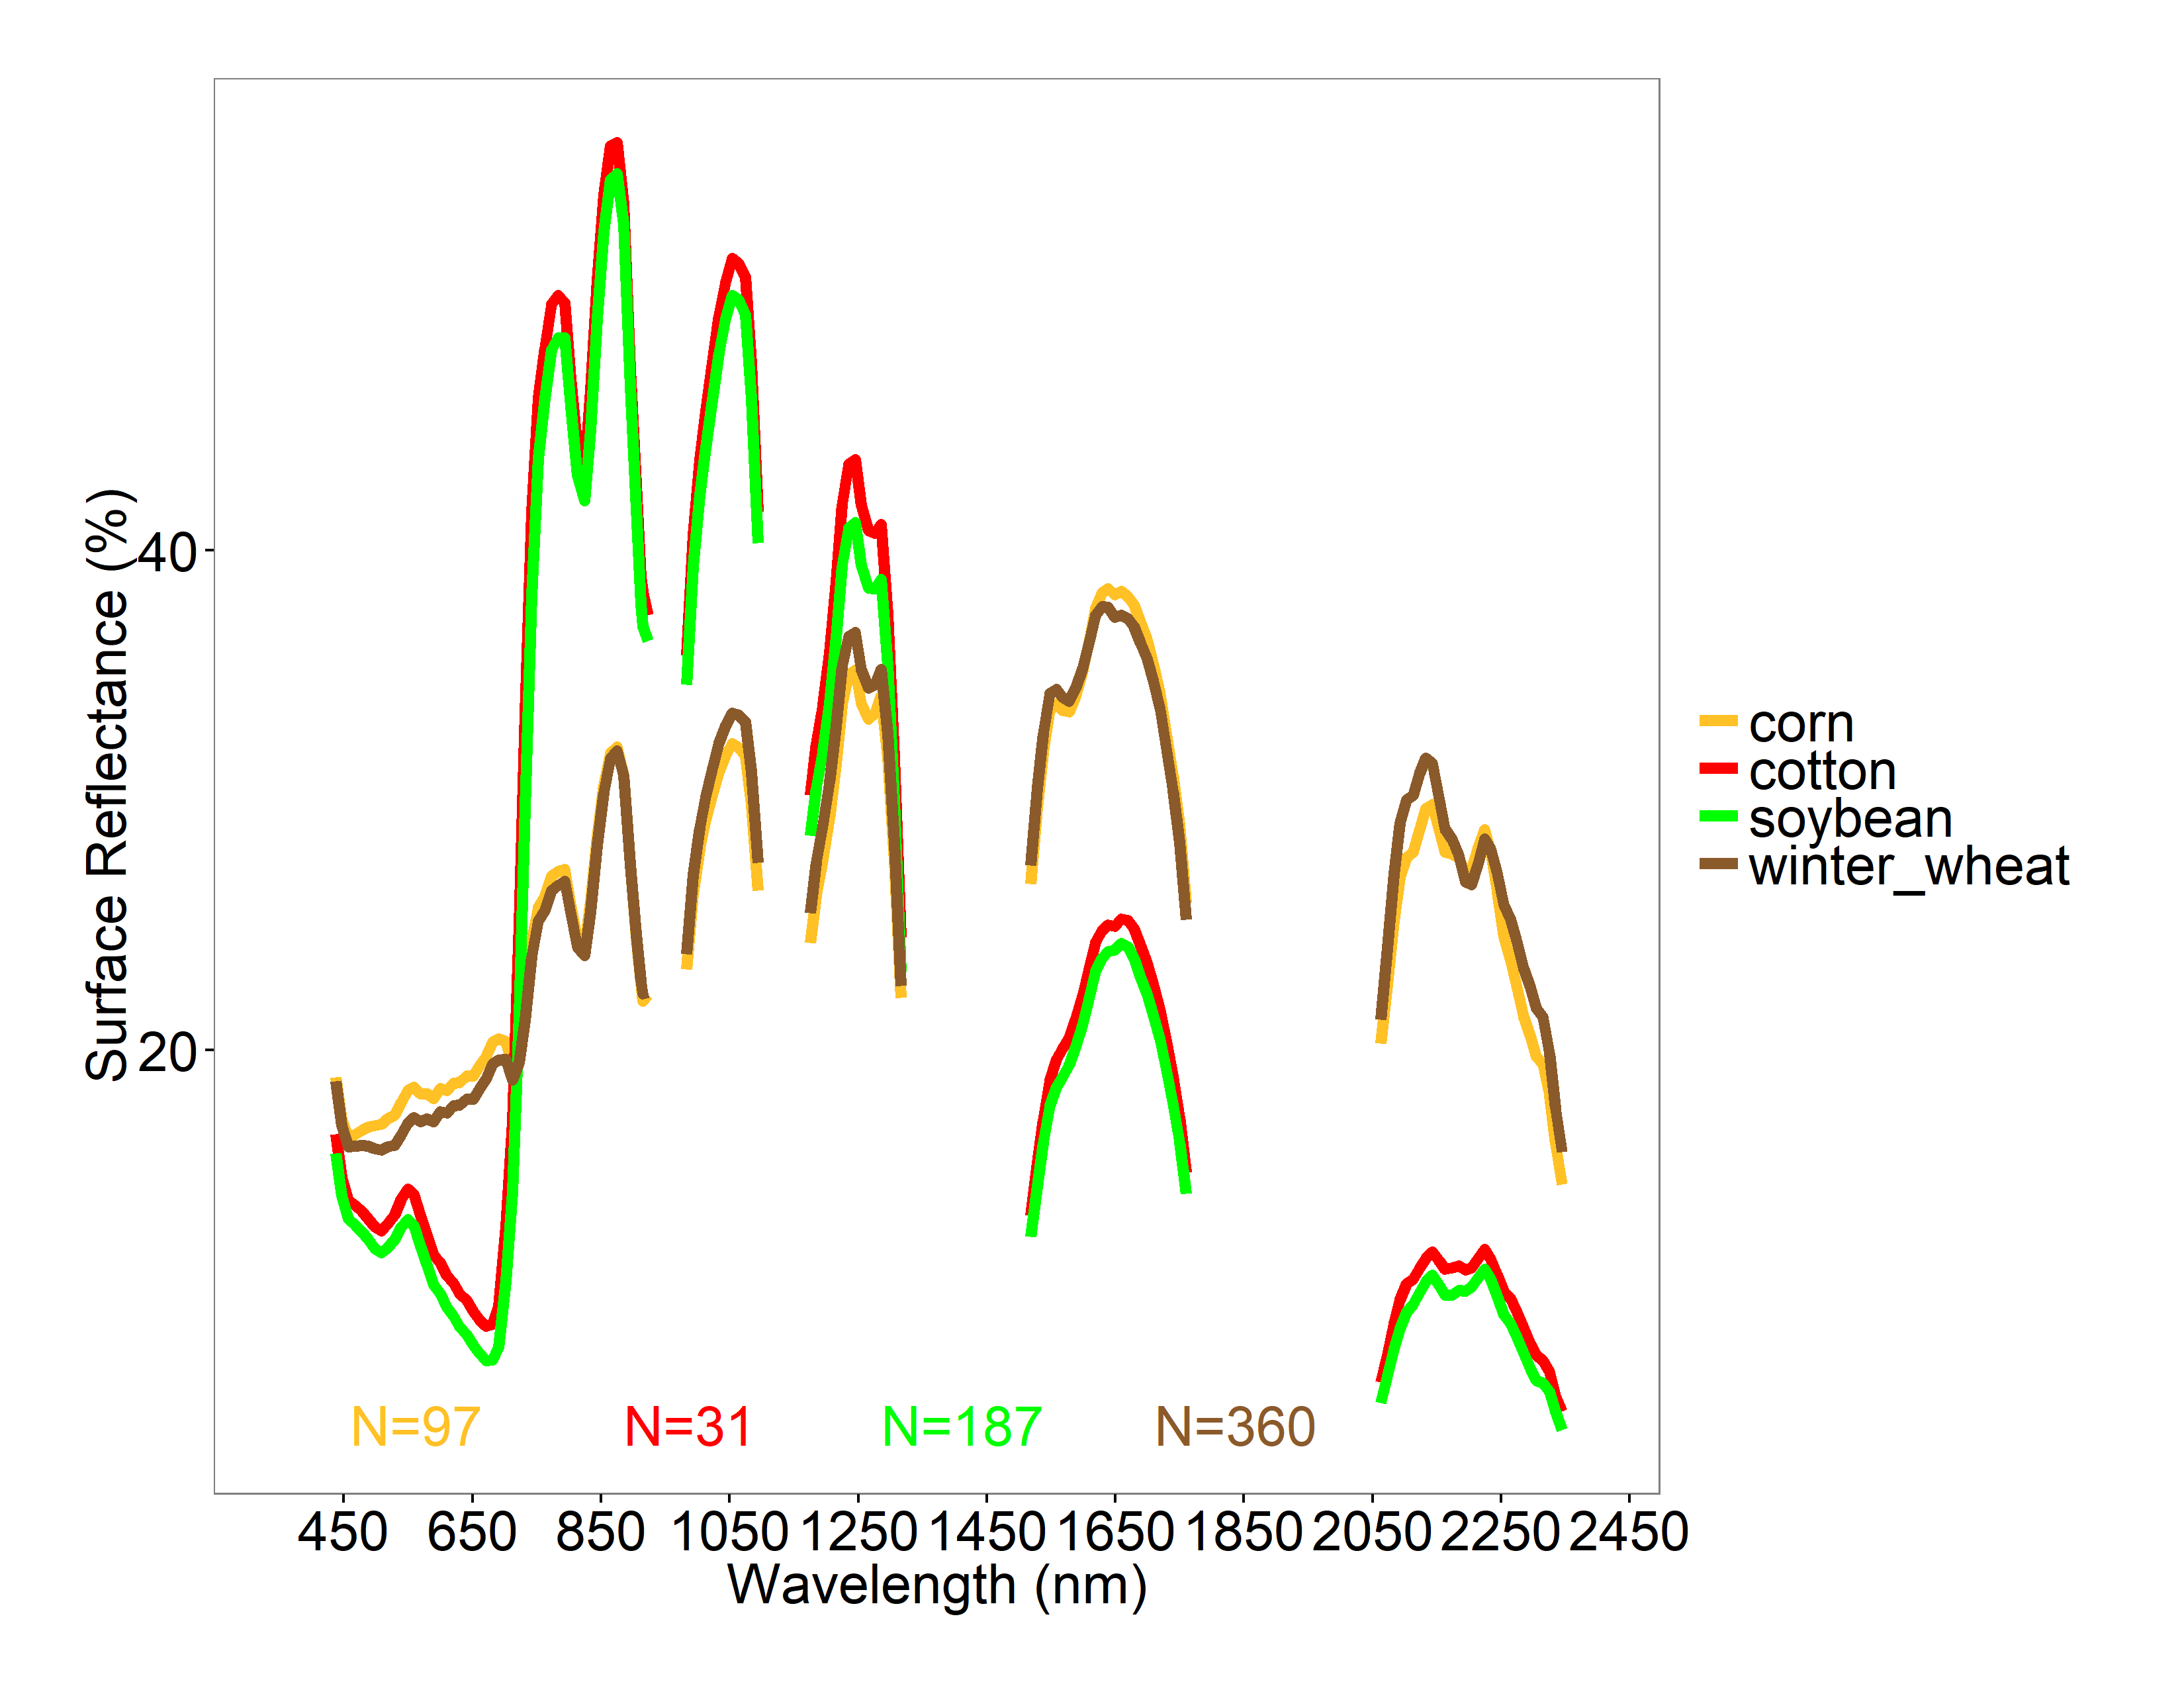
Figure 2: Example spectral profiles. Spectral profiles from an image in AEZ 9, averaged by crop type. N is number of spectra included in the average.

