U.S. Geological Survey Manual
Appendix 45-A
Part 445-2-H Chapter 45

The work rest times and fluid replacement volumes in the chart below should sustain performance and hydration for approximately 4 hours of work in any given heat category. Work/Rest times are to be applied hourly.
Work-Rest/Water Intake Schedule
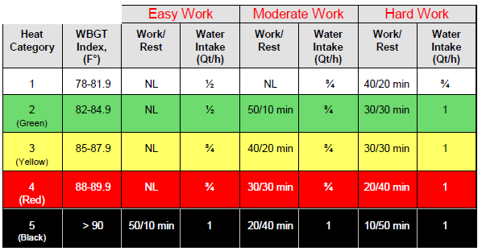
Adapted from US Army Public Health Command: http:// phc.amedd.army.mil

Fluid and recovery needs can vary based on individual differences. Values in this chart are only guidelines and should be used as a minimum. Individual needs may require more recovery and additional hydration. CAUTION: Hourly fluid intake should not exceed 1 ½ quarts; Daily intake of fluids should not exceed 12 quarts.

Wet Bulb Globe Temperature (WBGT): The WBGT is a measurement taken using a meter with three different types of measurements: 1) ambient air temperature (dry bulb), 2) natural wet bulb (temperature resulting from evaporation), and 3) radiant temperature (globe temperature). They are calculated as follows:
Direct sunlight: WBGT = 0.7(natural wet bulb) + 0.2(globe temp) + 0.1(dry bulb)
Without direct sunlight: WBGT equals 0.7(natural wet bulb) + 0.3 (globe temp)
NL: No limit on the amount of work that can be performed.
Rest: Sitting or standing, preferably in a cool or shady area. (Rest area should be cooler than worksite.)
Easy work: Walking on a straight, flat surface at a strolling pace without much of a load or riding in a motorized vehicle and performing light work such as paperwork and collecting specimens or samples.
Moderate work: Walking on a softer surface or at a purposeful pace and performing moderate work such as scaling moderate hills, carrying equipment and supplies, lawn mowing on a flat surface, and canoeing and kayaking at a leisurely pace.
Hard work: Manual labor such as digging, climbing, chopping wood, using a chainsaw, clearing brush, and carrying heavy equipment.
Note:
Add 5° Fahrenheit to the heat index WBGT measurement if an individual is wearing clothing or protective garments that might increase heat load; e.g., personal floatation devices, hip waders, coveralls, or other personal protective equipment.
Add 10º F to the WBGT measurement when wearing full body impermeable protective clothing while conducting “Easy Work”, and 20º F to the WBGT measurement when wearing full body impermeable protective clothing while conducting “Moderate to Hard Work”, e.g., Tyvek protective coveralls and hoods.

