HDDS Additional Criteria Tab
The ‘Additional Criteria’ tab is an optional input area that allows the entry of additional search criteria specific to the event(s) selected. Click the ‘Additional Criteria’ tab (Figure 1) to display the additional criteria for the first event selected. The type and number of options for the search criteria fields will vary by event.
Figure 1 - HDDS Explorer Additional Criteria Tab

A. Select Event
Select the event from the drop-down menu (if you only select one event, only one event appears in the drop-down menu) (Figure 2).
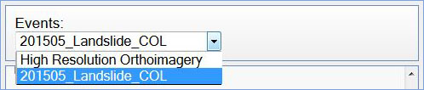
Figure 2 - Event menu

B. Select Additional Criteria
To narrow the results of a search, each event in HDDS Explorer has additional specific criteria that can be entered (Figure 3).
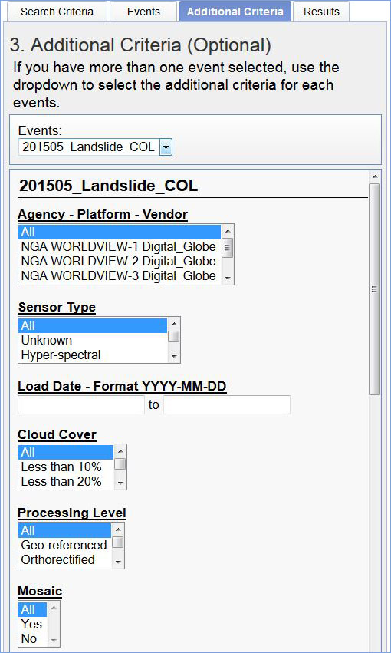
Figure 3 - Example Additional Criteria form
The following attributes are listed on the Additional Criteria tab for Emergency Operations events:
- Agency - Platform - Vendor
- Sensor Type
- Load Date
- Cloud Cover
- Processing Level
- Mosaic
- Data Restriction
- Vendor Scene ID
- EO Scene ID
- Catalog ID
- Batch Name
Each attribute title has a hyperlink to the data dictionary to provide information about the particular search field. The attribute options are based on the data available for a specific event. The Control key can be used to select more than one item from a pop down menu.
Enter the additional criteria as desired to narrow the search. The wild card character ‘%’ can be used in the text fields to help narrow down searches.
The ‘Reset’ button can be used to clear the criteria for the current event listed. The ‘Reset All’ button can be used to clear the criteria forms for all the events listed (Figure 4).
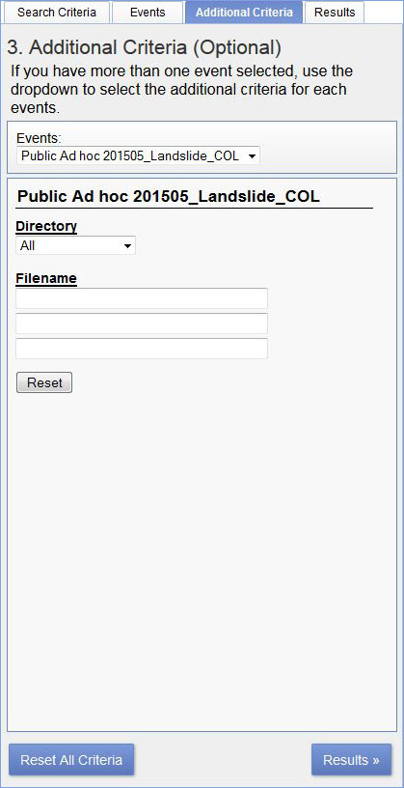
Figure 4 - Reset and Results buttons
Once you enter the additional criteria (if any), click the ‘Results’ tab near the top of the screen or the button near the bottom of the screen to execute a search.

