HDDS Events Tab
HDDS Explorer opens to the Events tab which provides a menu of established Emergency Operations events (Figure 1). Selecting an event is the first step in the data search process.
Figure 1 – HDDS Explorer Search Tabs – Events
The ‘Events’ menu (Figure 2) uses a dynamic tree menu with expandable/collapsible links for Baseline data and Event Year. Click the plus sign () next to the Event Year to expand the list of events for that year. Click the minus sign () to collapse the list.
Event categories include cyclone, debris, earthquake, explosion, fire, flood, hurricane, landslide, oil spill, other, storm, tornado, tropical storm, tsunami, typhoon, and volcano. The event type is included in the named event.
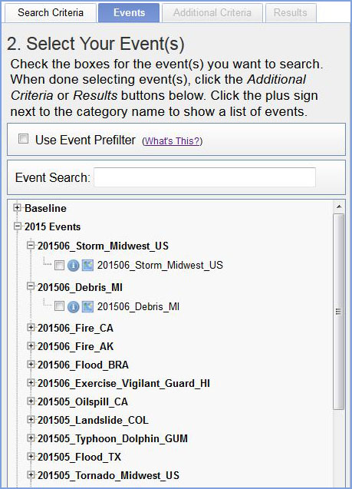
Figure 2 - Data Set Selection Expandable View
If a recent event is not listed, the Emergency Operations (EO) Collection Management Tool (CMT) (http://cmt.usgs.gov/) provides an interface to initiate data acquisition for new natural or man-made disasters.
Information about each menu item is identified with the Information icon (). Moving the mouse pointer over an item displays a longer description of the item (Figure 3).
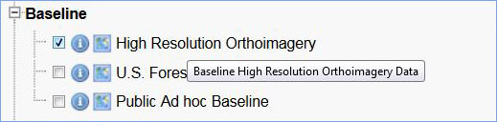
Figure 3 - Longer description of item
Baseline options are High Resolution Orthoimagery, U.S. Forest Maps, and Public Ad hoc Baseline. The Ad hoc option includes metadata (csv, kml, shapefile, and xml) and data that have not been ingested and managed. Note: Another option for baseline data is to look for ingests named “PreEvent” under the ‘Batch Name’ field on the ‘Additional Criteria’ tab. These data come from a variety of platforms and are in a managed state.
The event coverage map icon () displays the coverage area of the event on the map (Figure 4). The search results for an event are based on the area defined by the event coverage map.
Baseline data are not linked to the event coverage maps. The area of interest will need to be defined on the Search Criteria tab for baseline data.
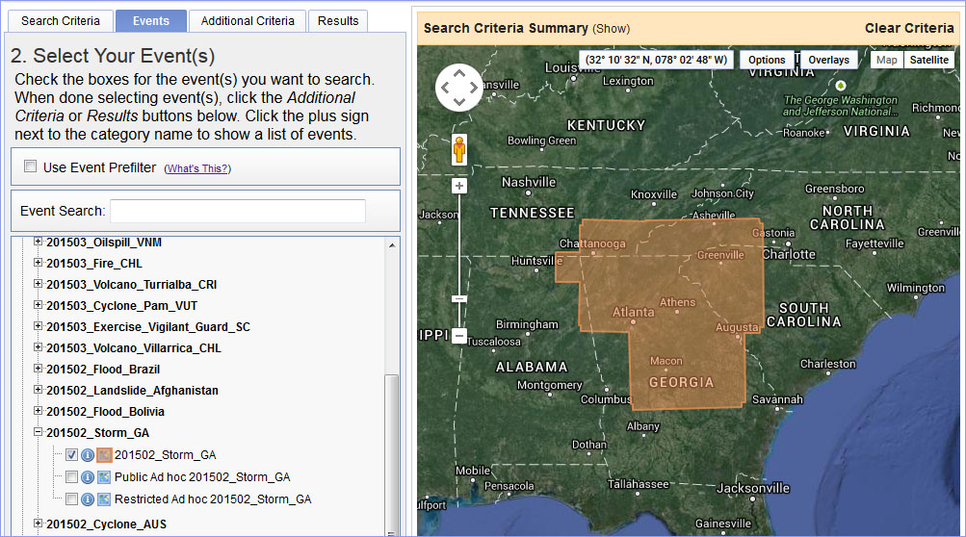
Figure 4 - Event coverage for 201502_Storm_GA
To find out if you have access to restricted data, go to your user name on the top menu bar and select 'Event Access' from the pop down menu. The Event Access page also provides a link to request access to restricted data. Restricted data are to be used internally for the event response with no redistribution or public or commercial access. Reminder: Login is required to access all features of HDDS and to download data.
Select the Event Prefilter option to filter out any events that do not match the parameters input on the Search Criteria tab (Figure 5). Apply the prefilter to narrow the list of events to include only those events that include the area of interest and date range selected on the Search Criteria tab.
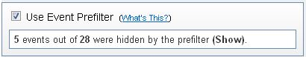
Figure 5 - Event Prefilter
Check the box next to a menu item to gain access to ingested and managed data. More than one item may be selected. An event or baseline data must be selected to active the ‘Additional Criteria’ and ‘Results’ tabs. Selecting an event will display additional search options on the ‘Additional Criteria’ tab that are specific to the event.
The ‘Clear All Selected’ button at the bottom of the screen can be used to deselect all events that were previously selected.
After choosing an event, select one of the options listed below.
- Go to the ‘Search Criteria’ tab to select a smaller area of interest within the area defined by event coverage map and/or to define the area of interest for baseline data.
- Go to the ‘Additional Criteria’ tab to refine search results based on criteria specific to the selected event.
- Go to the ‘Results’ tab to execute the search and view the results for a selected event.

