HDDS New Data Notification
HDDS offers the following options for notification of new data acquisitions.
- Standing Request - receive email notification of new data based on search criteria
- RSS Feed - subscribe to RSS feeds to receive timely updates of data ingests for specific events

1. Standing Request
The ‘Standing Request’ function allows registered users to run searches for new acquisitions, in the background, using the same criteria as the current search. The ‘Submit Standing Request’ button is at the bottom of the search results list panel (Figure 1) and is only visible if you are logged in to HDDS Explorer.
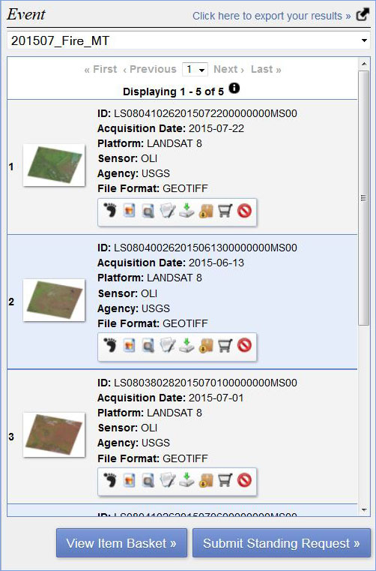
Figure 1 - Submit Standing Request Button
Select ‘Submit Standing Request’ to display the ‘Standing Request Submission’ form (Figure 2).
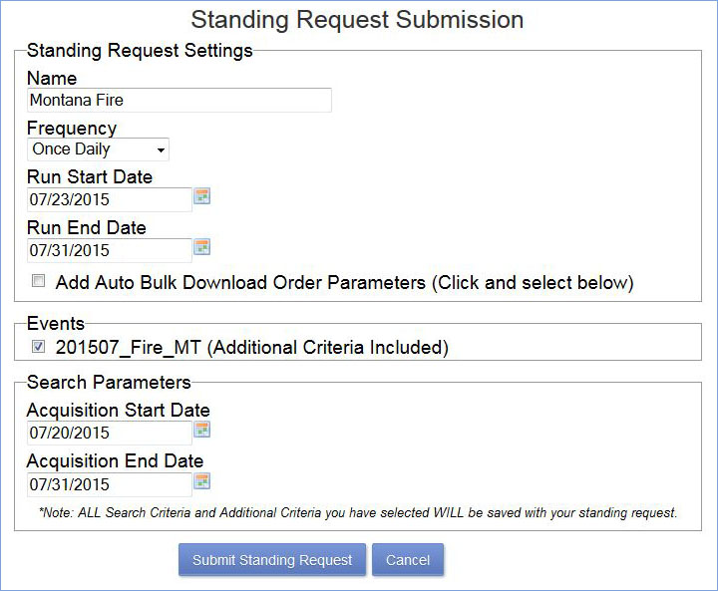
Figure 2 - Standing Request Submission Form
Enter the following criteria for a standing request:
- Name - Enter a name for the request.
- Frequency - Select Daily, Twice Daily, Weekly, Monthly, or Quarterly to determine how frequently the search will run.
- Run Start Date - Select the date the standing request should start running.
- Run End Date - Select the date the standing request should stop running.
- Add Auto Bulk Download - Check this box to create a bulk download order from the standing request results.
  - Once the checkbox is clicked a Bulk Download Parameters section will appear to show the type of downloads available.
  - Click on the download type desired for each event.
- Events - Lists of the events selected for the standing request.
- Acquisition Start Date - Select the start date for data acquisition.
- Acquisition End Date - Select the end date for data acquisition.
Click ‘Submit Standing Request’ to execute the standing request.
To review standing requests, go to the pop down menu linked to your username on the HDDS Explorer Main menu bar and select settings (Figure 3).
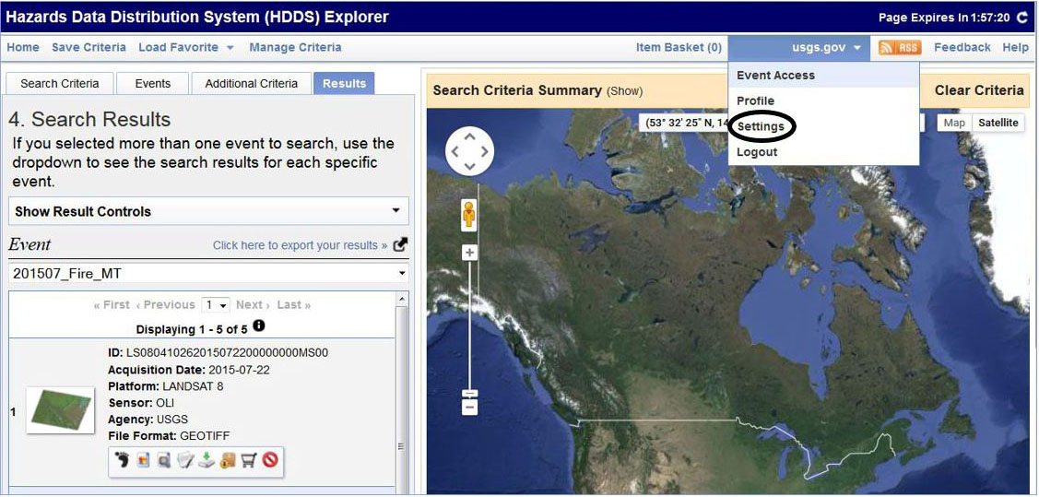
Figure 3 - Manage Criteria
This action displays the ‘Settings Menu’. Click ‘Standing Request’ on the menu to see the list of entered standing requests (Figure 4).
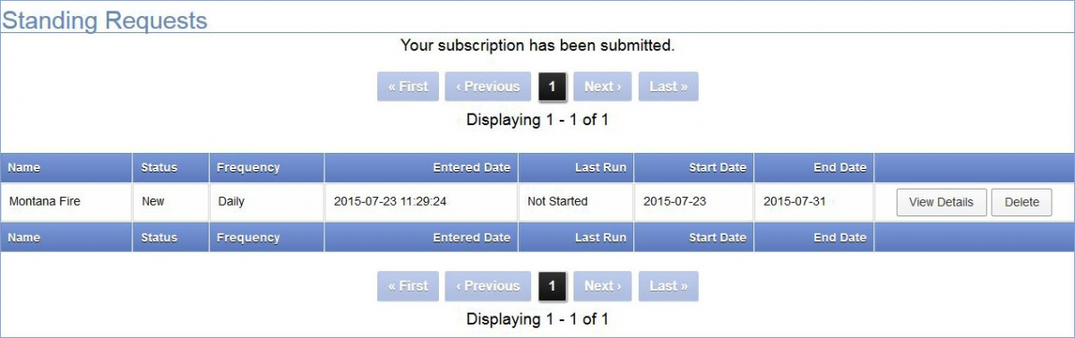
Figure 4 - Standing Request Subscriptions
The Standing Request module sends an email when a new acquisition matches the search criteria (Figure 5). Open the attached csv file, then copy the metadata link to a web browser to view the metadata and browse images for the returned scenes. Log in is required to download or order scenes.
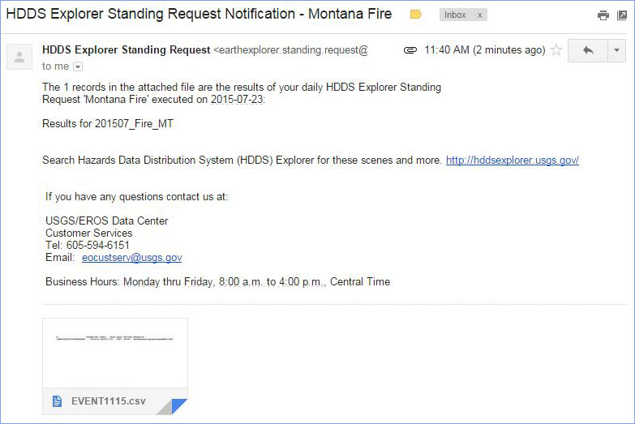
Figure 5 - HDDS Standing Request Notification email

2. RSS Feed
The ‘RSS Feed’ function allows registered users to subscribe to notifications to receive timely updates of data ingests for specific events. Subscribing to the RSS removes the need to manually check the HDDS website for new data.
To receive notification of new data ingests for HDDS events, click ‘RSS’ on the HDDS Explorer Main menu bar (Figure 6).
Figure 6 - RSS Link
The ‘RSS Subscription Menu’ provides a list of options for RSS feeds to subscribe to notifications of all data ingests or to ingests for specific events (Figure 7). Select ‘RSS’ for the desired event(s). Users can use the RSS reader of their choice.
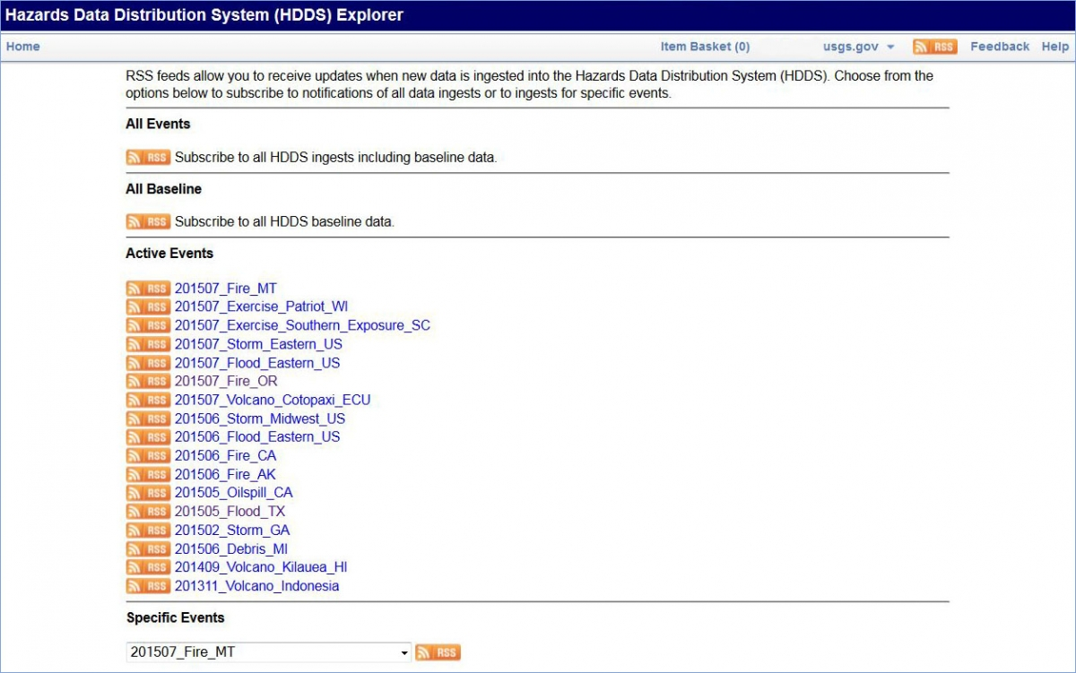
Figure 7 - RSS Subscription Menu
NOTE: Any use of trade, firm, or product names is for descriptive purposes only and does not imply endorsement by the U.S. Government. Any usability questions should be directed to the product vendor.
The example shown below depicts how to use the RSS feed in Firefox. Other RSS readers provide similar capabilities.
In Firefox, selecting ‘RSS’ displays options for the RSS feed subscription followed by a list of data ingests for the event (Figure 8).
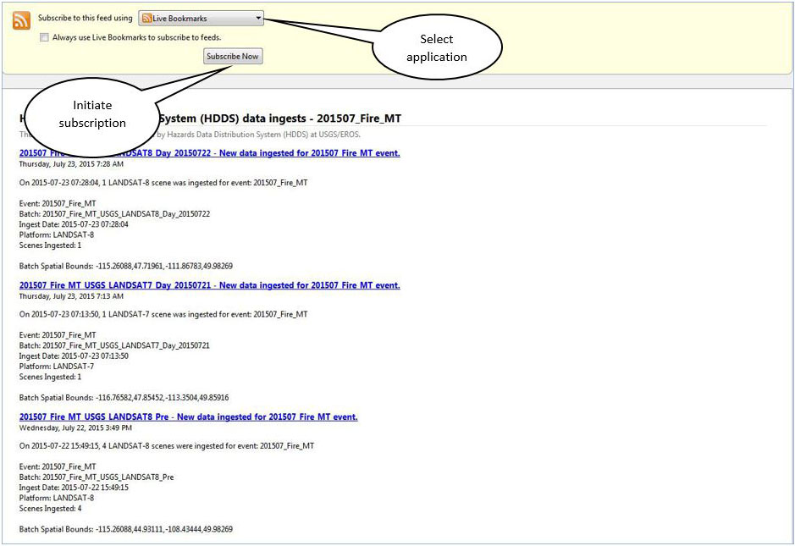
Figure 8 - RSS Subscription Page
Select ‘Live Bookmark’ as the application then click ‘Subscribe Now’. The bookmark name has been shortened in the “Subscribe with Live Bookmark’ dialog box to allow the event name to appear on the toolbar (Figure 9).
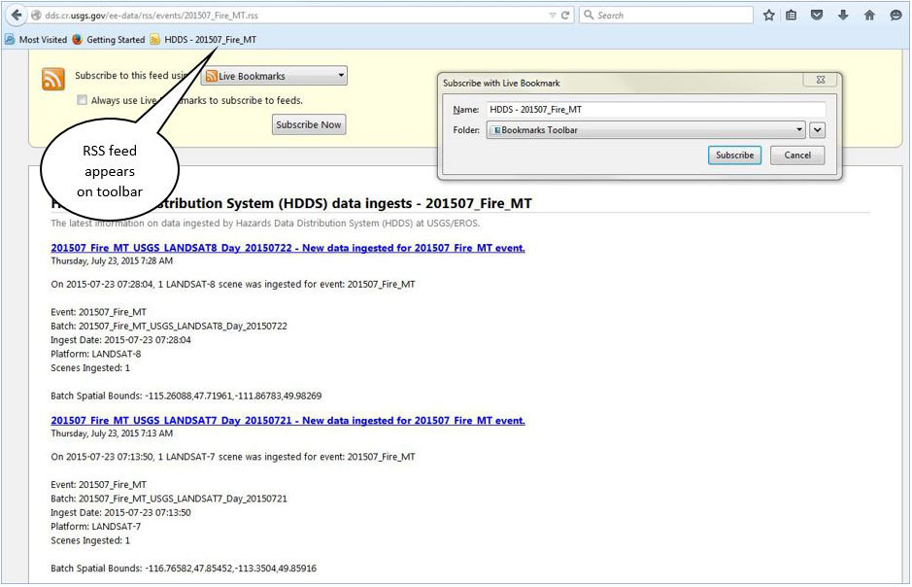
Figure 9 - RSS Feed on Toolbar
Select ‘Subscribe’ to save the RSS feed to the ‘Bookmarks Toolbar’ for easy access.
Click the link on the toolbar at any time to view a list of batch names for recent data ingests for the event (Figure 10). The batch name typically includes the name of the event, agency, platform, and acquisition date.
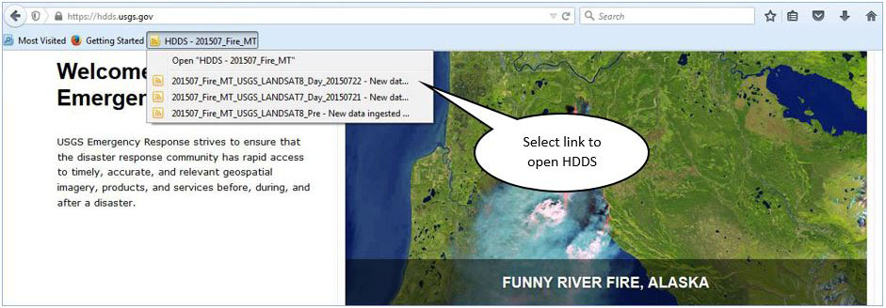
Figure 10 - List of Recently Ingested Data
Select a new ingest from the list to view the data in HDDS Explorer. The link will open directly to the results tab and show the data included in the batch ingest. The feeds icon on the list will change color when the link has been activated (other browsers will remove the link once is has been activated).
The bookmark can be deleted when the RSS feed is no longer needed.

