There are two free, easy options to create a KML file or shapefile for your potential project. You can use Google Earth. If you already have Google Earth this is probably the easiest option. Otherwise, you will need to download and install the software. You can also create a shapefile using the SeaSketch Interagency Elevation and Bathymetry Coordination site. To use this site, you need to create an account, then you can draw your project area using a map in your web browser.
How to Make a KML File on Google Earth to Submit as a Project Boundary
- Download and install Google Earth here: https://www.google.com/earth/
- Open Google Earth and zoom to your project area
- Select the “Add Polygon” button in the toolbar at the top of the Google Earth window

- A pop-up will appear asking for details on your new polygon. Give it a name and optional description. Do not press OK yet!
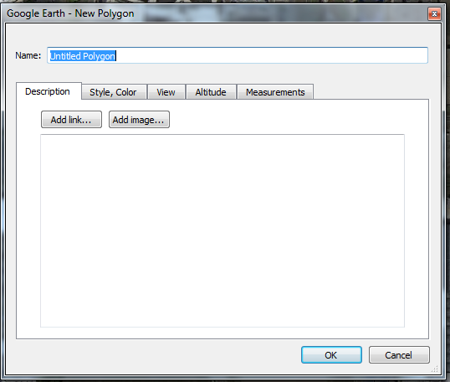

- Start drawing your polygon
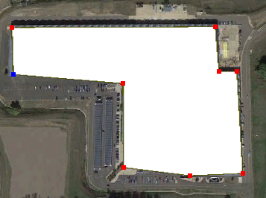

- When finished drawing polygon, hit the OK button on the pop-up
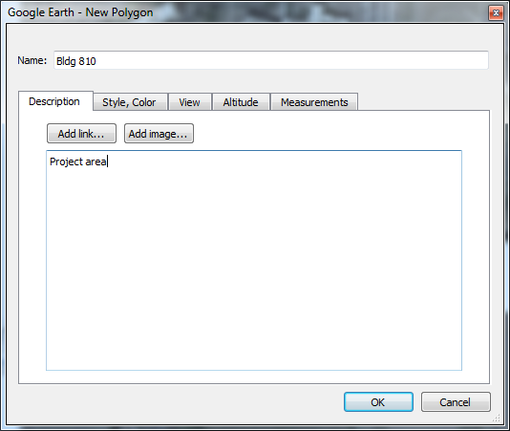
- New polygon will now appear on the left side of screen under “Places”
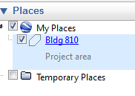
- Right click on the Polygon layer and select “Save Place As”
- Change the “Save type as” to Kml (*.kml) and save in desired location
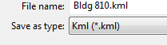
- Locate the new Kml file and send it in along with your project details through the USGS lidar priorities collector tool.

How to Make a Shapefile on SeaSketch to Submit as a Project Boundary
- Go to the SeaSketch Interagency Elevation and Bathymetry Coordination site: http://www.seasketch.org/#projecthomepage/5272840f6ec5f42d210016e4/sketches
- Create a SeaSketch account by clicking on “Sign In” and follow instructions to create a new account or you can use your login for existing Google or Facebook accounts.
- Zoom into your project area.
- Click on the “My Plans” tab, click “Create New”, and choose “General Polygons and Shapefiles”
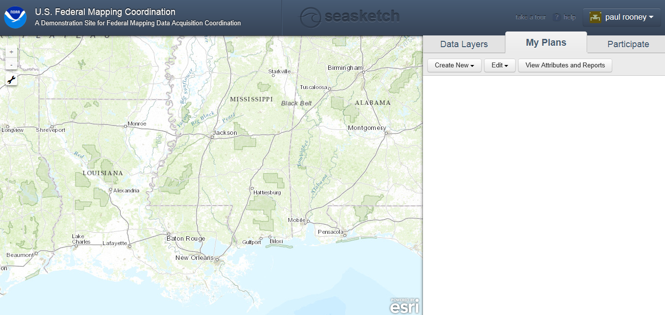
- Use the Sketch tool to draw your project area, give it a name, and click “Save Plan”.
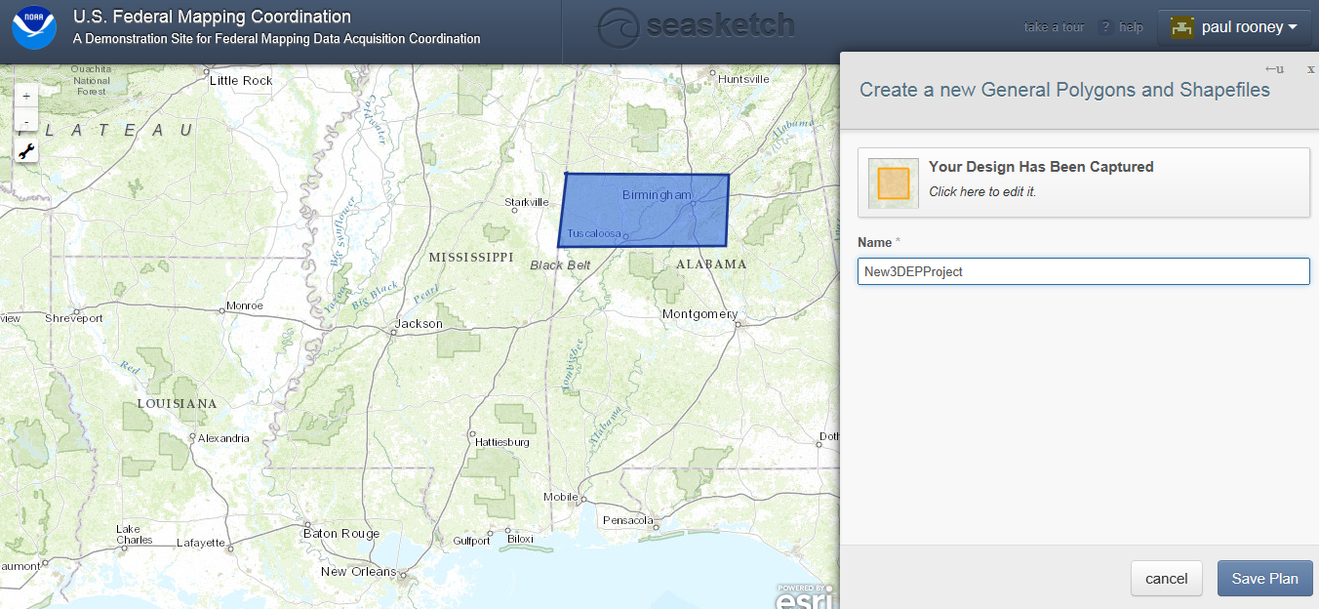
- Right Click on the project you create and choose “Export to Shapefile”. Save the shapefile to a new folder on your computer.
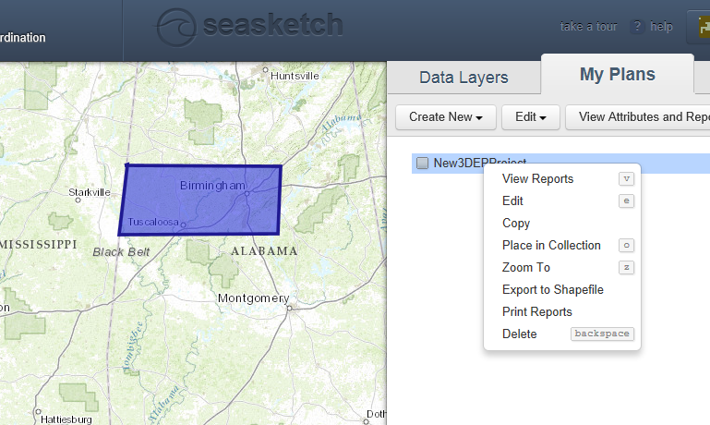
- Locate the new zip file which contains all the parts of your new shapefile and send in the whole zip file along with your project details through the USGS lidar priorities collector tool.
