Pre-concentration of Mercury in Samples for Stable Isotope Analysis by Oxidation, Purge and Trap

USGS-Mercury Research Laboratory
8505 Research Way
Middleton, WI 53562

Scope and Application

The following procedure is used by the U.S. Geological Survey’s Mercury Research Laboratory (MRL) for the pre-concentration of low concentration or mass limited mercury (Hg) samples for analysis by multi-collector ICP-MS (MC-ICP-MS). This method is a modification of the U.S. EPA Method 1631 for measurement of mercury in water. There are two main steps to this method. The first step is mercury oxidation and then reduction, followed immediately by gaseous purge and gold-sand trap capture. The second step is the thermal desorption of the mercury collected onto a gold trap, and recapture into an acidic oxidizing solution. This method is suitable for aqueous digestions of sediment/soils, biological tissues, filter-passing water samples (< 1L), and suspended particulate matter captured on a capsule filter. Additionally, the thermal desorption step can be utilized as a stand alone process for the pre-concentration of Hg from air collected onto gold traps. Quality assurance and control protocols are employed throughout the sample preparation including: laboratory practices to prevent contamination, analysis of certified reference materials, and pre-concentration of a secondary isotope standard (NIST 3133) to ensure pre-concentration accuracy and precision.

Laboratory Safety

Analysts who use the MRL must have read, understood, and signed the Chemical Hygiene Plan for the MRL prior to potential exposure to any chemicals. The analyst must have a thorough understanding of the required safety protocols for the lab chemicals prior to their use of the lab. Adequate personal protection equipment such as safety glasses, gloves, lab coat, and long pants must be worn when working in the main lab or otherwise exposure to hazardous chemicals is possible. Caution should always be exercised because chemicals are present in the laboratory and often in use by other analysts. Hazardous chemicals should only be handled by adequately trained personnel under a high volume fume hood with extreme caution.

Multiple safety concerns are present in the conduct of this method; detailed information is included for each reagent specific to the method later in this SOP, and additional safety information can be found in the safety data sheets (SDS) located in the lab. Mercury is a toxic metal and caution should be exercised to limit exposure during daily operations. While samples and working standards are relatively low in concentration, concentrated stock solutions containing elevated HgT levels are occasionally encountered. Concentrated HgT stock solutions should only be handled by experienced lab personnel. Other hazardous chemicals used in this method include concentrated strong acids, SnCl2, and BrCl (a strong oxidizer). All digestions should be performed in a fume hood. Trap desorption occurs at very high temperatures and presents a burn hazard.

Equipment

Thermal Desorption System

A thermal desorption system is used to liberate the Hg collected on gold traps and re-capture the gaseous Hg in a strongly oxidizing trapping solution. Similar to other dual amalgamation systems, two ni-chrome wire heaters are aligned in series. The heaters are constructed of 18 gauge ni-chrome wire wrapped around a quartz glass tube. The ni-chrome wire is connected to a programmable direct current (DC) power supply.
A Campbell Scientific CR1000 datalogger is used to control the overall desorption process. The programmable DC power supply varies voltage applied to the ni-chrome wire depending on the heater temperature set point. A thermocouple inserted inside the heater provides temperature data to the datalogger which is used to regulate the voltage supplied to the ni-chrome wire to maintain the temperature set point. The desorption system has two heating modes. The first is a quick desorption mode that is primarily used for “clean burning” the gold traps prior to use for sample collection. In the quick desorption mode, the sample and analytical gold traps are sequentially flash heated to 525C for 130 seconds. In the long desorption mode, the sample gold trap is flash heated to 525C for 130 seconds. Following the desorption of the sample gold trap, the temperature of the analytical trap is slowly increased stepwise to 525C (Table 1). The temperature set points and heat durations are listed in Table 1. Ultra-high purity argon is used as the carrier gas through the desorption system. Disposable Pasteur pipettes are used for purging into the chemical oxidant trap.

All equipment is disposable and is not washed or reused, except for the gas washing bottles. Teflon is not used for routine isotope analysis.

Reagents

All reagents and/or dry chemicals used to make reagents must be of the highest purity available from the vendor and shown to be low in mercury. Upon receipt at the laboratory, containers will be marked with the date of receipt and stored in the appropriate areas. When reagents are mixed for use in this method, the person who mixes them will record the chemical contents and concentration, and initial and date the reagent container. Reagents and manufacture instructions follow below.

Reagent water: Ultra-pure reagent grade water delivered through a 0.2 µm filter, containing less than 0.1 ng/L Hg and a resistance greater than 18 MΩ-cm.

Hydrochloric Acid (HCl): EM Science Omni Pure HCl (containing less than 5 ng/L Hg) or equivalent.

Nitric Acid (HNO₃): EM Science Omni Pure HNO₃ (containing less than 5ng/L Hg) or equivalent.

0.2 M Bromine Monochloride (BrCl): Dissolve 27.0 g of reagent grade Potassium Bromide (KBr) in a new 2.5 L bottle of concentrated HCl. Place a Teflon coated stir bar into the bottle and stir for 1 hour or until dissolved. Slowly add 38.0 g reagent grade Potassium Bromate (KBrO3) to the bottle while stirring. CAUTION: This needs to be done slowly and in a fume hood because large quantities of free halogens are produced. Addition of KBrO3 to the solution should produce a color change from orange to red to yellow. Cap bottle loosely, stir for an additional hour, and remove stir bar. BrCl is stored in the original acid container in the acid cabinet. Replace the original acid label with a preprinted BrCl label and record your initials and the date made.

30% w/v Hydroxylamine hydrochloride (NH2OH*HCl): Dissolve 120 g of NH2OH*HCl in a Teflon bottle containing 400 mL of reagent grade water. Hydroxylamine hydrochloride typically contains significant amounts of HgT and needs to be treated to reduce the contamination to acceptable levels (< 0.02 ng/ml). Add 50 µL SnCl2 to the solution and purge with Argon gas (300 mL/min for 1 hour). After the solution has been purged, analyze 0.1 ml in reagent water. If necessary, repeat the SnCl2 addition and purging steps until the solution is below the acceptable level. Store the NH2OH*HCl solution in the refrigerator when not in use.

3% w/v Stannous chloride (SnCl2): Dissolve 150 g of SnCl2 in 500 mL concentrated HCl in a 500 mL Teflon bottle. Half of the solution (250 mL) should be poured into a 2.5 L bottle containing Milli-Q water (2,250 mL) to make a 3% solution for the MC-ICP-MS.

Argon (Ar) -Grade 5.0 (ultra high purity) Argon gas is used as a carrier gas for Hg(0) during desorption

Nitrogen (N₂)- Nitrogen is generated by a Peak Scientific nitrogen generator (Model NM32LA). Gaseous Hg is removed from the gas stream by passing N₂ through a gold bead scrubber trap prior to use in the gas washing bottles.

Analytical and Quality Control Standards

Upon receipt at the laboratory and on the day of preparation, mercury standard solutions should be labeled with the concentration, date received/prepared, and analyst initials. The standard solutions NIST 3133 is used to validate method performance throughout analyses.

Stock mercury standard solutions: The stock mercury standard solutions are commercially available mercury standards of the NIST 3133 standard reference material.

Working mercury standard solutions: The working mercury solutions are used for daily operation and are prepared from the stock solutions. The quality control standard is prepared at 100 ng/ml. Dispense approximately 20 mL of reagent grade water and 4 mL of HCl into a new 40 mL glass vial. Pipette the appropriate volume of stock solution (or diluted stock solution) and bring to 40 mL with Milli-Q water. Label with concentration, bottle identification code, date prepared, and analyst initials.

Sample Preparation

The pre-concentration procedure can be performed for solid matrices that have undergone prior hot acid digestions as well as oxidized water samples. The following describes the preparation steps prior to pre-concentration. If samples produce concentrations high enough for dilution and direct run on the MC-ICP-MS (> 5 ng/ mL in solution and < 50% acid content) then pre-concentration is not needed.

Biological Tissues: 100 mg of biological tissues are digested in 2 mL of concentrated nitric acid, 1 mL can be used if the sample has a lower expected Hg content (e.g. prey or bait fish). Digests are capped loosely to prevent back pressure and digested in a water bath for 8-10 hours at 90°C. After initial digestion, samples are removed from the bath and BrCl is added to ensure full oxidation (0.1 mL of BrCl should be added for every mL of nitric acid in the digest). Samples should be further heated for an additional 2 hours following BrCl addition. Cool the samples to room temperature and then dilute to a 50% acid content using reagent water. All volumes of acids and water should be recorded. Samples are then analyzed for total Hg (HgT) to determine the concertation of the digest (refer to SOP for analysis of HgT in biological tissue using the MERX system).

Soils and Sediments: 500 mg of sediments or soils should be weighed out and digested in 5 mL of aqua regia (3:1 hydrochloric acid: nitric acid). Hydrochloric acid should be added first (3.75 mL) followed by nitric (1.25 mL). Vials should be loosely capped to prevent back pressure and digested in a water bath for 12 hours at 90°C. Samples should be cooled to room temperature and then diluted to 50% acid content using reagent water. All volumes of acids and water should be recorded. Samples are then analyzed for total Hg (HgT) to determine the concertation of the digest (refer to SOP for analysis of HgT in sediments using the MERX system).

Water Samples: Hg in filter-passing water samples should be fully oxidized to Hg²⁺ with the addition of 1% by volume 0.2 M bromine monochloride (BrCl). If yellow color does not persist then the BrCl content can be taken up to 5% by volume. Water samples are then heated at 55°C for 5 days. Volume of BrCl addition should be recorded. Samples are then analyzed for total Hg (HgT) to determine the concentration of the water sample (refer to SOP for filtered HgT using the MERX system). Prior to introduction into the gas-washing bottles (10 mins) excess BrCl should be neutralized with Hydroxylamine Hydrochloride (NH₂OH*HCl), 0.5 mL of NH₂OH*HCl should be used for every 5 mL of concentrated BrCl.

Capsule Filter Samples: Capsule filters are cut open and the internal filter is placed in a 250 ml glass jar. The filter should be completely submerged in a 30 % v/v bromine monochloride solution, created from the 0.2 M stock. A piece of ¼” Teflon tubing can be used to hold the filter down when the lid is in place. Samples are then heated at 55°C for 10 days. Sample should be inspected after 2 days in the oven, if yellow color does not persist then then additional BrCl can be added starting with a 5 mL addition of the BrCl stock. Original volumes and any additions of BrCl should be recorded. Samples are then analyzed for total Hg (HgT) to determine the concentration of the water sample (refer to SOP for filtered HgT using the MERX system). Prior to introduction into the gas-washing bottles (10 mins) excess BrCl should be neutralized with Hydroxylamine Hydrochloride (NH₂OH*HCl), 0.5 mL of NH₂OH*HCl should be used for every 5 mL of concentrated BrCl.

Air Samples: Mercury collected onto gold traps from air measurements in the field should be stored at room temperature and kept in the dark. Teflon trap ends should not be removed until the samples are on queue for desorption.

Method Description

Preparation of Gold Traps

- All gold traps must be “clean burned” prior to analysis even if they were used and cleaned the previous day.

- Place the gold trap in line on the desorption system with the dimple in the quartz tube orientated downstream and connect to argon flow.

- To “clean burn” the trap, select the shorter desorption program in the datalogger software and then run. This will heat the sample gold trap to 525°C and cool it over the course of 5 mins.

- Remove the trap from the system and replace Teflon trap end caps until gold trap is used

Preparation of the Gas Washing Bottles

- Triple rinse gas washing bottles and fill with approximately 125mL (or 1L in the larger bubblers) with reagent water. Larger bubblers are used for water samples, capsule filters, and digests with over 40 mL total volume.

- Acidify the gas washing bottles. Add 5mL of HCl to the smaller bubblers or 20 mL to the larger ones. When purging samples with high acid content (e.g. capsule filters) only add 5 mL of HCl.

- Add SnCl₂ to each bubbler. For large bubblers add 5 mL of SnCl2 and for small bubblers 0.5 mL.

- Empty and refill soda lime traps with 4-8 mesh soda lime and attach to gas out port on bubbler. If the Teflon connector or quartz wool is discolored replace with fresh trap.

- Connect the gas line to the top of the bubbler purge for 20 minutes. Gas flow should be set at 350 mL/min.

Sample Pre-Concentration

- If excess BrCl is present in the sample neutralize it using NH₂OH*HCl 10 minutes prior to sample addition into the bubbler.

- Uncap gold traps and connect to the soda lime trap on the bubbler gas out port. Orientate the gold trap so the dimple is downstream of the gas flow.

- Weigh the vial with sample.

- Pour or pipette desired volume of sample into the bubblers.

- Add SnCl₂ (0.5 mL for small bubbler and 5 mL for larger bubblers).

- Weigh sample container again to determine the mass of sample added.

- Purge sample for 40 minutes.

- Record the sample IDs, volume/mass added, and gold trap ID’s.

- After the 40-minute purge, carefully remove gold traps and recap until desorption step.

- Discard the left-over solution in beaker with sodium bicarbonate and triple rinse bubblers.

- Check soda lime traps for discoloration and change if necessary.

- Refill bubblers with fresh reagent water and add HCl, then proceed again from step 1 for next sample.

- A NIST standard should be run every 5 samples as a quality control standard. The process is the same as stated above for samples, but instead of adding a natural sample to a clean bubbler set up an aliquot of NIST 3133 from the 100 ng/mL stock should be added.

- When all samples are complete for the day, triple rinse bubblers with reagent water and fill with 2% HCl

Desorption of Gold Traps

- Prepare a 40% anti aqua regia (3:1 HNO₃: BrCl) solution for a trapping matrix. Add 21 mL of ultra-pure water, 10.5 mL of concentrated HNO₃, and 3.5 mL of 0.2 M BrCl to a 40 ml analytical vial.

- Prepare the solution at least 40-60 mins before first desorption, solution should not be warm when pipetted.

- Label a new 4 mL vial with the sample ID (MMDDYY-#), gold trap ID, and USGS MRL ID. Record sample vial ID in lab book along with other information from the purging step.

- Fill the vial with 2 mL of the 40% anti aqua regia solution.

- Connect a gold trap to the sample trap position, making sure that there is a snug fit between the sample and lower analytical trap. Attach the gold trap so the dimple is downstream of the gas flow.

- Attach gas flow to the top of the gold trap.

- Connect a new Pasteur pipette to the end of the analytical trap, then place the pipette in the oxidizing trap solution.

- The Pasteur pipette should not be flush against the bottom of the vial because that will impede gas flow.

- Check that heating coils are properly oriented over the gold traps and thermocouples.

- Select the longer desorption program (41 mins) and click start.

- The desorption program will run for 41 mins, do not remove trap prior to completion.

- After desorption, remove oxidizing solution vial from the set-up and cap.

- Remove and discard Pasteur pipette.

- Repeat from step 2 of this section for additional samples.

- All trap samples should be analyzed for HgT (refer to SOP for analysis of HgT in sediments using the MERX system) and percentage recovery should be calculated.

Quality Assurance and Control Protocols

Sample Recovery: Percentage recovery should be calculated for each sample as shown below:

% Recovery = [ng/mL of trap solution x 2 mL] / [mL of sample added x ng/mL of sample]

Samples that have % recoveries lower than 85% are not suitable for MC-ICP-MS analysis and should be re-processed.

Certified Reference Material: If the samples being processed are digests that have a corresponding certified reference material (CRM), that CRM should be weighed out and processed every 10 samples. Percent recoveries for CRMs should be greater than 90% and isotopic values should correspond with published literature values (see MC-ICP-MS SOP). If the CRMs fail within a pre-concentration run due to poor percent recoveries or isotopic composition, samples within that run should be reprocessed.

Quality Control Standard: A NIST 3133 standard should be purged between every 5 samples. Percent recoveries for NIST 3133 standards should be greater than 90% and isotopic values should correspond with published literature values (see MC-ICP-MS SOP). If NIST 3133 standards fail within a pre-concentration run due to poor percent recoveries or isotopic composition, samples within that run should be reprocessed.

Maintenance

Gas Washing Bottles: If the glass becomes coated with a cloudy residue or if percent recoveries are poor for NIST 3133 standards the glassware may need a more aggressive wash. Treat bubblers overnight with 50% aqua regia. Rinse well before using

Soda Lime Traps: Replace soda lime daily. If trap ends or quartz wool become discolored (yellowish tint) remove entire trap set up rinse and clean in 10% HCl overnight. Dry completely before use.

Rotometers: Check that gas flows monthly to ensure they are set to the 350 mL/ min for purging step.

Gold Traps: Gold traps should be tested quarterly for performance. This entails purging and trapping a NIST standard onto each current gold sample trap and ensuring good recoveries as well as isotopic composition of the NIST 3133 standard. If traps become discolored or wet during analysis do not use.

Table 1: Temperature steps for the desorption of the analytical gold trap into the chemical oxidant trap

Step | Temperature Set Point (C) | Duration (s)
1 | 250 | 600
2 | 275 | 600
3 | 300 | 300
4 | 325 | 180
5 | 350 | 240
6 | 525 | 240

Appendix 1

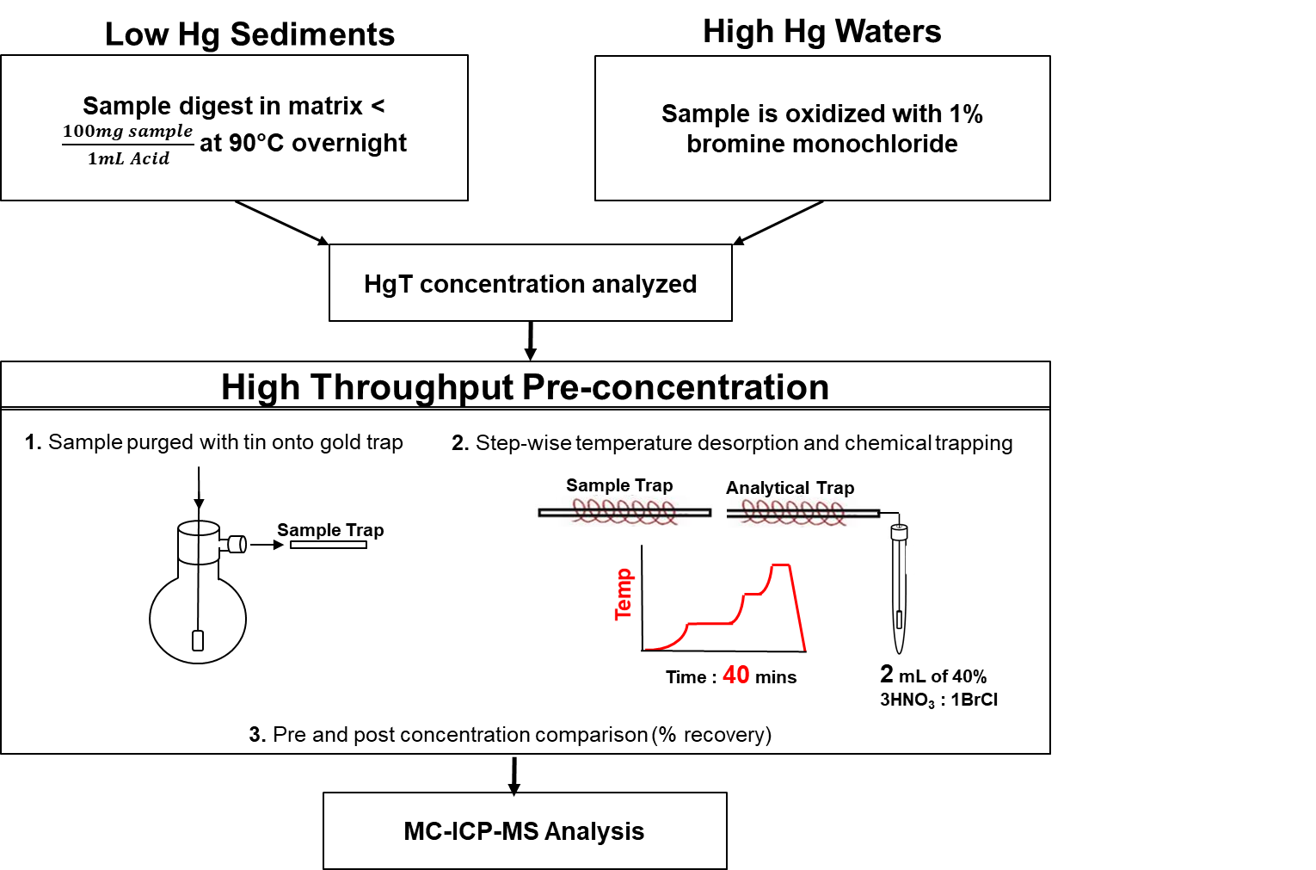

Fig. 1: Schematic of Pre-Concentration Procedure for Low Level Hg Samples

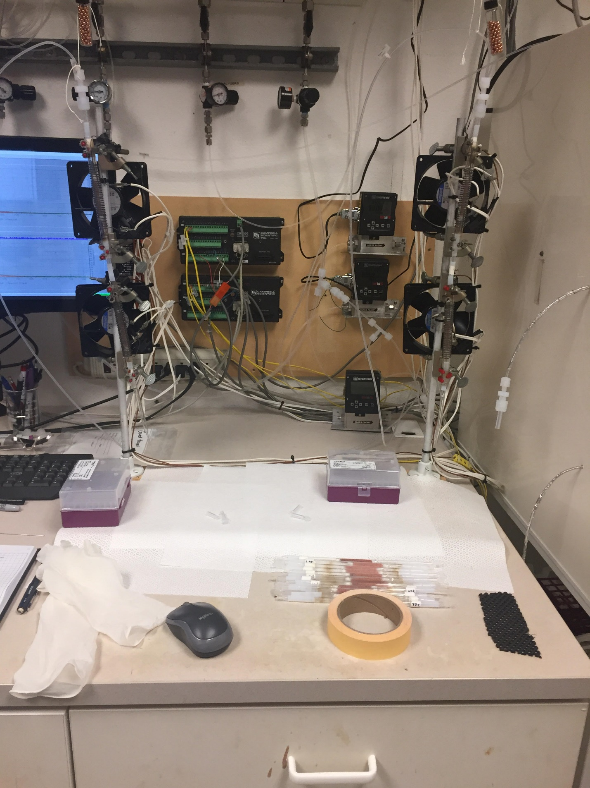

Sample Trap
Gas Flow

Analytical Trap
Pasteur pipette

Fig. 2: Analytical Set-up of Desorption System

