

SM 120.11, Figure 1
Geographic Regions of Responsibility

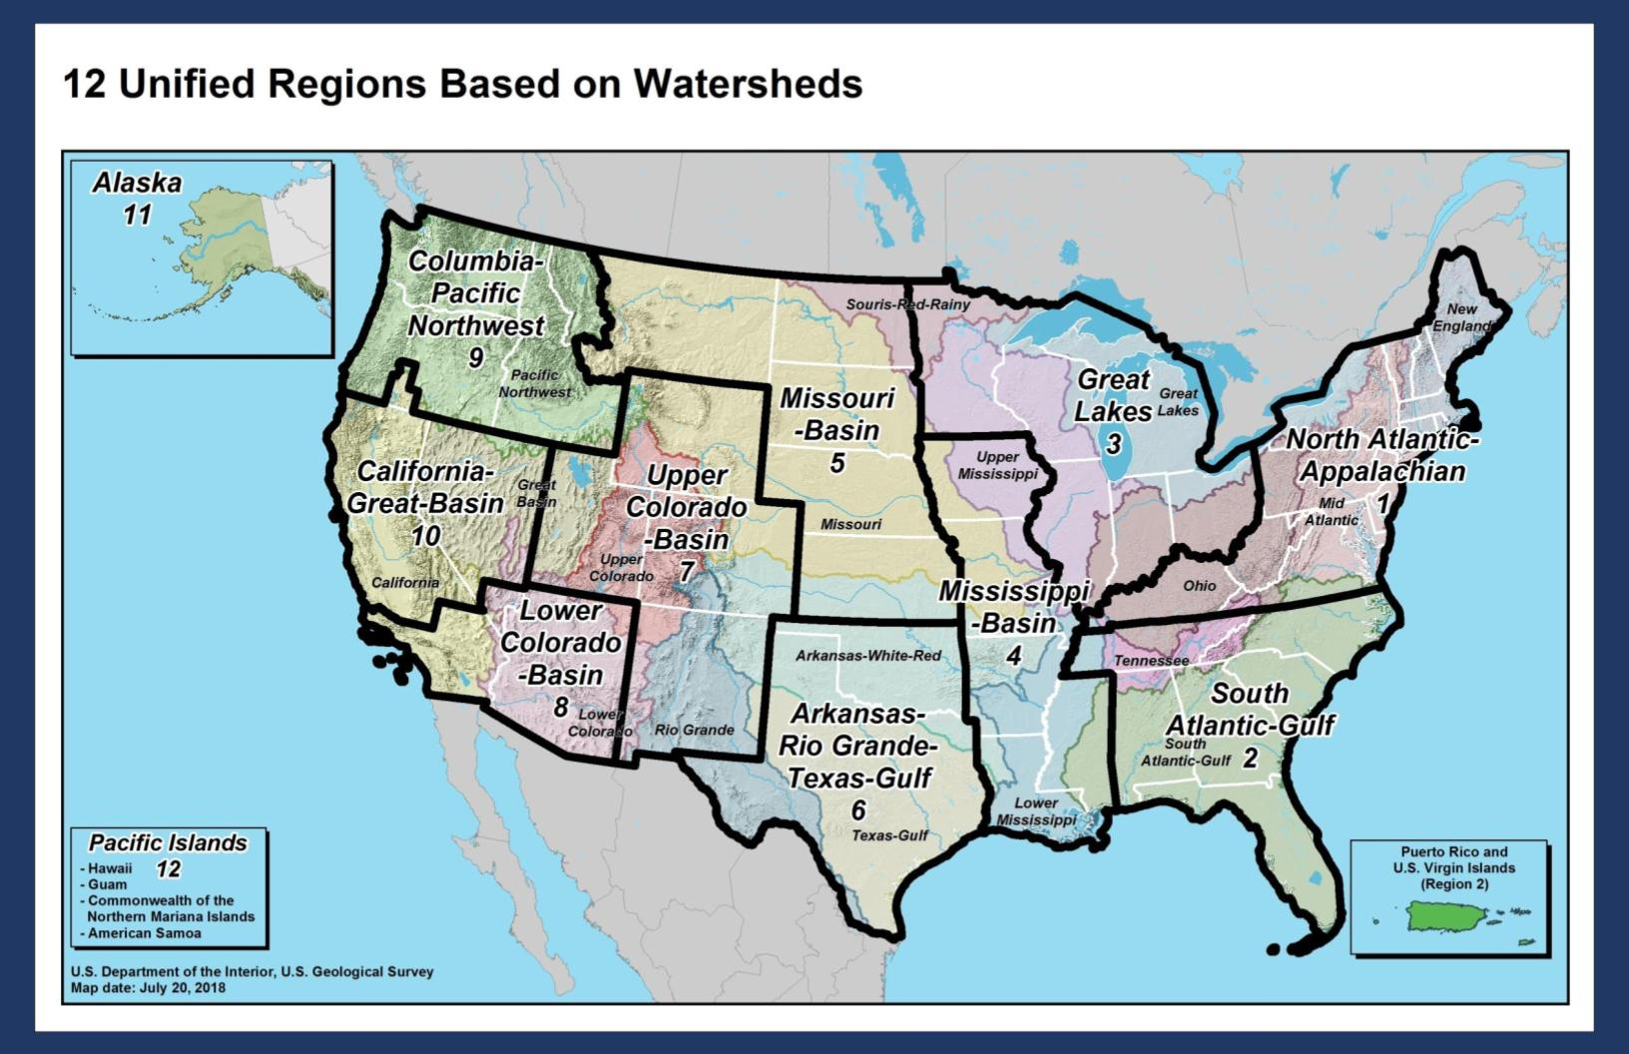

DOI Region | USGS Coverage | USGS Office Alignment
Region 1 | Connecticut, Delaware, Kentucky*, Maine, Maryland, Massachusetts, New Hampshire, New Jersey, New York, Pennsylvania, Rhode Island, Vermont, Virginia, Washington DC, West Virginia | Reston, VA
Region 2 | Alabama, Florida, Georgia, North Carolina, Puerto Rico, South Carolina, Tennessee, U.S. Virgin Islands | Raleigh, NC
Region 3 | Illinois*, Indiana, Michigan, Minnesota, Ohio, Wisconsin | Indianapolis, IN
Region 4 | Arkansas, Iowa, Louisiana, Mississippi, Missouri | Raleigh, NC
Region 5 | Kansas, most of Montana, Nebraska, North Dakota, South Dakota | Indianapolis, IN
Region 6 | Oklahoma, Texas | Raleigh, NC
Region 7 | Colorado, New Mexico, Utah, Wyoming* | Lakewood, CO
Region 8 | Arizona, Southern California, Southern Nevada | Sacramento, CA
Region 9 | Idaho, NW Montana, most of Oregon, Washington | Portland, OR
Region 10 | Most of California, most of Nevada, Klamath County Oregon | Sacramento, CA
Region 11 | Alaska | Anchorage, AK
Region 12 | American Samoa, Guam, Hawaii, Northern Mariana Islands | Portland, OR

*The following state water science center offices are managed by these USGS Regional offices: Kentucky (Region 3), Wyoming (Region 5), and Illinois (Region 4).

