USGS Responds to Oregon Wildfires
On Labor Day, September 7, 2020, dry conditions combined with unusually strong summer winds resulted in several fires in western and southern Oregon. These fires have caused property damage and fatalities.
Six fires grew significantly since Labor Day and include from north to south:
- Riverside Fire (Willamette Valley-Clackamas River watershed)
- Beachie Creek/Lionshead Fires (Willamette Valley-Santiam River watershed/Warm Springs River and other watersheds)
- Holiday Farm Fire (Willamette Valley-McKenzie River watershed)
- Archie Fire (North Umpqua River watershed)
- South Obenchain Fire (Rogue River watershed)
- Almeda Fire (Rogue Valley-Bear Creek watershed)
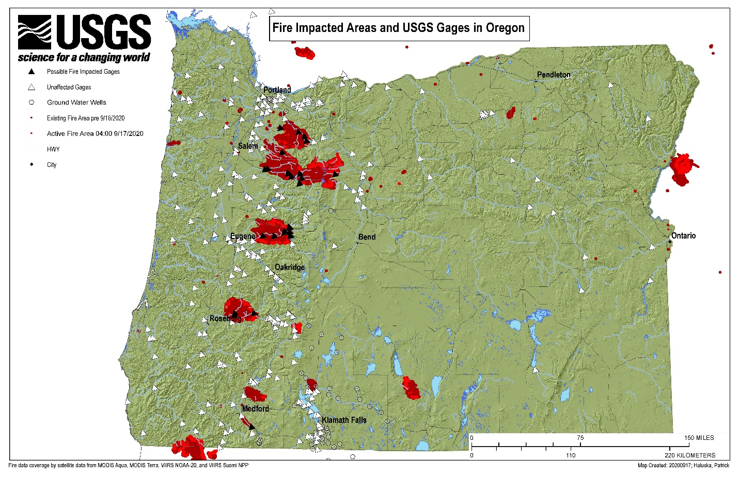
Archie Creek Fire
Beachie Creek Fire
Riverside Fire
Lionshead Fire
Holiday Farm Fire
S. Obenchain Fire
Almeda Fire
U.S. Geological Survey (USGS) operates sites to monitor discharge (or streamflow) and water quality, which are critical to infrastructure, ecology, and drinking water in the watersheds affected by fires. Sites are operated in cooperation with the U.S. Army Corps of Engineers (USACE) Willamette Valley Project for flood mitigation and ecological flows for Endangered Species Act-listed fish, PacifiCorp and Portland General Electric for hydroelectric dam operation, drinking water providers to understand the quality of the source water reaching their water intakes on rivers, U.S. Bureau of Reclamation, City of Ashland, Oregon Department of Transportation, and Douglas County. The fires affect areas upstream of drinking water intakes for Salem, Eugene, and the southern suburbs of Portland.
As a result of the fires, 18 USGS sites monitoring discharge, precipitation, and water quality were affected. Preliminary assessments indicate that damage was widespread to the equipment for power and communications, and more limited damage to the sensors which are typically in water and logging equipment in the gage houses. Cableways, which allow personnel to measure discharge in large rivers, were also damaged. Additional sites (not listed in table below) outside of the fires area were affected because power or communication interrupted the transfer of data to USGS servers and the National Water Information System (NWIS) website.
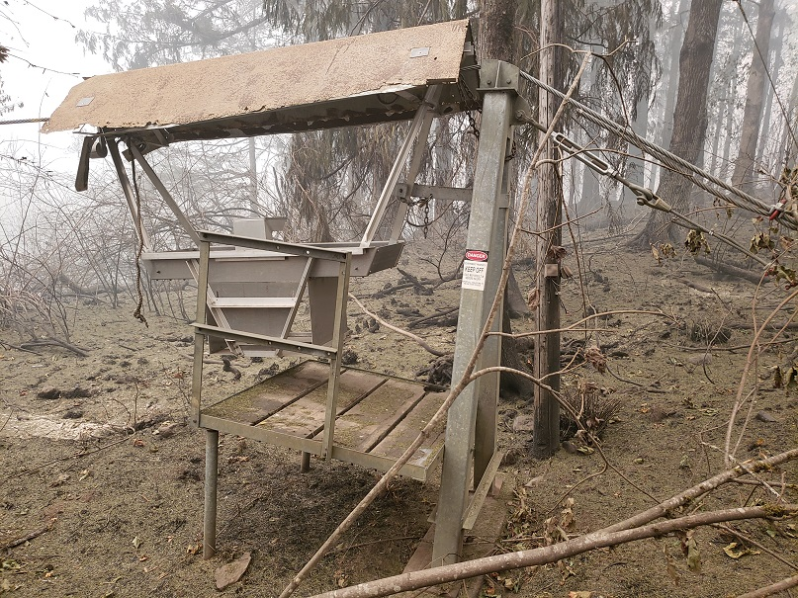
Cableway on North Santiam River at Niagara, Oregon (Site number 14181500)

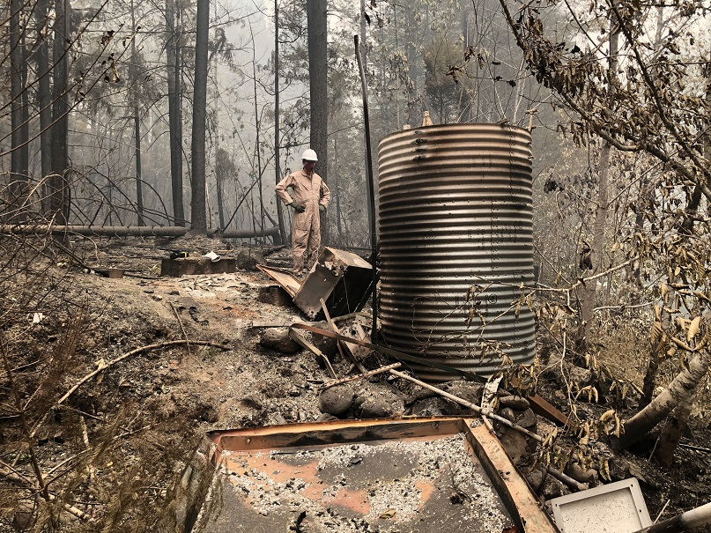
Stream gage on Blue River at Blue River, Oregon, (Site number 14162200)

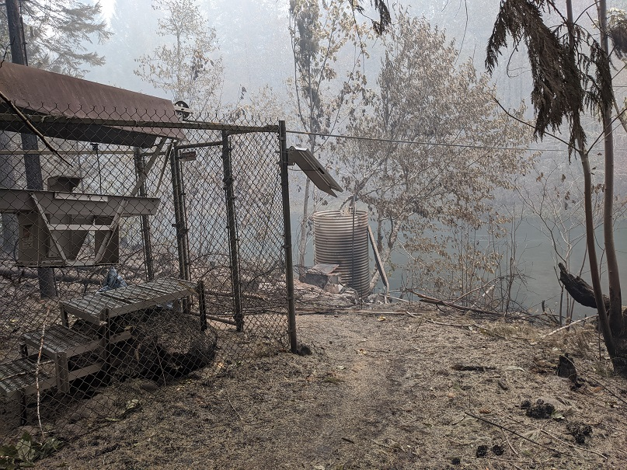
Cableway (foreground) and stream gage (background) on Blue River at Blue River, Oregon (Site number 14162200)

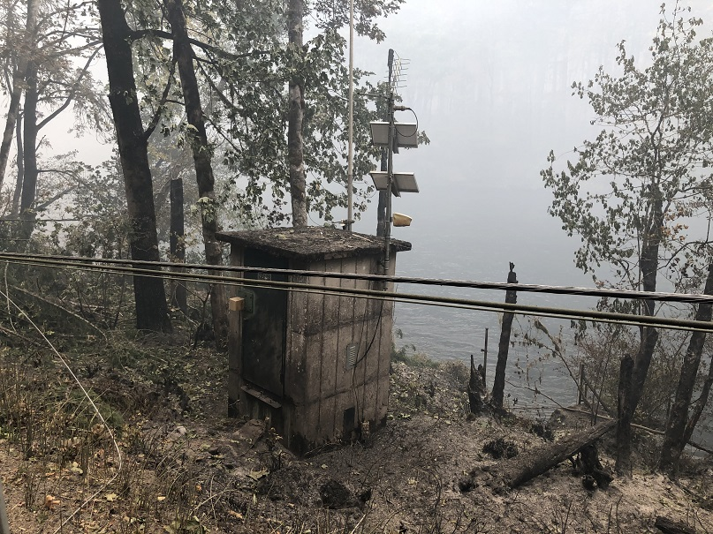
Stream gage on McKenzie River near Vida, Oregon (Site number 14162500)

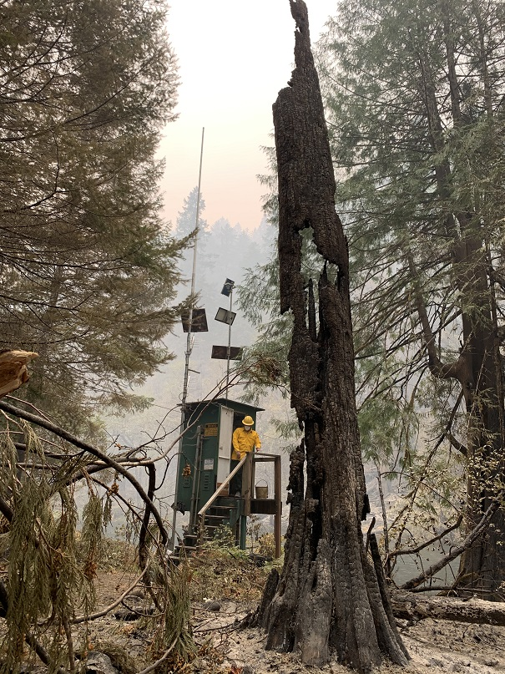
Stream gage on South Fork McKenzie River near Rainbow, Oregon (Site number 14159500)

Table of stream discharge and water quality monitoring sites affected by fires in western Oregon, 2020
Beginning on September 14, USGS staff—in collaboration with USACE, Eugene Water and Electric Board, City of Salem, PacifiCorp, and others—worked tireless to restore the discharge, precipitation, and water quality monitoring networks affected by the fires. As of September 21, eleven gages were partially or fully restored.

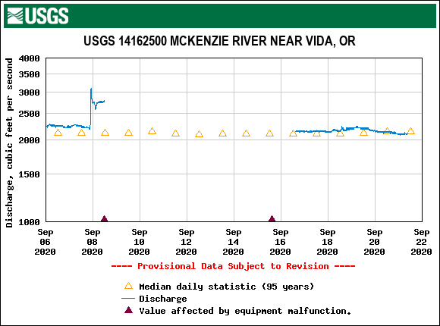
Hydrograph showing fire disrupting monitoring of stream discharge from September 8-16, 2020.

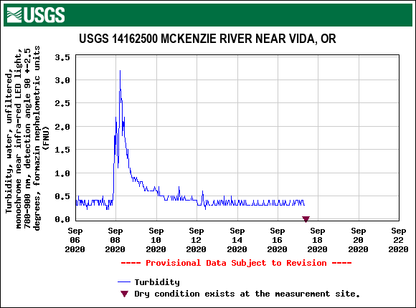
Turbidity response to start of fire (data stored in sonde retrieved on 9/17)

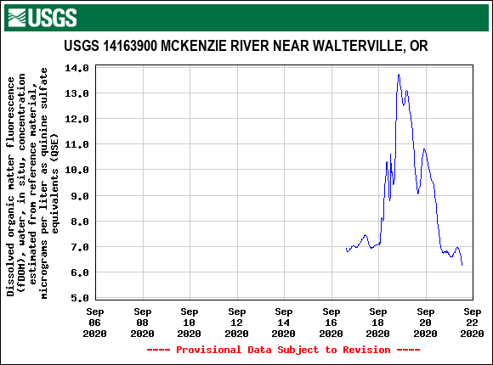
New temporary water quality monitor deployed upstream of drinking water intake on 9/16 to capture water quality response to forecasted rain on 9/18.

Restoration of sites continue. Where sites are destroyed, USGS will attempt to install temporary gages to ensure data are collected.
USGS plans to collect stream and sediment information and use the restored monitoring network to understand the effect of fire on water resources and water-related infrastructure.

