*This fictional workforce plan is intended to show one example of an effective Center or Office level plan. It follows the standard Center and Office template provided on the USGS Workforce Planning website and contains all of the required minimum components. The specific content of a particular Center or Office plan will vary, depending on the organizational structure, issues, and planning needs. This fictional Workforce Plan was put together from a number of varying sources and is not consistent throughout.*

**Description of the Center**

1. **Organization Title, Location, and Major Programs/Activities**

The Northwestern Science Center in Springfield, WA is part of the USGS Northwest Region within the US Geological Survey and conducts most of its activities in support of the Water and Hazards Mission Areas. The Center conducts its activities in formal partnerships with more than 50 other organizations representing all levels of government. In addition to the main Springfield office, the Center has field stations located in Marion, OR.

The Northwestern Science Center (NWSC) operates statewide data-collection networks for streamflow, water quality, groundwater levels, and precipitation quantity and quality. In 2015, the Center also conducted more than 60 scientific investigations that address many specific issues of concern to state water-management entities and citizens. Among these issues are:

* Sustainability of adequate, good-quality water supplies
* Conversion of historic water use to public supply
* Environmental hazards – drought, wildfire, floods
* Ecological impacts on water
* Challenges associated with regulatory-compliance requirements and goals
* Remediation of water-quality effects of mining and waste disposal
* Effects of human activities

1. **Mission Statement**

The mission of the Center is to be the principal source of timely, high-quality science information on the state’s water resources, and to be a leader in providing an understanding of how those resources relate to the people and environment of the state. This will help planners, managers, and others make critical decisions about the use of these limited and shared resources. As part of a national network of interdisciplinary scientists, including hydrologic technicians, we intend to achieve this mission by:

* Identifying current and emerging issues of concern in conjunction with our local, State, and Federal customers
* Forming partnerships with other scientists in the USGS, other agencies, and the academic community to address those issues
* Using innovative technologies and methods that are scientifically valid and cost-effective to collect, analyze, and interpret the needed data;
* Providing results in a form and timeframe that meet the needs of our customers
* Evaluating the quality and effectiveness of our products, and the processes and people that produce them
* Developing our capabilities through training, and fostering a challenging work environment with opportunities for career growth and advancement
* Promoting an awareness of water resources and the hydrologic sciences in the State.

1. **Current Center Workforce Characteristics**

**(*Note that detailed data related to these characteristics are contained in the Appendix to this plan)***

1. **Characteristic 1: Budget and Financial Information:**

Approximately 75 percent of the NWSC’s funding comes from reimbursable agreements. Thus, the long-term plan for NWSC scientific programs, and staff capabilities best suited to implement that plan, must recognize the needs and changing priorities of our external customers. Much of the reimbursable studies program tends to be driven by short-term needs associated with current and high-priority water-management issues, whereas the focus of USGS-funded program activities tends to be more perennial. The NWSC data program, on the other hand, tends to change little in overall scope from year-to-year from both reimbursable and USGS sources of funds.

For more detailed information on Center budget and financial data, including recent trends, See Appendix 1

1. **Characteristic 2: Current Organizational Chart:**

The NWSC Organizational chart (attached) has remained static for last 3 years, and no changes are expected unless a major increase or decrease in reimbursable funds occur.

1. **Characteristic 3: Workforce Demographics and Analysis:**

As of December 2016, the NWSC has 180 federal employees, 5 contractors, and 1 volunteer. There are a total of 5 veterans on staff. The number of employees at the Center has decreased from 210 to 180 over the past 5 years. The majority of the reduction was in the Hydrologic Technician and Physical Science Technician series, with 3 employees in the IT or Administrative series.

This reduction in staff is directly related to a reduction in funding from external partners. In the past 2 years, funding sources leveled to a point where no additional decrease in staff was required. In 2016, funding sources increased by 3%, creating a need for new positions in the Ecosystems and Hydrologic Networks branches.

For more detailed information on Center workforce demographics, including recent trends, See Appendix 1

1. **Characteristic 4: Diversity:**

The USGS bureau workforce plan has a stated goal to increase and maintain diversity in a high-skilled workforce. At the NWAC, most employees identify as being of Caucasian descent, with less than 3 percent of other races represented. The Center is 63 percent male and 33 percent female.

|  |  |  |  |  |
| --- | --- | --- | --- | --- |
|  | Center level | | National Civilian Labor Force (CLF) | |
|  | Male | Female | Male | Female |
| Hispanic | 2% | 5% | 12% | 10% |
| African-American | 1% | 1% | 12% | 10% |
| Caucasian | 80% | 80% | 60% | 60% |
| Asian | 3% | 2% | 20% | 18% |

1. **Characteristic 5: Contractors and Shared Resources:**

The Center currently has 5 contractors valued at approximately $186,000 annually. This includes 2 student contractors, 1 Hydrologic contractor, and 2 contractors to support maintenance needs (1 in Springfield and 1 in Marion). This has varied by only one or two contractors over the past three years.

These contracts have facilitated the Center workflow while allowing students to gain experience and interest in civilian scientific work. The contractors, while low in number, provide the center with support that can assure timely attention to facilities and field station remote needs.

**Strategic Future Direction**

1. **Future Direction**

The NWSC will always be focused on water-related science and technical activities. Thus, our future directions will largely stay true to our recent organizational path, which has been to pursue both DOI and USGS goals as well as local partner priorities. That said, there are immediate and near-term external and internal drivers that need to be considered and that will drive some degree of evolution of our efforts and workforce. These are described in more detail below.

1. **External Drivers**

* Budget forecast: Continued flat USGS appropriated funding levels are anticipated. Reimbursable funding from state partners has been and will probably remain stable, with the potential for some increases in the groundwater studies area.
* Appropriated Program forecast (briefly describe anticipated increases and decreases)
  + NAWQA – we expect $25,000 increase in project funding for 2017 & 2018.
  + NWIS – we expect single year $15,000 funding to research parasite in Columbia Basin.
  + Stream gaging / Data Program – we expect flat funding for next 3 fiscal years.
* Reimbursable Program forecast (briefly describe anticipated increases and decreases)
  + A $250,000 reduction due to partner reduction in research funding
  + Undetermined funding increase from local and State cooperators for groundwater studies and modeling
  + Additional funding (approximately $300,000) from FEMA in 2017 as part of a 3-year agreement to perform hazard-mitigation studies on volcanoes.
* DOI initiatives
  + We anticipate participating in the Water Sustainability initiative by evaluating methods for establishing urban water quality testing protocols in urban areas.
* Government policy (legislative, regulations, administrative)
  + Executive Orders such as EO: Delivering an Efficient, Effective, and Accountable Government (Campaign to Cut Waste) will continue to create some restrictions and will require administrative time for reporting
  + Administrative drivers that promote an efficient and effective government, hiring freezes, hiring practices, etc., may affect our ability to fill certain positions

During the past few decades, the bureau appropriated funds have been essentially flat in purchasing power and more recently been met with across-the-board rescissions and sequestration of appropriated funds. Added to these externalities has been the implementation of the government policies that are challenging to implement so that they do not impact the mission-critical science. Yet emerging environmental issues including contaminants, natural hazards and effects of climate change have shifted emphasis on science needs for the public benefit.

During these times of uncertainty, it is good to demonstrate partner-driven science directions, but it can result in short-term and highly variable science information delivery.

1. **Internal Drivers**

* Increasing facilities costs at NWSC field station 1 to support new IT infrastructure.
* Transition to cloud hosting of data forecasted to be slow over next 12 months due to IT security approval requirement.
* Aging workforce with 26% eligible to retire within the next 5 years.
* Need to increase WCF investments over the next 3 years to support capital equipment costs for repair of aging facilities, generator repair and water filtration system upgrade.

Workforce flexibility and versatility is important. The ability to quickly expand or contract the workforce in response to program changes, reduced federal appropriations, etc., will be based on diverse appointment types (permanent, term, temporary, or contractors) available.

Reimbursable funding poses specific workforce challenges. This funding is dependent upon decisions made by cooperating partners, and therefore may fluctuate significantly from year to year. Workforce planning in this situation requires that we maintain a flexible workforce and develop different scenarios to address possible reductions or increases in reimbursable funding.

**Future Workforce (Supply, Demand, and Discrepancies)**

1. **Future Workforce**

The base program of the NWSC will evolve over time as the dominant water issues of the state evolve, driven largely by continued population growth. It is unlikely, however, that dramatic changes to the base program will occur during the next five years. Therefore, we will continue to do much of the type of data collection and studies activities that we do now. However, we must also continually strive to develop targeted science activities that are new or currently under-represented in the NWSC program. Our list of these targeted activities is updated as resource conditions change and human-induced events unfold, and Center leadership and staff are continually looking for new program that aligns with our capabilities and skillsets.

Looking ahead five years, we expect to need for additional scientific and technical skills in:

* Statistical modeling
* Groundwater modeling
* Integrated watershed modeling
* Geochemistry, microbiology and emerging contaminants
* Geographic and other information technology, especially GIS
* Hydrologic database expertise
* Streamgaging and hydroacoustics
* Web and application development
* Administrative support (budget, finance, human resources, etc.)

An ideal NWSC workforce has a broad range of experience, technical capabilities, and diversity; is accomplished in abilities and skills to reach long-term strategic science goals; is flexible to meet short-term strategic needs; and is adept at dealing with external forces such as funding sources and amounts, administrative rules, and legislative mandates. The future workforce will be highly skilled in series and grade, and capable of meeting future work demands, including those in new science and technological areas. It is also a diverse workforce that brings strength in a variety of perspectives and experiences to accomplish complex, interdisciplinary work. Staff will have a range of experiences that will be proactively managed for effective succession planning, which is essential to accomplish long-term science goals. A critical attribute of the NWSC work force is flexibility to share capabilities and resources across Science Centers, Regions, and other USGS organizations across the nation. It also includes the creative use of service contracts, flexible staffing, and temporary work details.

These characteristics are already present in the much of the NWSC workforce, but the nature and scope of future challenges requires some shifts in focus, skills, and expertise. The time it takes to make these changes will depend on the our ability to mentor and train existing staff, the rate of retirements and departures of current employees, funding constraints and trends, and policies that affect our ability to hire new staff. As opportunities for new hires occur, we will work to increase the variety and types of appointments available. This will allow more flexibility during periods of budgetary constraint and flexibility to address the highest science priorities. The diversity of the workforce should be improved. New staff who bring in new expertise will also provide opportunities for new science capabilities and business improvements.

1. **Gap Analysis**

The table below lists some key skill gaps that need to be addressed as part of near-term workforce planning. This does not mean in all cases that these skills are absent in the current workforce; rather, inclusion here reflects anticipated additional need for, or an evolution in the direction of, these skills.

|  |  |  |  |  |
| --- | --- | --- | --- | --- |
| **Skill Gaps** | **Covered by Current Position(s)** | **Current Importance** | **Future Importance** | **Action/Training Needed** |
| Ecology (invasive species in the northwest) | No | 3 | 3 | Yes, there is a shortage of employees with the skillset needed to meet the demand. There could be a potential to partner with academia to train and mentor current employees. Two employees are currently in developmental stages of career and have shown an interest in invasive species. Allocation of resources may be needed to allow one or both employees to focus on invasive species and transition their work to new employees. |
| Statistical Modeling | Yes | 2 | 3 | The NWSC currently has one staff member that provides expertise for statistical modeling. The employee is used as a resource for other Centers as well. The current employee is eligible for retirement and we do not have other staff members that can function on the same level. Action will be needed to mentor and train an individual to perform statistical modeling at the same level. This will become part of the succession planning effort to find an employee that is interested in and would be eligible in gaining this skillset. |
| Organics, Emerging Contaminants. | Yes | 1 | 3 | Emerging contaminants is a topic of increasing visibility and importance, with resources and opportunities coming into the Center. Over the course of the next 1-3 years, the Center expects an increase in funding in this arena. While the current staff can meet the demands for organics, any further increase would not be able to be met. The Center would like to hire an entry level scientist to begin work with current staff in order to meet projected future needs. |
| Sediment | Yes | 2 | 2 | There is currently a shortage in personnel for sediment study need. 1-2 positions will need to be either reassigned or advertised to fill this need. Funding for sediment has been ongoing and active for 10+ years, We would look at the possibility of permanent hires. |
| Web Development | Partially | 1 | 2 | Within our IT structure one employee works on our website part-time. With the advancement of web real time technology, we would like to increase that percentage of time to look at possibilities to improve our data output online. There are a number of mobile apps and software for real time data that would be useful to our scientists and customers. We can see this becoming large in the future, but not at this time. Would look at allocating for an entry level position to start research into this topic. |
| Safety | Yes | 1 | 1 | There is only one employee with this skillset. Would like to use Succession Planning or mentorship to transfer that knowledge to other employees. Someone in the current roster should be identified and prepared to fill this need. |
| Administration | Yes | 1 | 1 | Administrative support for the center’s science operations is crucial, and the level and nature of administrative tasks is not likely to decline in coming years. Given anticipated retirements of key administrative staff, it is important to develop a training and transition plan for the remainder of the admin team. |

**Action Plan**

The NWSC will focus on 5 key areas to meet the short and long term goals of the Center.

1. **Recruitment and Retention**

* **FY 2017 actions:**

Action 1: Investigate options for NDAA (reemployed annuitant) or phased retirement for two employees retiring in January, 2017.

Action Owner: AO Due Date: October 2017 during center review

Action 2: Work with HR to develop a relationship with local university (specific name) for targeted recruitment of ecologists for Pathways CI position to be hired in summer, 2017 field season.

Action Owner: AO/Principal Investigator Due Date: Fall 2017

* **3-5 year goals:**

**Succession Planning**

Succession planning will be needed to replace management, administrative, information technology, technician, and hydrologic skills that will be lost to retirements within the next 5 years. Management is actively seeking opportunities to ensure a seamless transition and retention of organizational memory as the current staff retires. The NWSC will use an accelerated training program, cross-training opportunities, paired mentoring, and details throughout the organization. The addition of programs like the NDAA Reemployed Annuitant and phased retirement programs should help to transfer that knowledge to the next generation.

1. **Diversity**

* **FY 2017 actions:**

Action 1: Work to develop a relationship with diversity organizations (e.g., SACNAS, HBCUs, HIS, ASI) on campus at local universities. (Center Director, Deputy, Admin Officer; contact made in fall; one event held in the FY and targeted recruitment of term or student field staff through this university contact for x positions)

* **3-5 year goals:**

The Center goal is to focus on increasing Asian/African American and female diversity within applicant pools which will increase the opportunity to diversify the Center workforce. The area has four major colleges that have a large Asian / female attendance. The Center plans to advertise in these markets when filling vacancies by making contact with each college and university when vacancies occur or notifying them about volunteer opportunities to engage the youth generation. Additionally, the African American workforce will be targeted by contacting local job Centers in addition to standard USAJobs advertising to ensure as much awareness is possible about opportunities. Furthermore, there are approximately 4-5 professional job fairs held in the city each year and the Center will seek opportunities to attend when heavy hiring is needed such as temporary field assistants during summer season. Engaging our existing minority employees in these increased diversity outreach efforts will increase their impact and likelihood of success.

1. **Multisector Workforce**

* **FY 2017 actions:**

Action 1: perform a cost-benefit analysis of using contract staff vs. government term staff. Based on this analysis, decide whether to continue with on-site contract staff or to use term positions. (Admin Officer; analysis complete by end of CY 2016)

* **3-5 year goals:**

The recent budget decrease and analysis of upcoming retirements demonstrates the need for configuring a workforce that has a healthy balance between permanent, temporary, term, and contract positions. This will position the Center to have flexibility to react to funding fluctuations. The NWSC will need to evaluate every new position to determine if it can be initially filled through a non-permanent mechanism. By doing this, the Center can create possible developmental positions and make sure staff is appropriate for a flexible budget. The Center will also investigate opportunities such as student hires, Mendenhall positions, recent college graduates, and veteran programs.

We are currently using contracts to meet small workload needs. Contractors are hired to fill in for seasonal and (or) short-term project needs. The use of contracts has been very successful, and we plan to continue to use them. We currently have 5 contractors in the organization.

1. **Resource Sharing**

* **FY 2017 actions:**

Action 1: Work with other Science Centers to determine if a shared Safety Officer position is feasible. (Center Director, talk with counterpart NWSC Director by end of CY 2016)

* **3-5 year goals:**

With an increase in new science areas and new technologies, it is imperative that the NWSC stay up to date. Sharing resources inside and outside of the science Center is an excellent way to improve upon the skillset of the Center and to share our resources outside of the Center. By sharing our expertise, the NWSC gains additional exposure to future funding and science partnerships. Resource sharing internally is a possible way to ensure institutional knowledge and individual skillsets can be transferred to new employees. It is a great developmental tool for emerging leaders in the NWSC as well.

The NWSC would like to reach out to other science Centers in the Region, and to local academic institutions to review science priorities and look for resource sharing opportunities. Internally, the Center would like to review projects and sections and create details or part time special projects from other sections.

**Monitor, Evaluate and Revise**

The Center Director and Deputy Director will specifically monitor progress on each of the items listed in the Action Plan and each year will hold special staff calls to evaluate accomplishments and determine if actions need to be added, revised, or deleted. Success will require joint ownership of these actions by the entire Center management team. All new recruitments will be evaluated for consistency with the actions and principles described in this plan, before being approved and pursued. Each employee must be engaged in their own continued development, and managers must adhere to strategic planning and implementation to ensure the future of the NWSC workforce. Through an iterative process, this workforce plan will be evaluated annually by the Center Director and Deputy to ensure its ability to meet the fiscal and scientific challenges ahead.

**Appendix 1. Detailed information on Northwestern Science Center budget and financial data.**

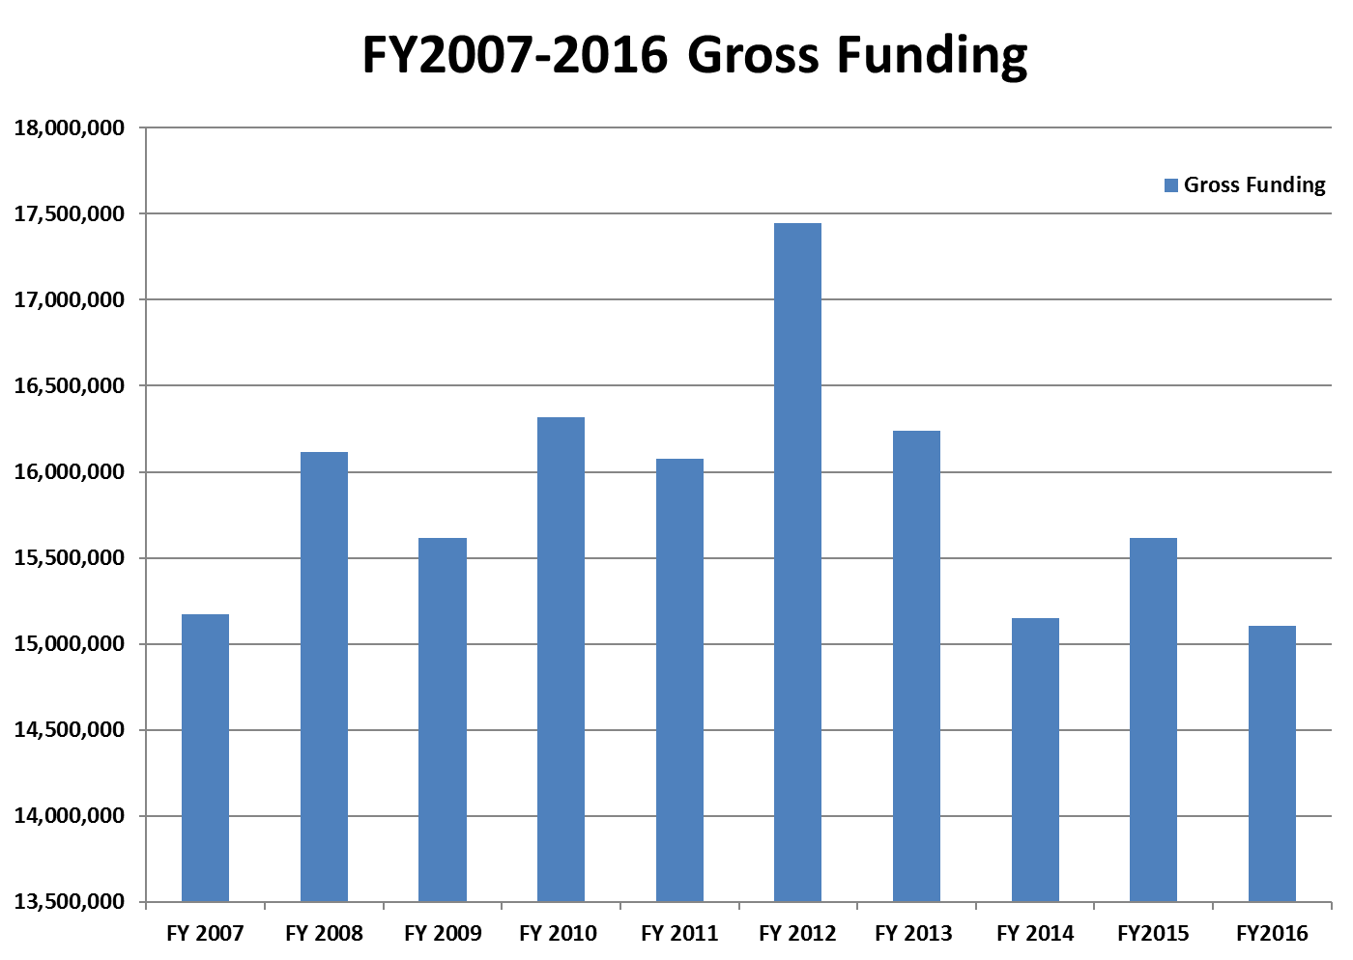

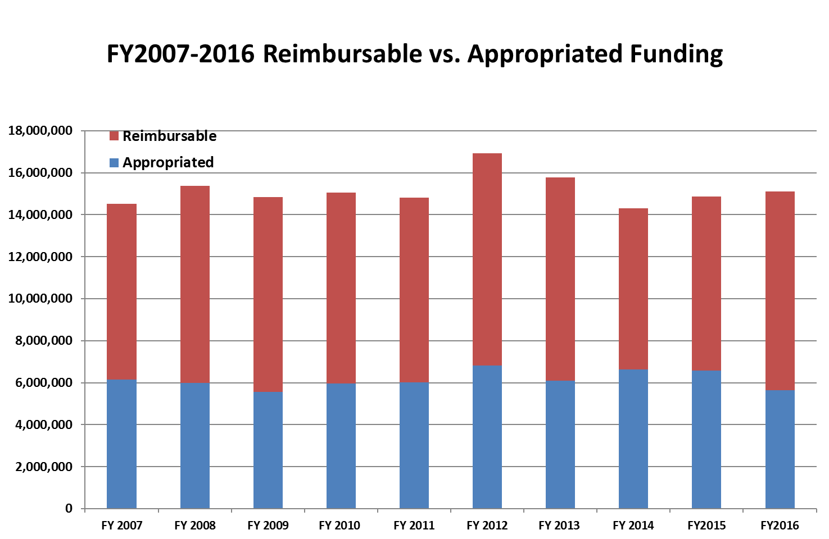

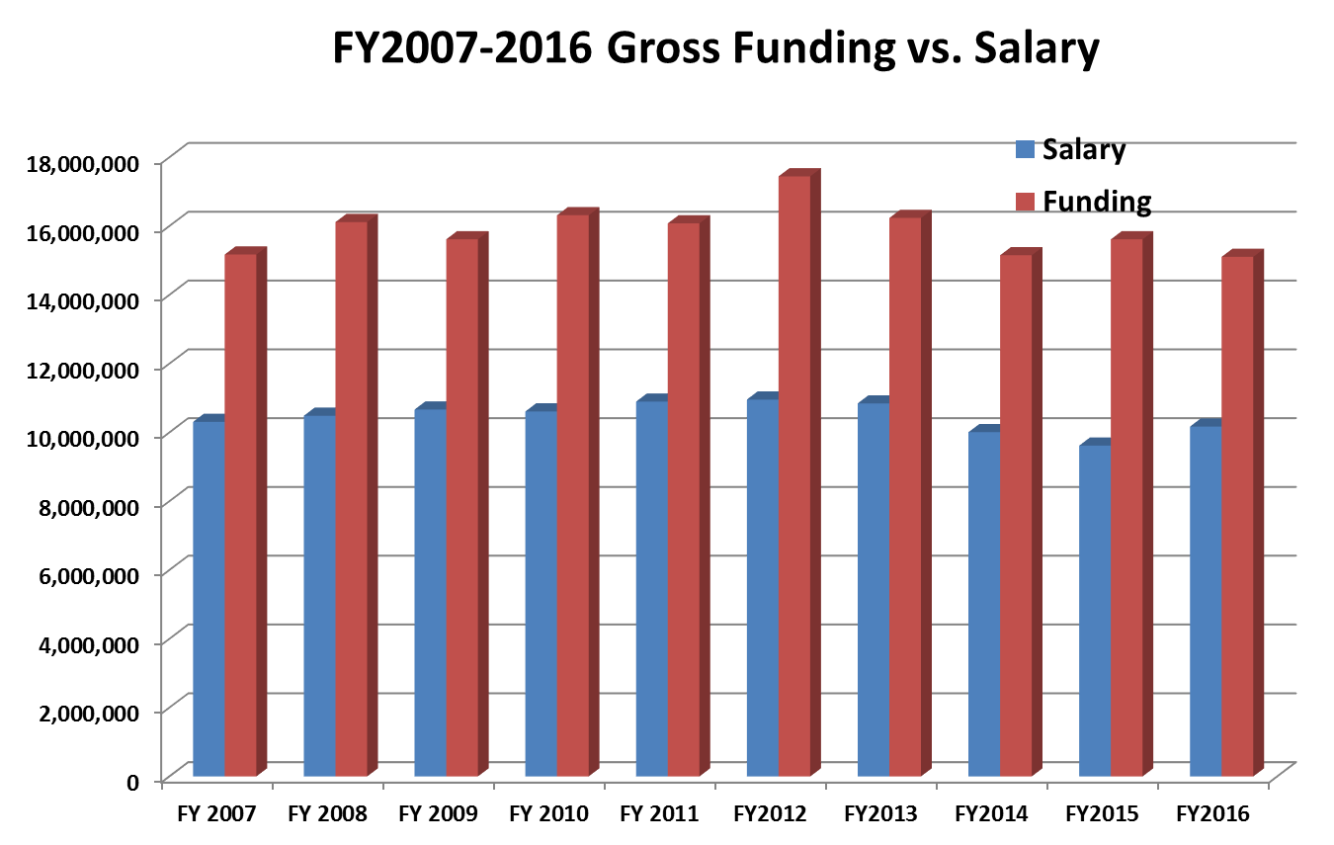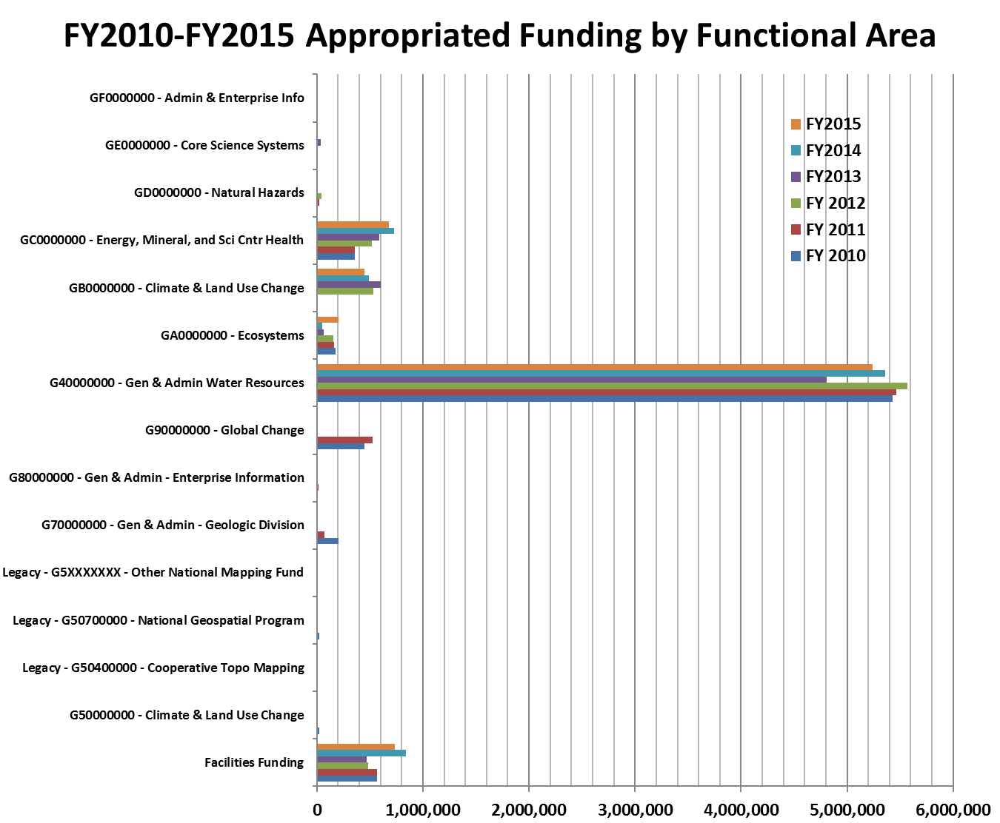

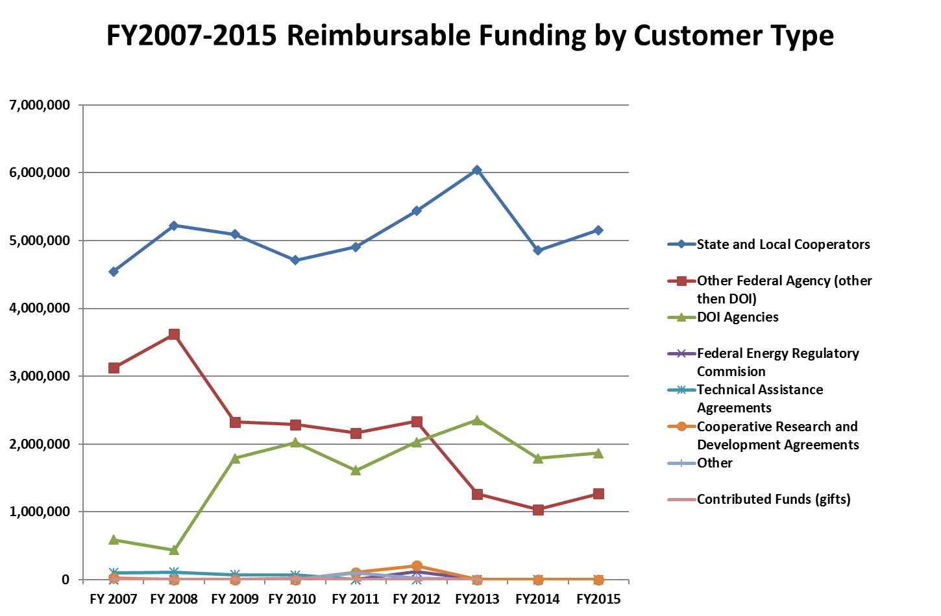

Appendix 1. Detailed information on Northwestern Science Center workforce.

**Distribution of Employees by Grade Level**

A table showing general schedule, permanent, non-student employees by grade FY12 to FY16.A table showing research, general schedule, permanent, non-student employees by grade FY12 to FY16.

**Distribution by Years of Service**

A table showing general schedule, permanent, non-student employees grouped by years of service FY12 to FY16.

A table showing research general schedule, permanent, non-student employees grouped by years of service FY12 to FY16.

**Supervisory Information**



**Employee Count by Occupational Series**



**Retirement Eligibility for previous, current, and next 3 fiscal years**

A table showing retirement eligibility for previous, current, and next 3 fiscal years at the end of FY16.

A table showing retirement eligibility by functional classification of science and engineering professionals as of the end of FY16.A

**Retirement Projections**

A table showing retirement projections as of the end of FY16.

A table showing retirement projections by functional classification of science and engineering professionals as of the end of FY16.

**Separations by Fiscal Year**

At table showing the counts of all separations by appointment types FY12 to FY16.