Youth & Education in Science (YES)

Lesson Title | Understanding Maps (All Lessons)
Grades | 6-12
Length | Expected duration: Two lessons of 2- 50 minutes each and one lesson of 50 minutes  Note: The time of the activities can be reduced considerably if some are assigned as homework. Please read the Teacher’s guide for suggestions.
Topics | Mapping, map components, topographic maps
Materials Needed | - Blank paper  - Pencil  - Colored pencils (optional)  - Magnetic compass and measuring tape (optional)  - Protractor and ruler  - Handouts  - Aerial photograph of the School  - Computer with Google Earth © and internet access (optional)

NGSS Alignment | Middle School: MS-ESS3-2 Earth and Human Activity  Analyze and interpret data on natural hazards to forecast future catastrophic events and inform the development of technologies to mitigate their effects.  Performance Expectation Grade: Middle School (6-8) (https://www.nextgenscience.org/pe/ms-ess3-2-earth-and-human-activity)  Middle School: Human Impacts (https://www.nextgenscience.org/topic-arrangement/mshuman-impacts)  Middle School -ESS3 Earth and Human Activity (https://www.nextgenscience.org/dci-arrangement/ms-ess3-earth-and-human-activity)  Fourth Grade: 4-ESS2-2 Earth's Systems (https://www.nextgenscience.org/pe/4-ess2-2-earths-systems)  High School: HS-ESS1-2 Earth's Place in the Universe (https://www.nextgenscience.org/pe/hs-ess1-2-earths-place-universe)  High School: HS-ESS2-3 Earth's Systems (https://www.nextgenscience.org/pe/hs-ess2-3-earths-systems)
Overview | In this lesson, you will learn how to create a map with its basic components: map scale, north arrow, legend, etc. By creating a map of your school, you will learn the purpose of the different map components that will help you recognize a good useful map, from an artistic depiction of a map.  After students understand the basic components and limitations of maps, topographic maps are introduced. Following the rules for contour lines and after reviewing some of the topographic map concepts, you will create a basic topographic map following specific descriptions.
Related Links | See additional resources for complete list.
Vocabulary | Refer to Teacher’s guide.
Teacher Background | Each lesson covers pertinent material associated with the lesson and activities. Lesson 1 goes over basic components of mapping and map reading. Lesson 2 goes over basic concepts of remote sensing and image interpretation, and lesson 3 enforces concepts learned in lesson 1.

Lesson Plans

Lesson 1: Understanding Maps

Time:
Two sessions of 50 minutes each, one session of 50 minutes if some activities are assigned as homework.

Materials:
- Compass*
- Measuring tape*
- Sketching paper
- Ruler
- Protractor
- Pencil
- Colored pencils (optional)
*Note: These can be omitted if the teacher uses the description provided in the teacher’s guide.

Objectives:
- Familiarize students with map reading and map making concepts.
- Understand limitations of maps.
- Know how to read USGS topographic maps and its components.

Introduction:
Maps are defined as "diagrammatic representation of an area of land or sea showing physical features, cities, roads, etc."
As such, some basic components are needed to provide specific information about the area/location or zone the map is providing.
Even the simplest of maps should include (Figure 1):
- A title- telling the area or features that the maps are showing.
- A map key or legend- defining and explaining the meaning of all the symbols, abbreviations or colors used in the map.
- A north arrow- defining the direction of the north (and thus allowing the inferring of the other cardinal points (east, south, west).
- A scale (bar, text or fraction)- defining the distance representation in the map.

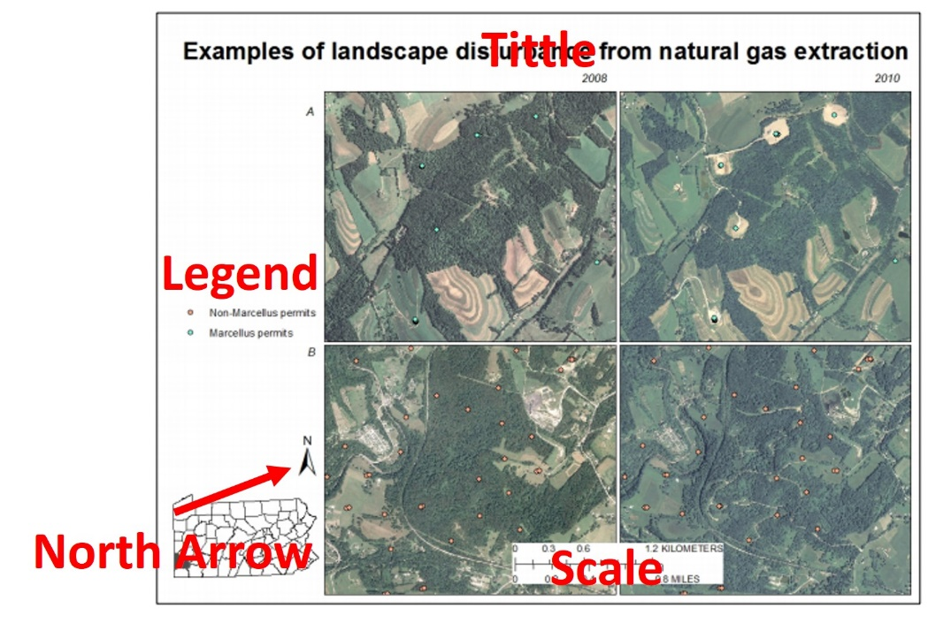
Figure 1: Example of map components.
Background image from:
Milheim, L.E., Slonecker, E.T., Roig-Silva, C.M., Winters, S.G., and Ballew, J.R., 2014, Landscape consequences of natural gas extraction in Cameron, Clarion, Elk, Forest, Jefferson, McKean, Potter, and Warren Counties, Pennsylvania, 2004–2010: U.S. Geological Survey Open File Report 2014–1152, 45 p., https://dx.doi.org/10.3133/ofr20141152.

All these components allow for the map to be interpreted within the context intended. As we will explore in lesson 3, maps can be used to represent multiple types of information, either individually or all at once. These thematic maps have a purpose and provide specific information in a geospatial context.

Overall assumptions:
Maps have some limitations. One of the most obvious limitation is the amount of information presented. Not every detail can be displayed or represented in a map. Other limitations are inherited from the basic construction of a map. When maps are created (or generated) there are some assumptions that are made. Some of these include how the Earth’s surface is represented.
- Overall shape of the Earth: When we look around us and take note of the different landscape features (hills, rivers, valleys, etc.) we see things in three-dimensions, however maps are two-dimensional representations. Therefore, to represent the Earth's surface in a piece of paper (or as a two-dimensional surface) cartographers have developed mathematical models to replicate the earth's surface as flat. These mathematical models are known as projection systems.
Different projection systems are used to define the spacing and extent of latitudes and longitudes in a two-dimensional surface. Different projections have different advantages and disadvantages, and their use will depend greatly on the location of the area being mapped with respect to the globe and the ultimate purpose of the map.
Orthographic projections, for example, show shapes as they appear when the globe is viewed from space. Equal-area projections do not distort the size of areas but do distort their shapes. Conformal projections are those on which the scale is the same in any direction at any point on the map.
Many projections retain one geometric quality, and a few retain more than one quality, but no single projection can accurately portray area, shape, scale, and direction.
Regardless of the projection used, there is going to be some distortion. Examples of these distortions and projections are shown in the USGS Poster titled: Map Projections (available for free download at: https://store.usgs.gov/product/16573, accessed on 12/22/2018).
The distortions will change the separation of the latitude lines and longitude lines making some areas of the globe look larger than they are. Many types of projections are used and exists, the map maker usually choose a projection with the least amount of distortion for the location they are mapping or based on the information that will be represented in the map, as such projections vary widely from map to map.
Another example of the usefulness of map projections is the Mercator projection. The Mercator projection was designed by Flemish cartographer Gerardus Mercator in 1569 to show compass directions as straight lines in all directions from all points on the map. This was an important breakthrough in mapping. Using a Mercator projection, navigators could draw a straight line to a destination, sail in that direction, and expect to reach it, allowing for the effects of ocean currents and other factors.
Mercator made longitude lines parallel and increased the distance between latitude lines away from the equator. As a result, extreme northern and southern areas appear enlarged. For example, Greenland looks larger than South America, although South America is eight times as large. This distortion at high latitudes (north and south) also makes the distances appear larger than they are. Even with these disadvantages, this projection remains one of the most commonly used.
- Coordinate planes and the direction of the North. For the most part the upper portion or top of a map is conventionally used to indicate north. When you look at a map, the bottom of the map indicates south, the left, indicates West and the right indicates East. This is especially useful when a map does not have an arrow indicating the north direction. The same rules can be used anywhere. Once you identify where north is in a location, if you look towards north, your right hand will be east, your left hand will be west, and your back will be south. Some maps will not follow this convention, however there should be an arrow somewhere in the map indicating the direction used to indicate North. Knowing the orientation of a map is crucial is the map is being used for navigation purposes.
- Map scale. The details a map will show about an area will be limited or constrained based on the map scale. The map scale provides an indication of the area covered in the map with respect to ground area. For example, a map with a scale of 1: 24,000 indicates that one inch of distance in the map is equivalent to 24,000 inches in the ground. The same ratio is used for any type of distance unit, the same ratio 1/24,000 can also be interpreted as 1 feet in the map is equivalent (or represents) 24,000 feet in the ground's surface.
An important consideration when defining the scale of a map it's the minimum mapping unit (MMU). The MMU is the is the smallest size that determines whether a feature is captured in a map; usually minimum mapping unit from a remotely sensed image, such as an aerial photograph or a satellite image. Determination of the MMU defines the amount of detail captured in the process of image interpretation. Given that many maps these days use some type of remote sensing image, the MMU will determine the scale of the map. Big scale maps will have many details and will cover a small area, while small scale maps will have less details and will cover a bigger area.

Basic elements of a map:
When studying a map or making a map we need to make sure to identify or show important components of the map. Showing information on a map is not enough, we need to provide some basic guidelines on how to interpret and analyze the map.
- Orientation: Any map needs to let the user know in which direction the map is displayed. This is usually shown with a North arrow. Although not every single map will have a north arrow, the north arrow allows the reader to determine the direction of the map as it relates to due north and provides clarification.
- Scale: The scale explains the relationship between the data shown and the real world; the description is a ratio. The scale can be presented in different forms: in text, as ratio expressed in numbers or in a graphical way (Figure 2) as a scale bar.
Examples:
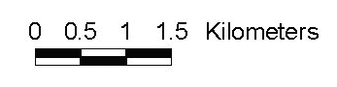
"for everyone paper map unit represents 10,000 real world unit"
1:10,000
Figure 2: Graphical scale or scale bar.

- Title: The title of the map provides a summary of the scope of the map and hints towards the information presented.
- Legend: The legend provides an explanation to the symbols and colors used in the map. The legend serves as a key explaining any color used and categorization used.
- Citation: This provides information on where explanatory data about the data sources and currency, projection information and any caveats are placed. In the example below, the citation tells the source and date of the data.
Other components that can appear on the map include a border and an inset map. The border usually provides information about the coordinates while the inset map shows the general area of the location of the map at a bigger scale. Figure 3 shows an example of a USGS map identifying all the basic map components.

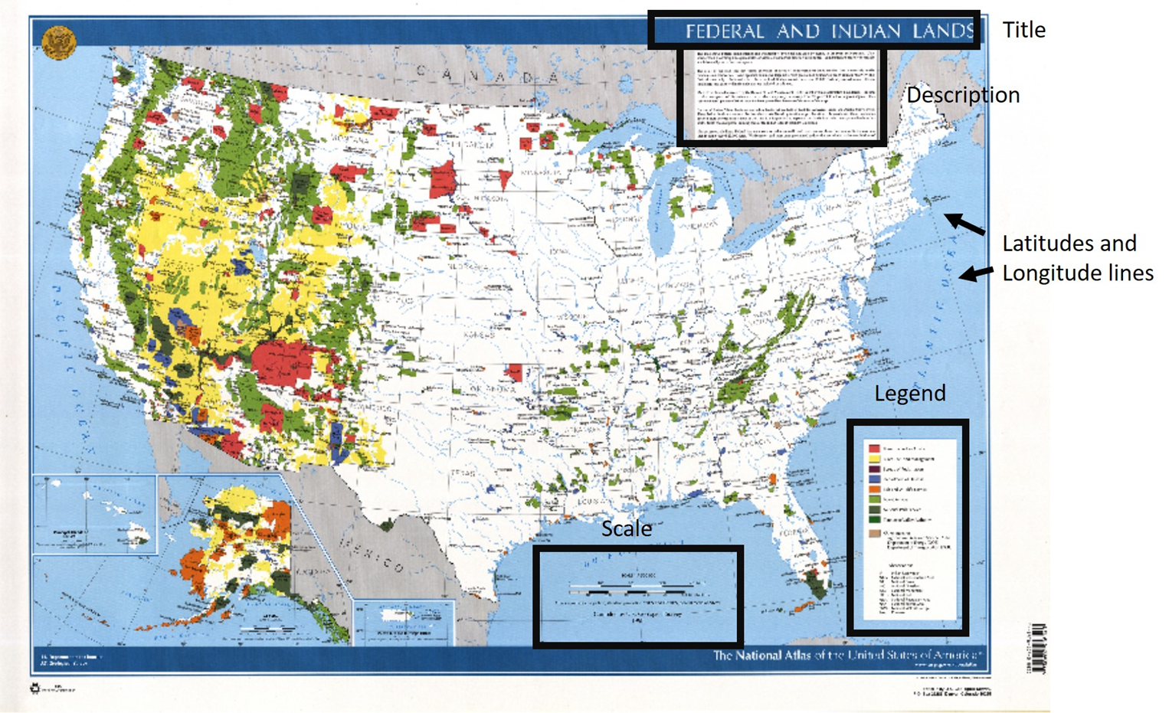
Figure 3: Example of a map with its basic components. Note that this map does not have a north arrow. Instead the map displays its geographical coordinate system which provides information of where is North located in the map.
Map taken from USGS Store product: US NATL ATLAS OFFEDERAL & INDIAN LANDS available at: https://store.usgs.gov/product/100854 for free digital download, accessed 12/11/2018.

Topographic Mapping
Topographic maps or "topo" maps for short, are two-dimensional representations of the earth's surface. Topo maps tend to have a lot of detail and represent natural and human made features.
Topographic maps use a variety of symbols to display both natural and man-made features. The United States Geological Survey is the Federal entity in charge of generating topo maps of the United States, hence it has developed a standard in symbology used in their maps. The list of symbology used in USGS topo maps can be found in USGS Publication Topographic map symbols.
U.S. Geological Survey, 2005, Topographic map symbols: U.S. Geological Survey Unnumbered Series, GIP, 4 p., available only online at https://pubs.usgs.gov/GIP/TopoMapSymbols/, accessed 12/07/2018.
However, the most notorious and distinguishing characteristics of topo maps are the contour lines. Contour lines are isolines representing points of equal elevation. Contour lines, are used to represent elevation on a map by connecting points of equal elevation. These imaginary lines provide a good visual representation of the terrain.
To do so, contour lines follow some specific rules. The rules ensure accurate representation of the surface.
The following are a summary of contour rules:
- Contour lines represent points of equal elevation, as such every point along the contour line has the same elevation.
- Contour lines never intersect, cut or cross other contour lines. A point in the surface of the Earth may not have two different elevations.
- Contour lines always close forming an irregular circle. In occasions contour lines extend beyond the area on a map so you may not see the entire closed circle.
- The separation between contours defines the steepness of the slope. Contour lines with a wider separation show gentle slopes, while contour lines closed together or even "merging" together will have steeper slopes. (See Figure 4).
- Hills are represented by a series of closed contours; the top contour represent the top of the hill. (See Figure 4).
- Depressions are represented with closed contour lines (circles) with small hachure marks pointing downslope (Figure 5).
- Contours form a series of "V"s when they cross a valley or drainage (creeks, streams, rivers). The tip of the "V" always points uphill, or the opposite direction of the river flow.
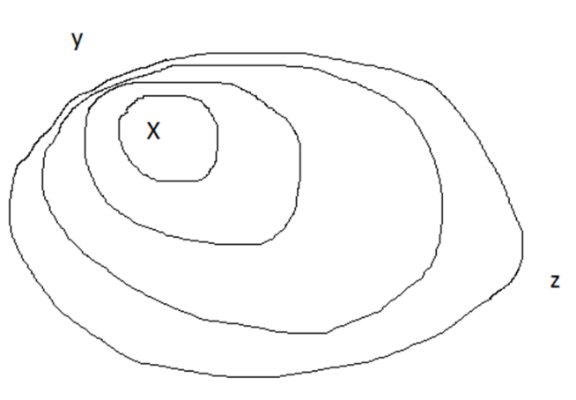
- Contour lines create V (or U) patterns when they cross a ridge. The tip or blunt end of the V or U at a ridge always points downhill (Figure 6).
Figure 4: Example of how contours work: The set of contour lines indicate a hill (or mountain). The x denotes the top of the hill. If we move from x downslope towards z, the slope is gentler denoted by the separation of the contours. Meanwhile, if we go downhill from x towards y, the slope is steeper, denoted by the small space between contours. The closer the contours are the faster is the elevation change. In really steep slopes (such as a cliff) contours will look like they merge or are on top of each other.

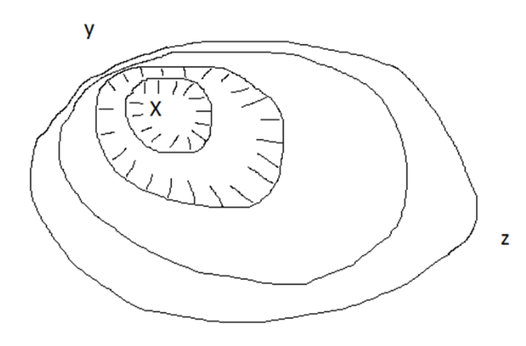
Figure 5: Example of contour lines showing a depression. Note that depressions are indicated by hachures around the contour.

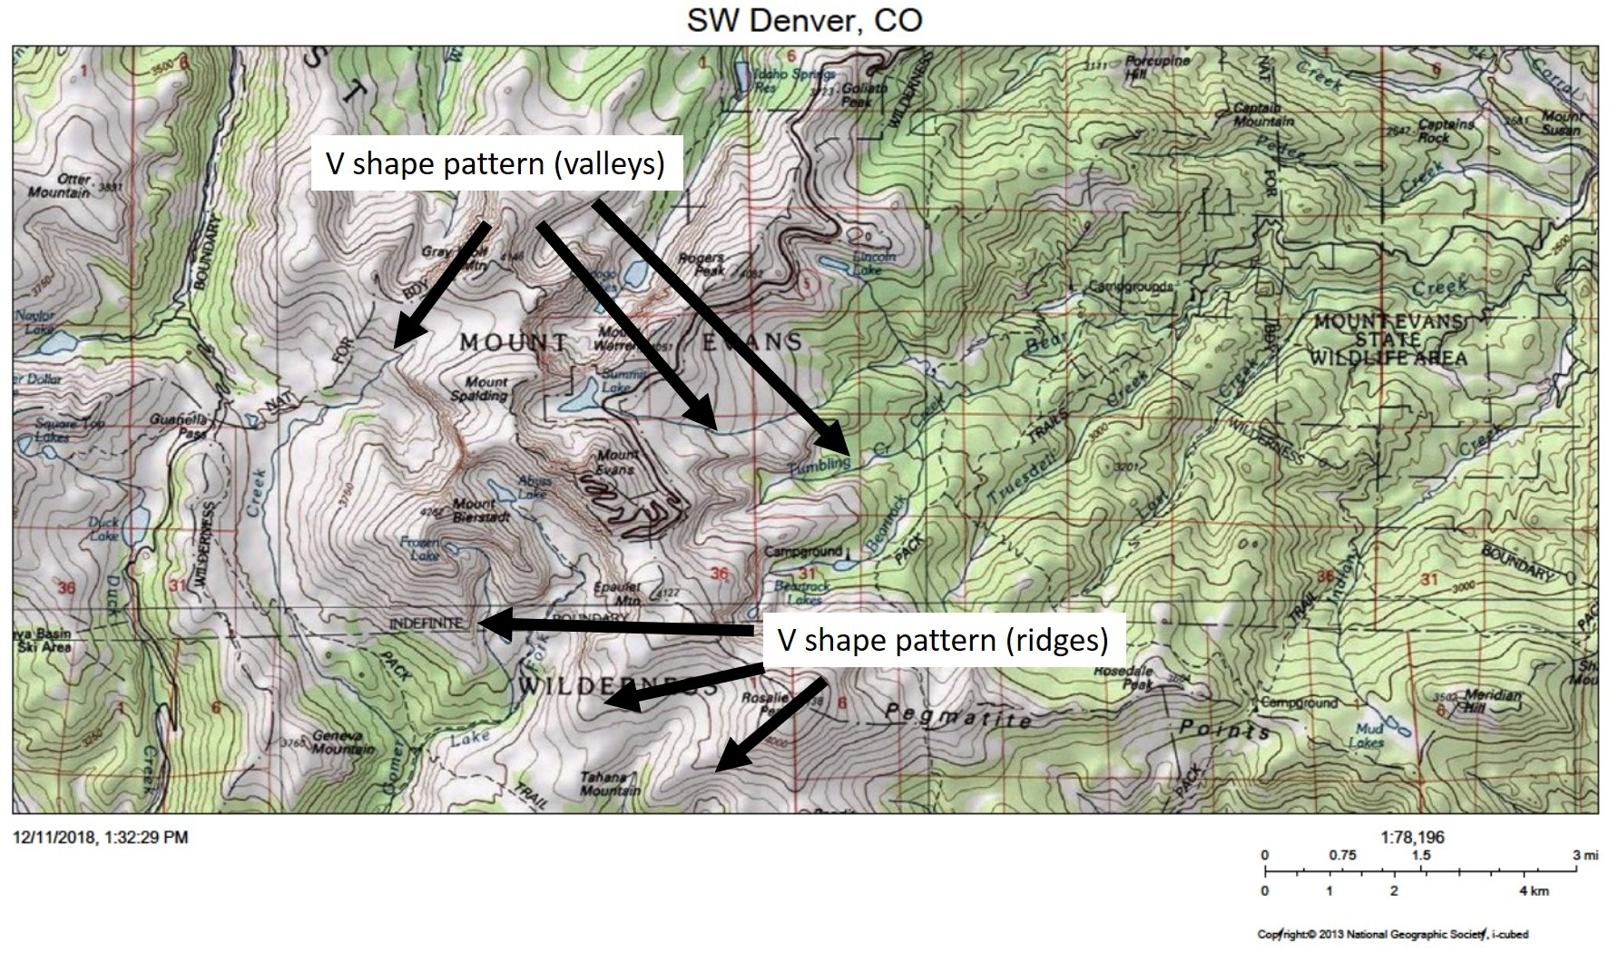
Figure 6. Topo map of the Mount Evans area near Denver, Co. Note the "v" or "u" shaped pattern created by contours when they cross valleys (streams or rivers) and the "v" or "u" shaped pattern created by contours on ridges. The area shows many examples of these patterns, can you spot them? Can you find the top of a hill?
Map generated using the USGS The National Map viewer, available at: https://viewer.nationalmap.gov/advanced-viewer/, accessed 12/11/2018.

USGS topographic maps: North Arrows
Information from: USGS FAQ: https://www.usgs.gov/faqs/what-do-different-north-arrows-a-usgs-map-mean, accessed on 12/11/2018.
One of the characteristics of USGS topo maps is the distinctive North arrow. In the case of USGS topo maps, instead of one north arrow orienting the map, there are three different types of North arrows shown. At the bottom of most USGS topographic quadrangle maps there is a diagram that shows three north arrows -- true north, grid north, and magnetic north -- and the angles between them. Some maps, especially very old maps, do not have this diagram.
True north, also called geodetic north or geographic north, is the direction of the line of longitude that bisects the quadrangle. All longitude lines coverage to points at the north and south poles. The star symbol in the diagram indicates true north.
Magnetic north (MN) shows the direction a magnetic compass would point at the time the map was published. The direction of magnetic north varies both with position on the earth's surface and over time, so magnetic declination values on old maps may no longer be accurate. Magnetic declination values shown on current maps are obtained from NOAA's National Geophysical Data Center (https://www.ngdc.noaa.gov/geomag-web/#declination, accessed on 12/19/2018).
You can learn more about magnetic declination here: https://www.usgs.gov/faqs/what-declination?qt-news_science_products=0#qt-news_science_products, accessed on 12/11/2018.
Grid north (GN) is the direction of a plane grid system, usually the grid associated with the map projection. On current US Topo maps (https://viewer.nationalmap.gov/basic/?basemap=b1&category=histtopo,ustopo&title=Map%20View, accessed on 12/19/2018.) the projection is Transverse Mercator, and the plane grid is Universal Transverse Mercator (UTM). All US Topo maps have a 1,000-meter UTM grid included on the map, and the angle at which this grid meets the map projection line visually shows the difference between true and grid north. Historical maps (https://ngmdb.usgs.gov/topoview/, accessed on 12/19/2018.) may relate grid north to other grid systems. The difference between true north and grid north is an inherent effect of transforming the earth's spherical surface to a plane surface. The size of this difference for a map depends on the projection and the map location relative to the projection origin.
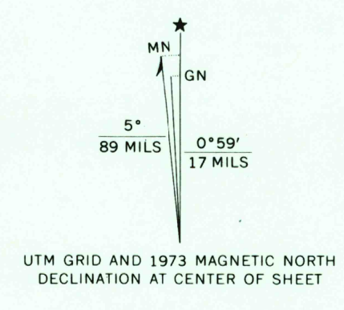
Figure 7: Example of a USGS topo map north arrows. Magnetic north (MN), Grid North (GN) and True North (star) are shown here. Note that the map provides information on magnetic declination for the time the map was generated (as magnetic declination changes with time).

The phrase "USGS topographic map" usually refers to standard quadrangle maps with scale between 1:10,000 and 1: 250,000. Within this domain there are two product categories:
- US Topo maps are the current topographic map series, published as digital documents in 2009 and later.
- The Historical Topographic Map Collection (HTMC) consists of scanned images of maps originally published as paper documents in the period 1884-2006.
The USGS also publishes other kinds of maps, including some topographic maps that are not standard quadrangle maps.
Visit the USGS FAQ website for more information: https://www.usgs.gov/faqs/what-a-topographic-map, accessed on 12/11/2018.
The USGS topo map provides all the descriptive information concerning the map creation including datum, references used, any revisions made to previous maps, etc.

Activity 1: Thinking about Maps.
In this activity students you will work in groups to create a map of your school and a map of your classroom.
The activity will help you start thinking and asking geographical questions using a well-known area.
Your teacher will explain what information is needed and how to access it or collect it.

Part I: Spatial thinking
Imagine a brand-new student is starting school next week. The student has never been to this school and you were assigned the task of help her familiarize with the location of important school areas: Nurse office, principal’s office, the cafeteria, gym area, etc. Turns out you are not going to be available to give the student a tour. You decide to make a conceptual map or sketch map of the school to help her out. In a conceptual map or sketch you will map the different locations with reference to the others but the map is not drawn to scale. Use an 8x11.5-inch paper to sketch out the school and the most important areas. Label the following locations:
- Parking Lot
- Bus drop off and pick up area
- Main entrance and other exit doors
- Principal’s or director’s office
- Gym
- Cafeteria
- Library
- Nurse
- Counselor’s office
If your school has multiple buildings make sure to draw them and label each. At this point don’t worry about the scale. You can use an aerial photograph of your school (You can access one using the USGS Earth Explorer web application - https://earthexplorer.usgs.gov/ - and follow the Help link at the upper right corner to find a tutorial. Alternatively, you can use any other web map application available to you - Google maps, Bing Maps, etc.) to help you sketch out the outline of the buildings.
After completing the maps students will exchange maps with other students to evaluate each other’s work. Remember that this is not about artistic level, but how useful is the information.

Consider the following questions:
- If you were completely new to school, would you be able to find the principal’s office from the main entrance?
- If you were assigned a room number and didn’t know where to go, would you be able to find the room with reference of another area?
- Could you estimate how long it will take you to walk from the principal’s office to the nurse area just by looking at the sketch? (remember this is just based on the sketch not your knowledge of the school).
- Return the sketch to its creator and discuss how the sketch could be improved. Is there any information missing? Was it good enough or is there a need for more detail? Does your sketch look like this other’s persons map? What are the differences? What are the similarities?
An important aspect of map making is that maps are interpretative. Maps display facts, but their very nature is interpretative. Not too maps will look exactly alike. From the selection of the amount of details provided, the projections used, and the color schemes and symbols used will vary from map maker to map maker. Sometimes there are conventional notions used for specific features (i.e. water is blue) but they may vary. m

Part II: Map components.
*Your teacher will provide details on how to collect the data. If the data cannot be collected, your teacher will provide the needed details to create the map.
Using an 8x11.5-inch paper generate a map of your classroom. You will want your map to show the following components:
- scale bars and scale fraction
- an arrow indicating the North direction
- a legend describing the different symbols or color used.

One of the most important aspects of map making is identifying and describing the features to be mapped. The fist-steps in this activity involves observation and information gathering. When gathering this information consider the spatial context of the features, and what features are important to consider.

Instructions: Gathering the right geographical information.

- Look around your classroom. Identify a main reference point (it could be the main entrance, a point along the board or the teacher’s desks). Make sure this reference point is easy to identify, and it won’t change its location. All measurements and information will be taken from this spot. Your teacher may decide what will be the reference point.
- Next identify the objects or features that need to be mapped: student’s and teacher’s desks, your sitting area, the door or doors of the room, the board, any storage cabinet. You can be as detailed as you would like, but consider the time allowed for the data collection and the time you will have to make the map. Another consideration is your minimum mapping unit (MMU) and your mapping scale. Remember that the scale you use will determine the amount of detail you will have in your map.

Exploring scale and details in maps: A good exercise to compare different scales and the level of details can be opening a web map application (USGS The National Map, Google Earth, Google Maps, Bing Maps, etc.) and zoom in and out of an area. As you zoom in and out, notice how and what information changes in the display. This will give you an idea of how much detail to include or not in your map.

- With some assistance, use the compass and the measuring tape to take the information to draw the map.
- Example: Standing from the entrance door, the teacher’s desk is located 10 feet in the N50°S.
- Once the information is gathered, consider the most important features. Set up your base map: define the scale, north direction, and reference point. Once these are set, add the features to be mapped to your map.

- Once you complete the map, add a tittle and make sure that any symbols used are explained. Go over the basic map components and include them in your map. Once completed, exchange your map with other students and consider the following questions:
- Is your map identical to the map your peer made?
- How are they similar?
- How do the maps differ?

Activity 2: Identifying features in topographic maps.

Directions:
Using the following maps, answer the questions provided.
Northern Virginia, USA
- Mark with an "H" at least 2 hills in the area. Label them H1 and H2. What is the elevation of the highest contour?
- Identify at least 3 streams in the area, label them S1, S2 and S3. If north is the top of the map, in which direction are the streams flowing?
- Using the USGS topographic map symbols as an aid, identify any residential or urban area.
- Can you locate Indian Creek? Where it is located?
- Can you locate Beaverdam run? Where it is located and in which direction is the water flowing?
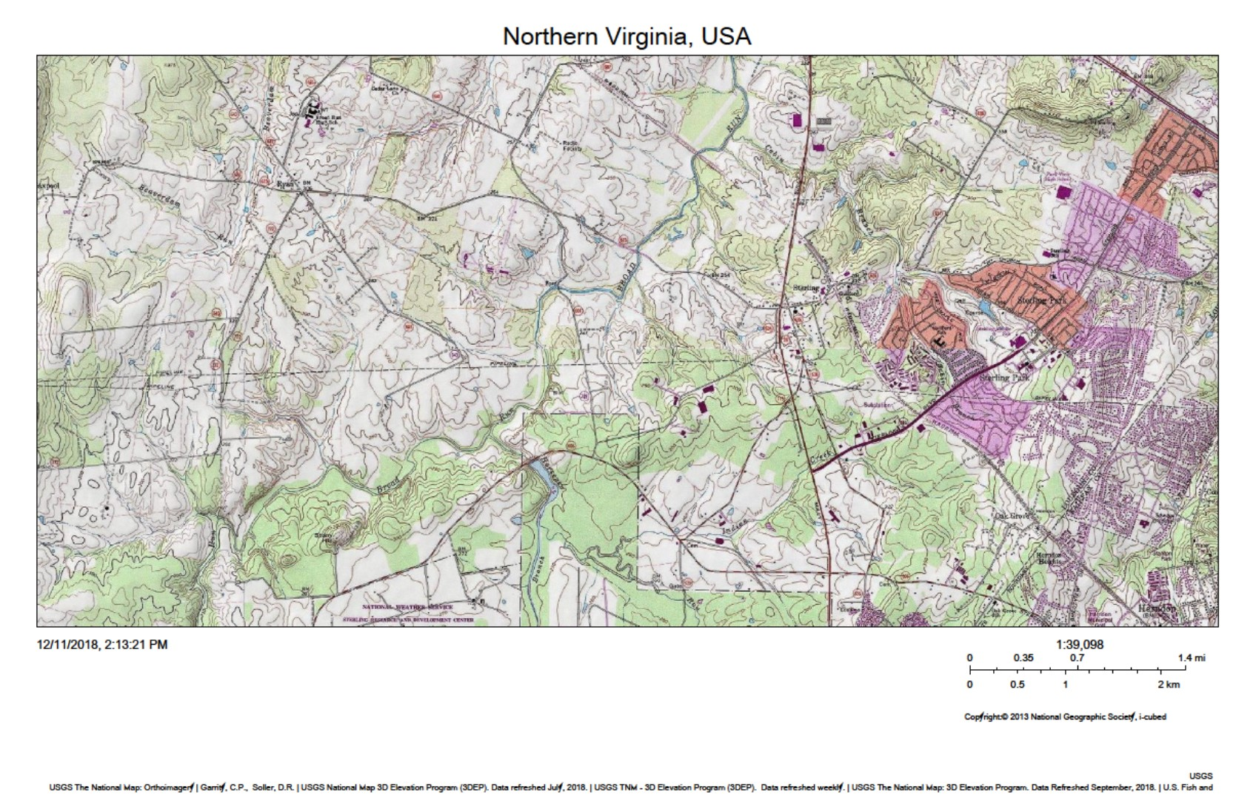
Map generated using the USGS The National Map Viewer web application: https://viewer.nationalmap.gov/advanced-viewer/ (accessed 01/28/2019).

Shaw Lake, Rio Grande National Forest, Colorado
- Locate Shaw Lake in the map, what is its approximate elevation?
- Locate Table Mountain at the NW corner of the map, what is the approximate elevation?
- What is the elevation difference between Shaw Lake and Table Mountain?
- Locate The Hill in the map, how far is The Hill from Shaw Lake in miles? How far in kilometers?
- How far is Table Mountain from The Hill?
- How far is Table Mountain from Shaw Lake?
- Does Kitty Creek drains to Shaw Lake?
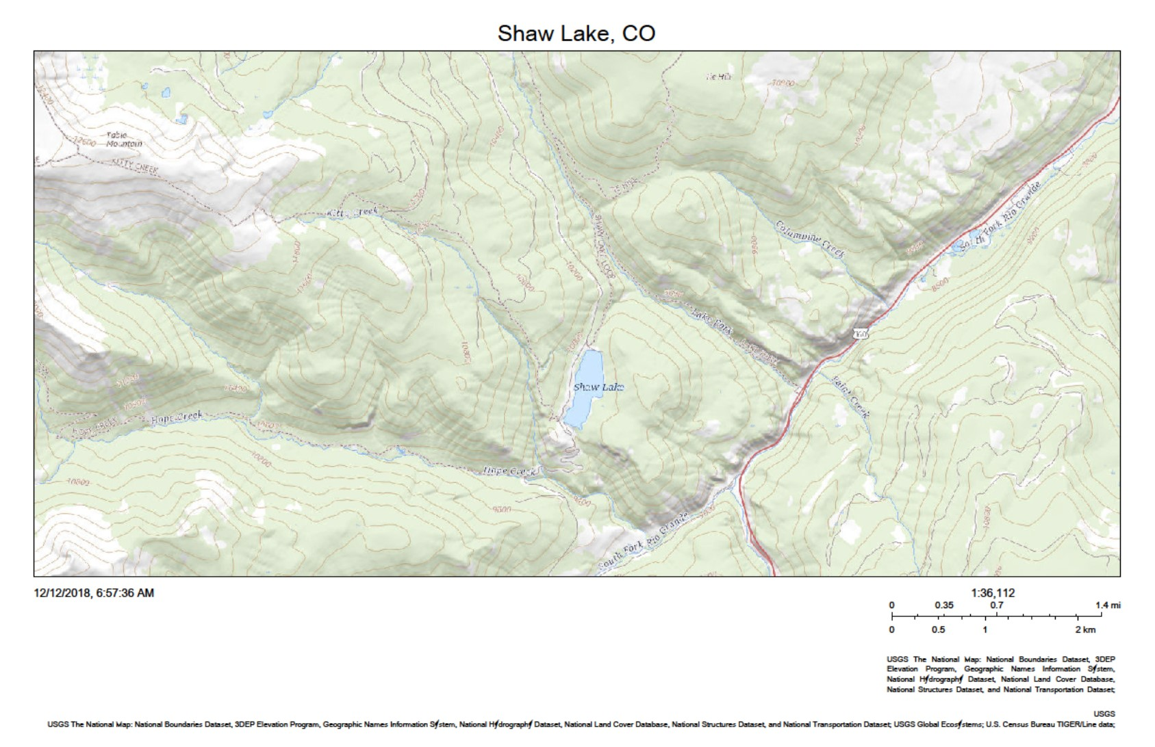
Map generated using the USGS The National Map Viewer web application: https://viewer.nationalmap.gov/advanced-viewer/ (accessed 01/28/2019).

Lesson 2: Aerial Photographs and other remote sensing tools

Time:
Two 50-minute lessons. Can be reduced to one 50-minute lesson if some activities are assigned as homework.

Materials:
- Earthshots handouts of website (https://earthshots.usgs.gov/earthshots/, accessed 02/01/2019).
- Optional: materials to build a stereoscope and a print out of the Colorado River stereographic photographs.

Objectives:
In this series of activities, you will explore and familiarize yourself with tools currently used to aid mapping efforts. Although site visits and traditional field work are still used in today's modern world, advances in technology have provided the means to develop maps of many kinds, improving accuracy and even providing the means for monitoring efforts without the need of physically visiting the mapping area.

Introduction
Advances in technologies made during the 20th century have paved the path to a new world of opportunities to explore and acquire information of remote places or in a different perspective. Information that used to be collected on the ground it is now collected by sensors on board of satellites lurking at Earth from space.

Remote Sensing:
Remote sensing is the process of detecting and monitoring the physical characteristics of an area without the need of physically being there.
Examples of remote sensing data collectors include cameras and sensors mounted in planes and satellites.
Fundamental to remote sensing is the practice of photogrammetry (measuring from photographs). Photogrammetry is built on developments in many fields of science and technology.
Today, the term remote sensing is mostly used to refer to satellite collected data (USGS Mapping, Remote Sensing and Geospatial Data web page: https://www.usgs.gov/faqs/what-remote-sensing-and-what-it-used?qt-news_science_products=7#qt-news_science_products, accessed 12/12/2018).. Remote sensors collect data from parts of the electromagnetic spectrum, usually outside of the visible spectrum. Some other types of data collected include data outside the electromagnetic spectrum to include gravity, magnetic, and other types of data.
Preceding all current technologies in remote sensing is the practice of photogrammetry. Photogrammetry is the use of photographs to take measurements. To this day it is widely used techniques that provide substantial information. Mathematical contributions and conceptual contributions in optics led to the establishment of the geometric foundation of photogrammetry. Using stereoscopes and two slightly overlapping photographs it was possible to generate a three-dimensional image. When photographs went airborne (first balloons and then airplanes) stereographic cameras were used to make topographic maps.
Since the late 1960's, map information has been collected, stored, and used in digital form. Sensors in satellites collect data and then it is transmitted to Earth were the information is collected and processed to generate images that look like photographs. Using specialized software scientist can extract information and generate maps faster than ever. The accuracy of this maps is usually good. Digital mapping has allowed for the almost near real time mapping that can be transferred electronically within a short time frame.
The addition of geographic information systems (GIS) to store, manipulate and display geographic information allows for results to be displayed instantly in the computer, greatly speeding the process of generating maps at different scales, using different symbology and even displaying different information from the same dataset.
However great these advances in technologies, there has never been a greater need to understand a maps limitation. The limitations may come from differences in the scale data was acquired, data analysis is only as objective as the analyst, display techniques that control the information emphasized in the map, and of curse positional accuracy, among others.
Positional accuracy of information is being further refined by the Global Positioning System (GPS). GPS is a USA government owned program that provides geolocation and time-information to a GPS-receiver. Portable GPS receivers on Earth receive the signals from GPS satellites above the horizon and calculate absolute position to accuracies far better than those on existing maps of most of the globe. The process is basic triangulation, but the new tools provide much greater precision. Today, GPS positional accuracy can be within one foot (for the most updated, technological advanced receivers).
Today many smartphones either have GPS receivers or use a combination of receivers and internet network to accurately calculate your position. This allows the use of navigational apps installed in the phone.

Electromagnetic Spectrum:
The electromagnetic (EM) spectrum is described as the continues spectrum of energy or radiation. This radiation (or energy) goes from high energy gamma rays and x-rays to very low energy microwaves and radio waves (SGS Landsat information web page: https://landsat.usgs.gov/atmospheric-transmittance-information, accessed 12/17/2018). As shown in Figure 2.2, the visible light, light that our eyes can detect is a very small portion of the electromagnetic spectrum. With the advancements in technologies and development of specialized sensors on aerial or satellite platforms we can see portions of the electromagnetic spectrum outside of the visible light.

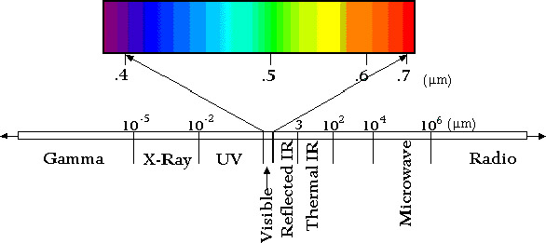
Figure 2.1: Electromagnetic Spectrum. (from: USGS Landsat webpage Atmospheric Transmittance Information https://landsat.usgs.gov/sites/default/files/images/Spectral_Bands.jpg, accessed 12/17/2018). https://landsat.usgs.gov/atmospheric-transmittance-information

Satellite Images:
Information taken from: https://landsat.usgs.gov/atmospheric-transmittance-information (accessed 01/29/2019).
Today, most of remote sensing data is collected in aircrafts, even unmanned aircrafts, and satellites. In general terms there are two types of sensors: passive and active sensors. Passive sensors collect naturally transmitted electromagnetic waves from the viewed object, while active sensors generate their own electromagnetic waves that is transmitted by the sensor to the observed object and back to the sensor (Figure 2.1).
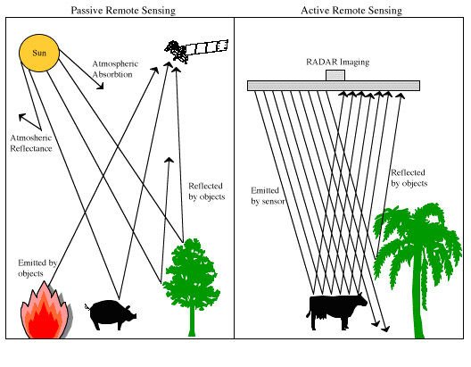
Figure 2.2: Active versus passive remote sensing. (from: USGS Landsat webpage Atmospheric Transmittance Information https://landsat.usgs.gov/sites/default/files/images/Passive_Active_RS.jpg, accessed 12/17/2018). https://landsat.usgs.gov/atmospheric-transmittance-information
The Landsat satellites are an example of passive sensors. Radar, lidar and microwave are examples of active sensors.

Landsat Mission:
Launched in 1972, the Landsat program is a series of Earth-observing satellite missions managed by NASA and USGS.
In cooperation with NASA, on July 23, 1972, the Earth Resources Technology Satellite (ERTS-1) was launched. It was later renamed Landsat 1. Additional Landsat satellites followed in the 1970’s and 1980’s, and in 1999, Landsat 7 was launched. Landsat 8 (initially named Landsat Data Continuity Mission - LDCM) was the most recent satellite to be launched on February 11, 2013. Landsat 9 is in development, with a launch scheduled for late 2020.
The instruments in the different Landsat missions have gathered millions of images, the data are valuable resource for global change research and applications in agriculture, geology, regional planning, and education.
More information about the different Landsat mission programs can be found at https://www.usgs.gov/land-resources/nli/landsat/landsat-satellite-missions?qt-science_support_page_related_con=2#qt-science_support_page_related_con (accessed 01/28/2019).
Landsat data products are available at no charge and can be used without restrictions by all users and can be accessed and downloaded via the USGS EarthExplorer web site available at https://earthexplorer.usgs.gov/ (last accessed 01/28/2019). Creating an account and logging in is required to download images and data.

Image composites:
When we work with remote sensing data, although we tend to think of them as photographs, the truth is that a satellite image is created by combining measurements of the intensity of certain wavelengths of light, both visible and invisible to human eyes. An example of these are the Landsat 8 bands (see Table 2.1).

Band | Wavelength | Useful for mapping
Band 1 – Coastal Aerosol | 0.435 - 0.451 | Coastal and aerosol studies
Band 2 – Blue | 0.452 - 0.512 | Bathymetric mapping, distinguishing soil from vegetation, and deciduous from coniferous vegetation
Band 3 - Green | 0.533 - 0.590 | Emphasizes peak vegetation, which is useful for assessing plant vigor
Band 4 - Red | 0.636 - 0.673 | Discriminates vegetation slopes
Band 5 - Near Infrared (NIR) | 0.851 - 0.879 | Emphasizes biomass content and shorelines
Band 6 - Short-wave Infrared (SWIR) 1 | 1.566 - 1.651 | Discriminates moisture content of soil and vegetation; penetrates thin clouds
Band 7 - Short-wave Infrared (SWIR) 2 | 2.107 - 2.294 | Improved moisture content of soil and vegetation and thin cloud penetration
Band 8 - Panchromatic | 0.503 - 0.676 | 15 meter resolution, sharper image definition
Band 9 – Cirrus | 1.363 - 1.384 | Improved detection of cirrus cloud contamination
Band 10 – TIRS 1 | 10.60 – 11.19 | 100 meter resolution, thermal mapping and estimated soil moisture
Band 11 – TIRS 2 | 11.50 - 12.51 | 100 meter resolution, Improved thermal mapping and estimated soil moisture
Table 2. 1: Landsat 8 band list.

From < https://www.usgs.gov/land-resources/nli/landsat/landsat-8?qt-science_support_page_related_con=0#qt-science_support_page_related_con> (accessed 01/28/2019).

The list of bands gives information about the different areas of the spectrum data is being collected. The analyst can then combine different bands to create images that provide different information. The bands are combined in groups of 3: one assigned to Red, one assigned to green and one assigned to blue. Table 2.1 list some of the uses of the different bands in Landsat 8.
A natural or “true-color” image combines actual measurements of red, green, and blue light. The result looks like the world as humans see it.
However, to be able to use the data collected in the other bands in the non-visible part of the spectrum, scientist combine them into the red, green and blue to create "false color" images. A false color images uses at least one non-visible wavelength. The colors in a false color image may not be what you would expect them to be, vegetation won't always appear green for example. However, false color images can reveal unique aspects of the earth's surface that might not be visible in a true color image. Certain combinations have been identified to its usefulness and ease to understand.
A great resource in understanding image and band composition is the National Aerospace and Satellite Administration website: Why is that Forest Red and that Cloud Blue? How to Interpret a False-Color Satellite Image available at: https://earthobservatory.nasa.gov/features/FalseColor/page1.php, accessed 01/28/2019.
The activities in these lessons will provide additional information on how objects and features look like in images utilizing different band combinations.

Activity Lesson 2 Interpreting Images

Part I: Observations through time

Objective:
Using the USGS online publication Earthshots, students will explore how to make observations of satellite images. The images cover several subjects in environmental change using the Landsat archive.

Materials:
Earthshots handouts of website (https://earthshots.usgs.gov/earthshots/, accessed 02/01/2019).

Directions:
Using the images and information below, answer the following questions.

Dallas, Texas
The image below shows the area of Dallas-Fort Worth in northeastern Texas for the dates of October 19, 1973 and August 31, 2013. The table below describes the different Landsat bands used to generate the images. Both images show a false color infrared band combination, where near infrared, red and green spectral bands are mapped to match red, green and blue (RGB). This band combination is widely used in optical remote sensing.
In this case, plants reflect near infrared and green light, while absorbing red. Since plants reflect more near infrared than green, plant-covered land appears deep red.
Denser plant growth is darker red. This band combination is valuable for gauging plant health.
Cities and exposed ground are gray or tan, and clear water is black. In the image below, the water is muddy, and the sediment reflects light. This makes the water look blue.
- Observe both images. Are there any features that appear in one image but does not appear in the other? What are these differences?
- If you observe the 1973 image you can see that there are some areas that appear blue or light blue, but they don't seem to have the same colors in the 2013 image. Why you think this is?
- What is the white looking structure near the center of the 1973 image?
- If you have access to a computer with internet and Google Earth installed, navigate to the general area (search for Dallas). Using the "Show historical imagery" feature navigate to the oldest image available. As you scroll through the different images (dates):
- Can you pin point a date when the water feature in the 2013 first appear? Note: the dates for the historical imagery will vary depending on the scale you have your view. If you try to match the extent of the Earthshots images above, you will get 1984 as the earliest available date. Also note that the images in Google Earth are shown as "true color" composites, meaning that the bands designated in red are shown in red, the blue on blue and the green in green.
- Additional information of Dallas, Texas Earthshot can be found at https://earthshots.usgs.gov/earthshots/Dallas-Texas#ad-image-0-0 (last accessed 12/17/2018).
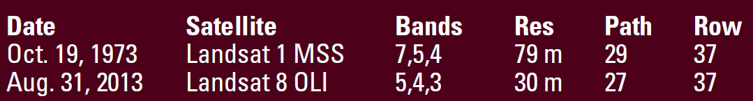

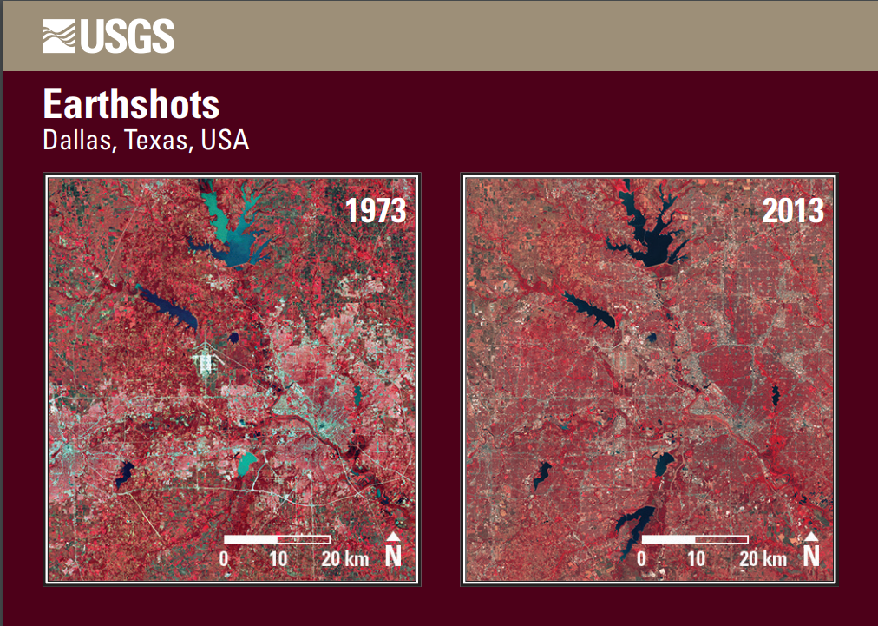

Las Vegas, Nevada USA 1972-2013
Below is an image of Las Vegas, Nevada in 1972 and 2013. The population in Las Vegas grew from 273,000 to over 2 million.
One of the most common false-color band combination uses the shortwave infrared (shown as red), the near infrared (green), and the green visible band (shown as blue).
Water absorbs all three wavelengths, so it is black in this band combination, however it can be blue if there is suspended sediment.
Sediment reflects visible light, which is assigned to look blue in this band combination. This means that both sediment-laden water and saturated soil will appear blue. Because water and wet soil stand out in this band combination, it is valuable for monitoring floods. Saturated soil will also appear blue. Ice clouds, snow, and ice are bright blue, since ice reflects visible light and absorbs infrared. This helps distinguish water from snow and ice; it also distinguishes clouds made up mostly of liquid water or ice crystals.
From <https://earthobservatory.nasa.gov/features/FalseColor/page1.php> accessed 01/28/2019.
Using the image below answer the following questions:
- What is the biggest difference between images?
- If you have access to a computer with Google Earth, navigate to Las Vegas, Nevada and using the historical imagery function navigate to 2013. Compare the image shown in Google Earth with the Landsat scene above. What are the mayor differences? Are any features easier to see in one image compared to the other? Why you think this is?
- Additional information on Las Vegas, Nevada Earthshot can be found at https://earthshots.usgs.gov/earthshots/Las-Vegas#ad-image-0-5 (last accessed 12/17/2018).

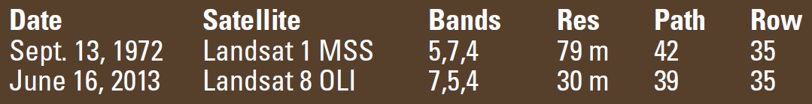

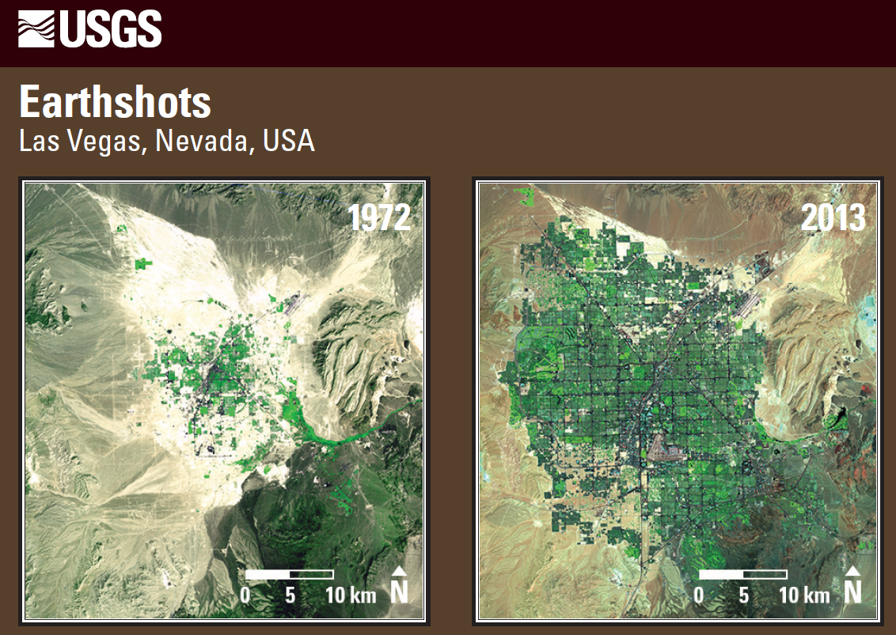

Extension:
- If you have access to a computer with Google Earth, look up your school. Use the historical imagery feature to look at your school area through time.
- If you want to learn more about image interpretation and how the data is used, you can check USGS Earthshots collection by accessing: https://earthshots.usgs.gov/earthshots/ (last accessed 12/17/2018)
  - Other resources:
- USGS Earth Resources Observation and Science (EROS) Center webpage, available at: https://www.usgs.gov/centers/eros (last accessed 12/17/2018).
- NASA's Earth Observatory Web Page: Remote Sensing available at https://earthobservatory.nasa.gov/topic/remote-sensing (last accessed 12/17/2018).
- NASA's Earth Observatory Web Page: Why is that Forest Red and that Cloud Blue? How to Interpret a False-Color Satellite Image available at: https://earthobservatory.nasa.gov/features/FalseColor/page1.php (last accessed at 12/17/2018).

Extension Activity
Activity taken from USGS Exploring Maps Lesson Plans.

Activity 1: Mapping the Third Dimension

Make a stereoscope.
Great advances in mapping in the 20th century were based on the three-dimensional image visible in the stereoscope. In this activity, students work in pairs to construct a simple stereoscope. A pair of stereo photographs is
included to use to view a three-dimensional image.

Time:
One 50-minute period for step 1.
30 minutes for remainder of the activity.

Materials for each pair of students:
- One cardboard box (an empty copier box works nicely)
- Knife for cutting the box
- Two locker mirrors (durable, light weight, about 4 by 5inches)
- Ruler
- Transparent Tape
- Overlapping (stereo) aerial photos (enclosed)

Procedures:
- Make the stereoscope as follows.
- Remove the top of the box, leaving the box at least six inches deep.
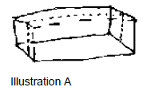
- Cut the box in half along the longer dimension (see illustration A) and set one half aside.

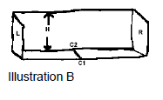
- Place the half of the box (let's call this the "frame") in front of you so that you are looking into it. Along the back and front edges of the bottom panel, measure half the distance between the left (L) and right (R) end panels. Mark these points C1 and C2 and connect them with a line (see illustration B.) Measure the height of the back panel of the frame (H). Set the frame aside temporarily.

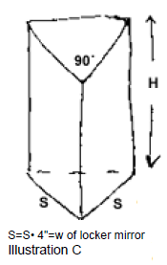
- Using another piece of the original box, cut a prism-shaped piece that has a 90-degree angle (see illustration C). The two sides (S) of the prism that meet at the 90-degree angle must be the same size, one inch wider than the locker mirrors. The long dimension of the prism need not be longer than the value H.

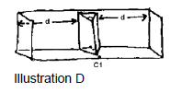
- Attach the prism to the frame (see illustration D). Orient the prism so that the edge with the 90-degree angle is on the center line (C1-C2) and is pointed at the open side of the frame. The sides of the prism should be against the back panel of the frame, and the distance (D) between the sides of the prism and the end panels should be equal.

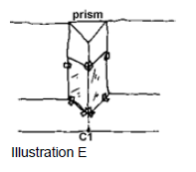
- Tape the mirrors to the prism, resting them on the bottom panel of the frame, as shown in illustration E.

- Mirrors should meet at the 90-degree angle. This completes the stereoscope.

- Using paper clips, attach the enclosed stereo photographs to the ends of the box, being careful to position them so that the right eye sees the area of overlap in the right mirror and the left eye sees it in the left mirror.

Position the stereoscope so that both photographs are illuminated equally.
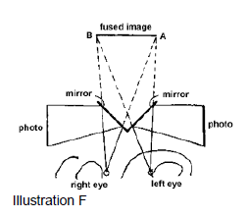
Look straight at the near edge of the mirrors from about a foot away (see illustration F). Tips for seeing the three-dimensional image: As you look for the stereo-image, try closing first one eye and then the other. Choose a distinctive feature and find it on both photographs. As you look, keep one image fixed and move the other image slightly to make the images of a distinctive feature on the two photographs come together. The three-dimensional image of the whole scene may suddenly appear (and perhaps, disappear). Once you see the stereo-image, it is generally easier to see it again.
- As a class, discuss how your brain constructs a three-dimensional from the two, two-dimensional air photos.

Photographs are taken sequentially along a flight line so that adjacent photographs overlap by about 60 percent. The left photo shows the perspective from the left camera station, and the right photo shows the perspective from the right camera station. Thus, your left eye sees the image from a different perspective from the right eye. The brain fuses the two images so that you see the entire area of overlap in three dimensions.

In this exercise, the three-dimensional image in your brain exaggerates the vertical relief; the slopes look steeper and buildings look taller on the stereo image than they are. This vertical exaggeration is a function of the geometry of the camera and the altitude of the camera when the photographs were taken. Vertical exaggeration, which can be useful in topographic mapping, can be quantified (or even eliminated) by photogrammetric mapping instruments. Judging by the vertical relief in the stereo image you see, sketch a topographic map of the area of overlap; select a contour interval and make the map at the same size as the stereo image.

Colorado River in the Grand Canyon.
Cartographers would use information acquired from surveying to measure elevations and distances (i.e., scale). For making the topographic map from this image use the following dimensions: top of peak A, altitude 5,600 feet; point B on the river, altitude 2,700 feet; horizontal distance from B to C, 1,000 feet.
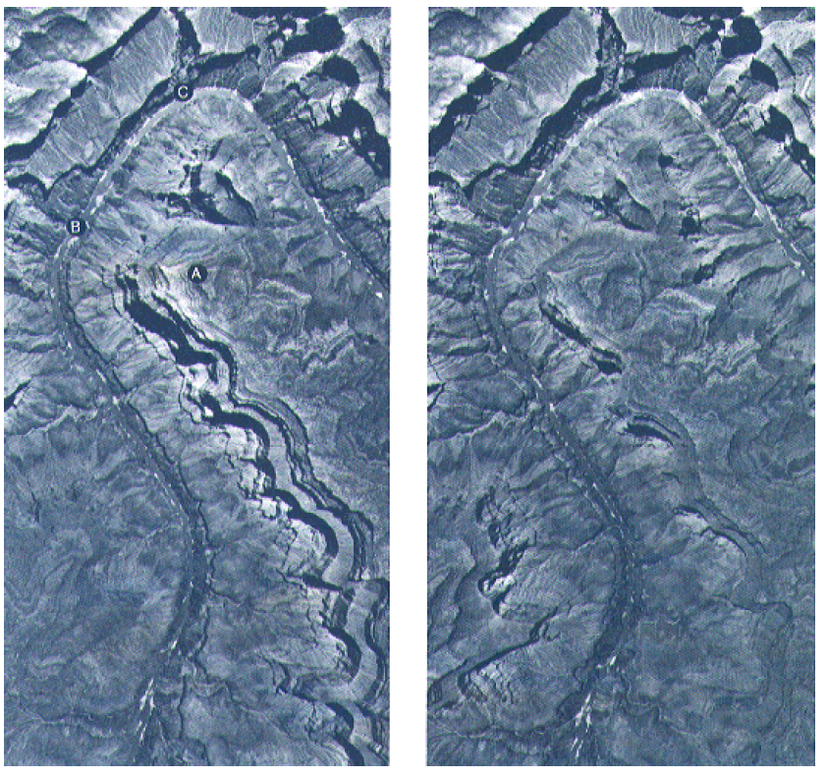

Lesson 3: Information
(Adapted from Exploring Maps: Information)

Time:

Materials:

Objectives:

Introduction:
There are many reasons why maps are made. Some maps are made for general purposes or to portray some information. Road maps showing cities, towns, rivers, lakes, parks and state and local boundaries are simple examples of maps displaying general information and often referred as base maps. However, some maps are intended to display specific information and they serve a specific purpose.
A map that depicts earthquake occurrences throughout the United States is a good example of a special-purpose map, or thematic map.
Maps can vary widely, even within a culture, a time, and a geographic realm. The differences stem from the inherited cartographer's bias and the purpose of the map. Cartographers make decisions about how to generalize and symbolize the information they are trying to show, they often generalize the data, simplifying the information so that the map is easier to read.
Map makers choose the scale and determine how large an area they can map and how much detail they can show. The selection of symbols (which can include lines, patterns, and colors) also affects the legibility, aesthetics, and utility of the map. Cartography blends science and art.
A beautiful map may become popular, even though it may be less accurate than a plainer version. Details of cartographic style affect how a map is perceived, and perception varies with perspective. In short, people understand the world differently, have different modes of expressing this understanding in maps, and gain different understanding from maps.
As we discussed in Lesson 1: Understanding Maps, geographic features can be shown at different sizes and levels of detail by using scale. Maps include selected basic geographic information to provide context. Every map has purpose or theme. The map design, which includes artistic aspects such as composition and balance, affects the success of the map—that is, its ability to communicate.
Context and distortion are other important considerations for map makers. Context is information that serves to orient the map reader to the mapped place. An example would be to look for the "boot" shape to identify Italy in a map of Europe. Geographic information that provides context can include coastlines, boundaries, roads, rivers and lakes, cities and towns, topographic features, place names, and latitude and longitude.
Distortion is another important aspect of context; every flat map of a curved surface is distorted. The choice of map projection determines how, where, and how much a map is distorted.
Examples of different map projections are shown in the USGS Map Projections Poster: https://store.usgs.gov/product/16573 (last accessed 12/06/2018).
The USGS Earthquakes Hazards program provides information about earthquake activity and hazards by region. Such information can be accessed at: https://earthquake.usgs.gov/earthquakes/byregion/ (last accessed 01/29/2019).
The typical mapping project now plots information on a base map, which shows where the place is and establishes the scale, orientation, context, and spatial distortion of the information to be mapped. The type and scale of the mapping project affect the choice of base map.
A map’s purpose is usually clear from its title and explanation, but other information (author, date, publisher, source of funding, etc.) hints at why and for whom the map was made. A knowledgeable map reader, recognizing that a map is both a simplification and a distortion of reality, will look for clues to the cartographer’s purposes and biases.
The information collected for a mapping project is called spatial data. Any object or characteristic that can be assigned a geographic location can be considered spatial data.

Activity I: On the Trail of Knowledge
(adapted from Exploring Maps, activity lessons).
Plot the earthquake epicenter data (figs. 1-2), on the base map of the North Atlantic Ocean floor. Use different symbols or colors to characterize different values.

Time:
One 50-minute class period.

Materials:
- Earthquake data (fig. 2)
- Base map (fig. 1)
- Colored pens or pencils
- Ruler
- Scrap paper

Procedures:
- Study the data to learn what information you have and to determine the range of values. This may be easiest to do by reorganizing the data in a new list or table. What are the lowest and highest magnitude values?
Considering that the Richter scale of earthquake magnitude includes values from 0 to about 9, are mid-Atlantic earthquakes weak, medium, or strong?
- Consider generalizing or grouping data to simplify the mapping. In other words, decide whether you need to map all points to see the pattern in the data. Decide on symbols to use in plotting the data. Consider making a sample plot of some data points to test symbol size, color, etc.
- Plot data points by latitude and longitude coordinates on the base map. Use a ruler as needed to help estimate locations between latitude and longitude lines. Choose a descriptive title and make a scale and legend for the map.
- Discuss the pattern revealed from mapping the data. Discuss the fact that two tsunami warning centers monitor the Pacific Ocean, but none monitors the Atlantic. What does this imply about magnitudes of earthquakes in the Pacific Ocean?

Earthquake data for 1990
Area from latitude 45EN to 45ES, longitude 0EE to 45EW.
Note: Magnitudes are measured on the Richter scale, in which every 1-point difference in magnitude represents a ten-fold difference in energy released by an earthquake.
From U.S. Geological Survey, National Earthquake Information Center’s global hypocenter data base.
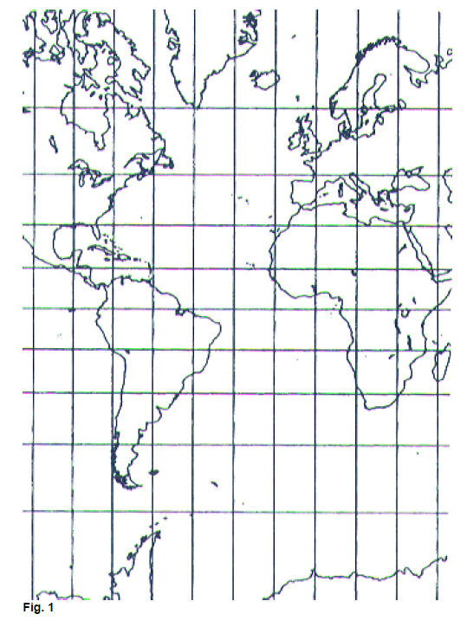
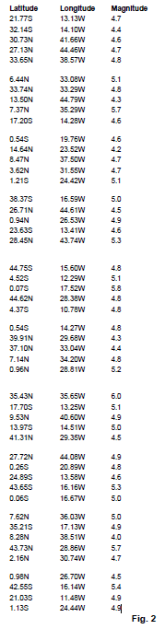

Additional Resources and Information
Note: External links (outside USGS) are denoted by (*). The USGS is not responsible for content, maintenance or information in external links. Inclusion of such links does not mean endorsement or support by the US government or any of its affiliate or cooperators.
Any use of trade, firm, or product names is for descriptive purposes only and does not imply endorsement by the U.S. Government.
Material provided is for informational purposes only. The data and information provided does not qualifies it as a scientific reference and it is only intended to be used for the exercises provided.

Map projections and Datum:
- Map projections: A working manual
USGS Professional Paper 1395 By: John P. Snyder: https://doi.org/10.3133/pp1395
Accessed 12/06/2018.
- USGS Map Projections Poster: https://store.usgs.gov/product/16573
Accessed 12/06/2018.
- GIS Lounge: Cartographic anomalies How Map Projections Have Shaped Our Perceptions of the World: https://www.gislounge.com/cartographic-anomalies-map-projections-shaped-perceptions-world/
Accessed 12/06/2018.
- GIS Lounge: Is this the Most Accurate Worldwide Map Projection? https://www.geolounge.com/accurate-worldwide-map-projection/
Accessed 12/06/2018.

Map Scales, resolution and minimum mapping unit
- ESRI Blog Post: A Question of Scale, Resolution, and MMU: https://blogs.esri.com/esri/esri-insider/2015/05/21/a-question-of-scale-resolution-and-mmu/
Accessed 12/06/2018.

Maps:
- Historical Maps of the Unites States: http://historymatters.gmu.edu/d/2503/
Accessed 12/06/2018.
- Basic Map information: Making sense of maps, http://historymatters.gmu.edu/mse/maps/
Accessed 12/06/2018.

Earthquakes:
- USGS Earthquake Hazards Program Web Site: Magnitude/ Intensity Comparison, https://earthquake.usgs.gov/learn/topics/mag_vs_int.php
Accessed 12/18/18.
- USGS Publication: The Severity of an Earthquake, https://pubs.usgs.gov/gip/earthq4/severitygip.html
Accessed 12/18/2018.

- USGS Earthquake Hazards Program Web Page: Earthquake Topics, https://earthquake.usgs.gov/learn/topics/
Accessed 12/18/2018.

Remote Sensing and Interpretation:
- USGS Landsat Mission Program Web Site: https://landsat.usgs.gov/
Accessed 12/12/18.
- USGS Landsat Program Information web page: Atmospheric Transmittance, https://landsat.usgs.gov/atmospheric-transmittance-information
Accessed 12/17/2018.
- USGS Mapping, Remote Sensing and Geospatial Data web page: https://www.usgs.gov/faqs/what-remote-sensing-and-what-it-used?qt-news_science_products=7#qt-news_science_products
Accessed 12/12/2018.
- USGS Earth Resources Observation and Science (EROS) Center webpage, available at: https://www.usgs.gov/centers/eros
Accessed 12/17/2018.
- NASA's Earth Observatory Web Page: Remote Sensing available at https://earthobservatory.nasa.gov/topic/remote-sensing
Accessed 12/17/2018.
- NASA's Earth Observatory Web Page: Why is that Forest Red and that Cloud Blue? How to Interpret a False-Color Satellite Image available at: https://earthobservatory.nasa.gov/features/FalseColor/page1.php
Accessed at 12/17/2018.

Urban Growth:
- USGS Publication: Urban Growth in American Cities, https://pubs.usgs.gov/circ/2004/circ1252/
Accessed 12/18/18.
- USGS Publication: Analysis of land use change in urban environments, https://doi.org/10.3133/fs18899
Accessed 12/18/18.
- USGS Publication (Teaching Lessons): Tracking Change over time, https://pubs.usgs.gov/gip/133/
Accessed 12/18/18.

Additional Lessons in Geography

USGS Publication: Tracking Changes Over Time
Landsat satellites capture images of Earth from space—and have since 1972! These images provide a long-term record of natural and human-induced changes on the global landscape. Comparing images from multiple years reveals slow and subtle changes as well as rapid and devastating ones. Landsat images are available over the Internet at no charge. Using the free software MultiSpec, students can track changes to the landscape over time—just like remote sensing scientists do!
The objective of the Tracking Change Over Time lesson plan is to get students excited about studying the changing Earth. Intended for students in grades 5–8, the lesson plan is flexible and may be used as a student self-guided tutorial or as a teacher-led class lesson. Enhance students’ learning of geography, map reading, earth science, and problem solving by seeing landscape changes from space.
Available at : https://pubs.usgs.gov/gip/133/, accessed 12/18/18

AmericaView

USGS is a partner in AmericaView, which has lesson plans and other education resources for working with satellite imagery. Mostly targeted to grades 6-12. Includes links to various lesson plans, games, tutorials, and other educational resources.
Available at https://www.usgs.gov/science-support/osqi/yes/resources-teachers/americaview, accessed 12/18/18.

USGS, Earth as Art
A special collection of satellite images that record beautiful sights, events of historic significance, and scenes that stir the imagination. Includes the 'Earth as Art' collection. All images can be downloaded for free as high-resolution JPEG files.
Available at https://eros.usgs.gov/image-gallery/earth-art, accessed 12/18/2018.

Understanding maps- Teacher's Guide

The following teacher’s guide provides suggestions and summeries of the material covered in the lessons. Please make sure to review the information provided in the lessons and adjust the activities as needed. Most of the activities can be easily customized for your geographical area by accessing the resources provided.

Lesson 1: Understanding Maps.
The lesson goes over basic map construction components and limitations.
It is a good idea to use examples of maps to go over the components and discuss the information such components provide.
You can access the USGS website to gather examples of different maps: https://www.usgs.gov/products/maps/overview (last accessed 01/28/2019) or use the USGS National Map Viewer web application to generate local maps: https://viewer.nationalmap.gov/advanced-viewer/ (last accessed 01/28/2019). Also check the USGS Store website: https://store.usgs.gov/ (accessed 01/30/2019) to order printed copy of different map products or download free digital versions.

Summary of activities for Lesson 1:
In the activities for Lesson 1, students will sketch a map of their school, labeling important locations and areas such as entrance, director's office, nurse office, gym, etc. This will get students to start thinking geographically. They might notice relationship of places they didn’t notice before. The idea is to get students to think about basic map construction decision making, especially the scale of their drawings and the limitations maps have.
The second part of the activity involves creating a map, to scale of their classroom (or using the description provided). For this, students will need a compass and a measuring tape. It is advised that the data collection process is done collectively and under the teacher’s supervision so that every student has the same information. If a measuring tape and a magnetic compass are unavailable, we provide details of an imaginary room to be use instead of collecting the data. You might also decide to collect the data in the classroom and assign the map making process as homework.
The maps are then evaluated by peers. Students will understand that not two maps are going to be identical. This does not mean that one is better than the other, but since maps are representations of places, these are subject to some bias from the map maker and differences in how features are represented.

Classroom description:
Notes: Not all details are included, but feel free to create additional details. Maybe have students measure their own desks and count the number of desks available in your room to add them to their map. Note that the sketch provided is not made to scale. Also note that there is not just one reference point, but all dimensions and measurement have a reference point explaining how the data was collected and measurements taken.

- Room size: 50 feet by 75 feet.
- The longer side of the room trends N-S.
- There are 2 white boards (measuring 4 feet by 7 feet) on the southern end of the room There is a 15 feet separation between the SE corner of the room and the edge of the first board). Entrance doors are located on the eastern wall. One located 3 feet from the SE corner of the room and the other door located 5 feet from the NE corner of the room.

- The teacher’s desk and working station is located between these doors, about 20 feet from the northernmost entrance door. The desk is about 3 feet wide and 9 feet long.

- The western wall is covered by a storage area in the northern side and windows in the southern side.

  - The storage area measures about 15 feet long (towards the south of the room) and 5 feet wide.
  - Following the storage area, about there is about 3 feet between the storage area and the windows, the last window is about 5 feet from the southernmost wall.
- Student’s sitting area is in the center of the room.

Sketch of the above details:
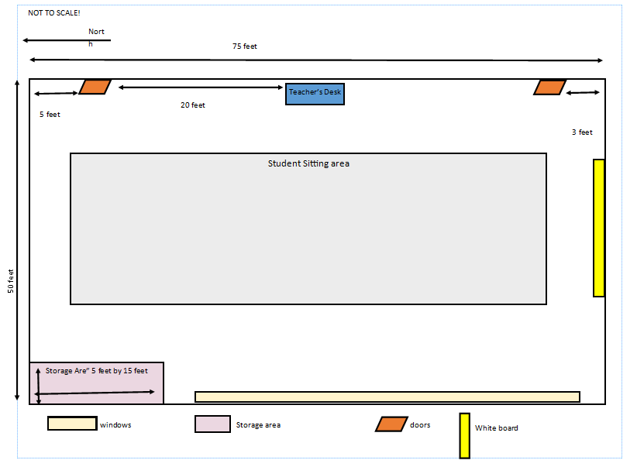

Topographic Mapping
This section provides basic knowledge to understand and use USGS topographic maps.
It is highly recommended to spend some time looking at a topographic map for the school area as a tool to get acquainted with how topographic maps display the information. You can either use any of the USGS resources provided below to access a topographic quadrangle. It is recommended to use The National Map (TNM) viewer web application to access the most current map for the area. TNM facilitates locating the topographic map by providing a search window where the school address can be used as input and the topographic map displayed. The mapped area can then be printed and saved as a pdf file. Feel free to create your own maps and use them as part or as a replacement for the exercises provided.

Lesson 2: Aerial photographs and remote sensing
Lesson 2 goes over basic concepts in remote sensing and aerial photographs. Nowadays, satellite imagery provides a powerful tool used in many mapping efforts. The lesson covers the basic concepts for remote sensing image interpretation.
Activity 1 in lesson 2 uses the USGS product: Earthshots, available at https://earthshots.usgs.gov/ (accessed 02/01/2019). Earthshots features different locations from around the world and shows and explains the changes that the satellite images reveal. The activity uses a couple of the Earthshots showcased. Feel free to include more and go over the entire selection of changes featured in the Earthshots collection.
Activity 2 in lesson 2, explain how to construct a pair of stereoscopes to be used in viewing a pair of stereographic pictures included. The construction of the stereoscopes could be assigned to students as a special project where students work in groups.

Lesson 3: Information
Lesson 3 enforces concepts of map bias and limitations discussed in lesson 1. The activity associated with this lesson involved plotting several earthquakes events in a map. The student needs to decide how to identify and classify the earthquake events. Students will decide on their own if they symbolize events by geographical location or by event magnitude, and how to represent those classifications.

Glossary:
Accuracy: the degree to which the result of a measurement, calculation, or specification conforms to the correct value or a standard.
base map: a map showing certain fundamental information on which can be compiled additional, specialized data.
compilation: production of a new map from existing maps, aerial photographs, and other sources.
concept map: a map-like illustration that shows relationships between concepts.
context: the interrelated conditions in which something exists.
Digital: A digital image is a two-dimensional array of pixels. Each pixel has an intensity value (represented by a digital number) and a location address (referenced by its row and column numbers).
digital mapping: the making of maps using computerized data and procedures.
distortion: the lack of proper proportion; directions, shapes, distances, and sizes of areas may be shown inaccurately.
Electromagnetic spectrum: the range of wavelengths or frequencies of electromagnetic radiation including gamma rays, visible light, and the longest radio waves.
Energy: is the ability to do work. Energy comes in different forms: Heat (thermal) Light (radiant) Motion (kinetic)
generalization: the simplification of data by eliminating unneeded detailed data.
Geographic information system: is a framework for gathering, managing, and analyzing data.
grouping: the simplification of data by sorting data into similar sets.
Global positioning systems: It is a global navigation satellite system that provides geolocation and time information to a GPS receiver anywhere on or near the Earth where there is an unobstructed line of sight to four or more GPS satellites.
Image: likeness of an object or view; in remote sensing, a likeness produced without photography using an electronic spectral sensor.
Intensity value: (in a pixel) represents the measured physical quantity such as the solar radiance in a given wavelength band reflected from the ground, emitted infrared radiation or backscattered radar intensity. This value is normally the average value for the whole ground area covered by the pixel.
isoline: a line through points of equal value.
layer: in digital cartography, map data on a common theme manipulated separately from other types of data.
map design: the choices made in creating a map; decisions are generally based on the maps purpose, intended audience, and characteristics of the spatial data.
mosaic: a whole image or map made from parts from more than one source.
optics: the science that deals with light and closely associated phenomena.
orientation: alignment, usually in reference to points on the compass.
Photogrammetry: is the art and science of making measurements from photographs, especially for recovering the exact positions of surface points.
perspective: the appearance to the eye of objects in respect to their relative distance and position; the technique of representing the spatial relationship of objects as they might appear to the eye.
positional accuracy: the accuracy of the location of a point.
Pixel: Each pixel represents an area on the Earth's surface. A pixel has an intensity value and a location address in the two-dimensional image.
Radiation: the emission of energy as electromagnetic waves.
remote sensing: the process of detecting and monitoring physical characteristics of an area by measuring its reflected and emitted radiation.
scale: the relationship of the size of a feature on a map to its size in reality.
bar scale: scale shown by a line, which is labeled to represent a stated distance.
representative fraction scale: scale indicated by a ratio of one unit on the map to some number of the same units on the ground, for example 1/24,000.
verbal scale: scale indicated by a phrase such as "one inch represents one mile."
large scale: good for showing detail in small areas.
small scale: good for showing a general view of a large area.
spatial data: information pertaining to a place linked to coordinates or other positional information.
stereoscope: a device used to view overlapping photographs to obtain the mental impression of a three-dimensional
qualitative: related to quality or kind.
quantitative: related to quantity, value, or amount.
thematic map: a map designed to show information on a single topic.
Triangulation: the tracing and measurement of a series or network of triangles in order to determine the distances and relative positions of points spread over a territory or region, especially by measuring the length of one side of each triangle and deducing its angles and the length of the other two sides by observation from this baseline.

See teacher’s guide.
Any use of trade, firm, or product names is for descriptive purposes only and does not imply endorsement by the U.S. Government.
Maps provided throughout are for descriptive purposes only and are not for navigational use.
Maps provided are for descriptive purposes only and are not for navigational use.
Maps provided are for descriptive purposes only and are not for navigational use.
Any use of trade, firm, or product names is for descriptive purposes only and does not imply endorsement by the U.S. Government.

