CHAPTER 12

Title: Professional Development

Issuance Date: 1/7/2022
Instruction: This chapter is revised to relocate responsibilities elements to Survey Manual (SM) 445-2-H, Chapter 2 Responsibilities and 445.1, Occupational Safety and Health Policy and Responsibilities.
Approving Official: Katherine M. McCulloch, Associate Director for Administration

- Purpose and Scope. This chapter specifies the minimum Occupational Safety and Health (OSH) Program requirements for developing and administering a formal career development program for the U.S. Geological Survey (Bureau or USGS) full-time and collateral duty safety and health personnel.
- Authority and References.
- 29 CFR 1960, Basic Program Elements for Federal Employees, Subpart H, Training.
- USGS Training and Technical Knowledge, Skills and Abilities Handbook for Collateral Duty & Full Time Safety Personnel (internal).
- SM 445-2-H, Chapter 13, Collateral Duty Safety and Occupational Health Program Coordinator.
- SM 445-2-H, Chapter 14, Safety and Health Training.
- Requirements.
- OSH Programs must consider distinct knowledge, skills, and abilities required of safety and health positions. OSH Professional Development plans must include career development programs, with mandatory curricula, meeting the present and future training needs of full-time safety and health personnel and Collateral Duty Safety Program Coordinators (CDSPCs). Reference: USGS Training and Technical Knowledge, Skills and Abilities Handbook for Collateral Duty & Full Time Safety Personnel; SM 445-2-H, Chapter 13, Collateral Duty Safety and Occupational Health Program Coordinator; and SM 445-2-H, Chapter 14, Safety and Health Training.
- Full-time safety and health personnel can use Appendix 12-1, Mandatory Career Development Requirements for USGS Full-Time Safety and Health Personnel, to documenting completion of specific required courses. Records and supporting documents are kept locally.
- Credit may be given for equivalent courses completed prior to the establishment of the career development program or those completed through prior employment outside the USGS.
- Current professional certifications received through private organizations, may be recognized as meeting part or all of the mandated career development requirements (e.g., Associate or Certified Safety and Health Professional issued by the Board of Certified Safety Professionals (CSP); Certified Industrial Hygienist (CIH) through the American Board of Industrial Hygiene; or Certified Safety and Health Manager (CSHM) from the Institute for Safety and Health Management).
- USGS full-time safety and health personnel have up to 6 years to complete all the mandatory training requirements. Full time safety and health staff who have finished the USGS required mandatory training, must complete a minimum of 24 hours per year (Department of the Interior (DOI) requirement) of career development courses in OSH training.
- Collateral Duty Safety Program Coordinators (CDSPCs) must be trained, within six (6) months of appointment, in the basic elements of organizing, planning, and managing an effective safety and health program, unless they have had the training or experience within the last 3 years. CDSPCs must complete general orientation training within the first year of appointment. CDSPCs must complete 16 hours of annual training thereafter.
- Cooperative agreements may be established with external training vendors, to facilitate instructional offerings that meet mandatory and recommended career development needs.

CHAPTER 12, APPENDIX A
Mandatory Career Development Requirements for USGS Full-Time Safety and Health Personnel
Reference document USGS Training and Technical Knowledge, Skills and Abilities Handbook for Collateral Duty & Full Time Safety Personnel (internal) for a list detailing specific training and links to the sources for the courses below. Numbering in the list below corresponds to listings in that document. If alternate courses are taken, add the information in the Alternate Course Name columns below.
Training required within 45 days of assignment.
· 1 (SAFETY: 1338 USGS Authorities, Roles, and Responsibilities (shortname DOIU-1338-OLT-USGS))
· 2 (SAFETY: DOI Safety and Occupational Health Overview (shortname DOIU-OLT-1342))
· 3 (SAFETY: 1340 USGS Resources, References, and Standards (shortname DOIU-1340-OLT-USGS))
· 6 (SAFETY: 1315 USGS Safety and Occupational Health Program Overview (shortname DOIU-1315-OLT-USGS))
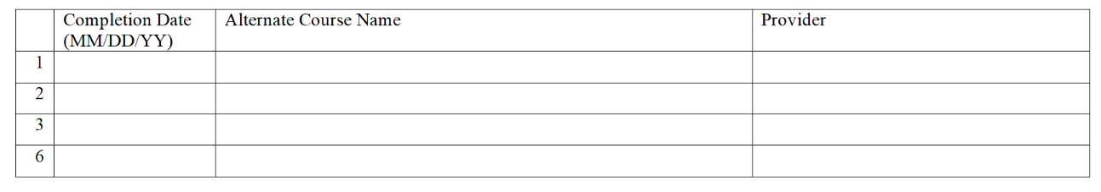
Training required within 6 months of assignment.
· 4 (SAFETY: 1304 USGS Industrial Hygiene Program Requirements (shortname DOIU-1304-OLT-USGS))
· 5 (SAFETY: 1300 USGS Safety Program Requirements (shortname DOIU-1300-OLT-USGS))
· 7 (Behavior-based Safety for Supervisors (shortname ehs_hsf_d63_sh_enus))
· 10 ((Globally Harmonized System of Classification and Labeling of Chemicals (GHS) (shortname ehs_hsf_d17_sh_enus)) or 83 (Hazard Communication - GHS (shortname BSEE-HCGHS-001)) or 84 (Hazard Communication (HAZCOM) Program with GHS (shortname BLM-H-010))
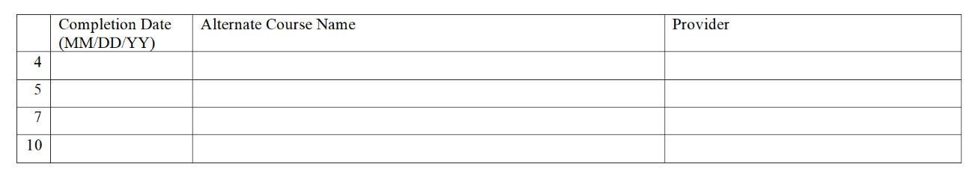
Training required within 1 year of assignment.
Complete one course from below or attend a face-to-face seminar (when scheduled).
· There are two versions of Occupational Safety and Health Course for Other Federal Agencies course: 46 (OSHA 6010 - Occupational Safety and Health Course for Other Federal Agencies) and 47 (OSHA 6015 - Occupational Safety and Health Course for Other Federal Agencies)
· 45 (OSHA 511 - Occupational Safety and Health Standards for General Industry) (this is a prerequisite to 41)
· 41 (OSHA 501 - Trainer Course in Occupational Safety and Health Standards for General Industry)
· 44 (OSHA 510 - Occupational Safety and Health Standards for the Construction Industry) (this is a prerequisite to 40)
· 40 (OSHA 500 - Trainer Course in Occupational Safety and Health Standards for the Construction Industry)
· 59 (DOI Implementing and Managing a Safety Program (shortname BLM-TC-1112-02))
· DOI/USGS Safety & Health face-to-face training (yearly, week or day(s) seminar)
Training required for years 2 and beyond.
Complete a minimum of 24 hours of training by choosing from the list of courses within reference document USGS Training and Technical Knowledge, Skills and Abilities Handbook for Collateral Duty & Full Time Safety Personnel (internal) or equivalent. In years 2-6, it is required to take a minimum of six (6) advanced courses from the advanced course list. Document the completion of advanced courses in the below table.
